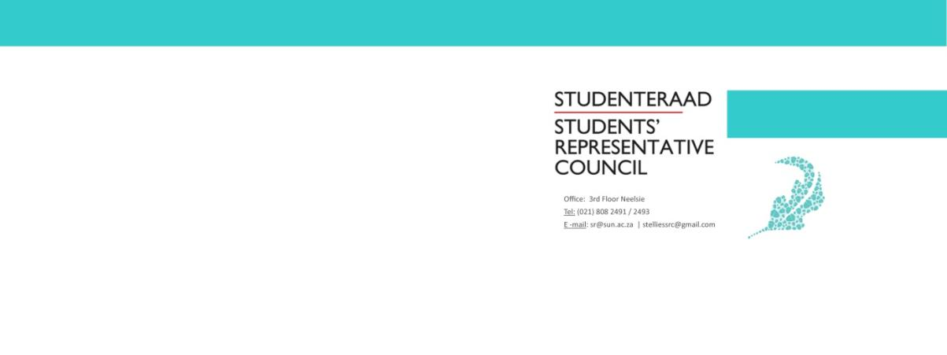
Name and Surname: | Joconde Nsumbu
Portfolio: | SU International Manager
Subject: | Handover report
Email: | 20361785@sun.ac.za
Constitutional Responsibilities
According to the Stellenbosch University Student Constitution, 2018, the SRC Manager of Internationalization is responsible for:
- Running portfolios that entail mainly organizational or administrative functions.
- Attend at least on SRC meeting per term.
Portfolio Overview
The role of the SU International manager is to organize and administrate functions concerning the international students registered at Stellenbosch University.
My role as SRC rep for internationalisation as per the student constitution entailed organising and administrating functions concerning international registered students, however, after Covid-19 hit the challenges that presented themselves required a shift in thinking and my role became more administrative in nature, and functions to help facilitate the integration of international students on campus took a back seat. Therefore, assisting international student facing unique problems as the result to the pandemic, maintaining a healthy working relationship with the International office, and voicing the concerns of my fellow students to relevant parties became my main objective.

Key duties:
- Immediately open applications and appoint a SU internationalization committee
- Create some form of WhatsApp group chat or Google drive. This will be a good official platform for communication.
- Compile a functioning budget for the year.
- Create a year plan with proposed events and dates.
- Focus on issues that students are facing, sometimes they are more meaningful to students than events are.
- Meet regularly with the international office. Maintain a health work relationship as many structures within this department.
- Serve on the African Student Board.
- Attend office duties as an SRC member.
- Attend at least one term SRC meeting.
- Complete term reports
- Write down a handover report for the next chair

Other Committees / Task Teams
As the SRC manager of Internationalization, I serve on the African Student Board and the International Student Board.
Year Overview
2020 has been a challenging and stressful year. This overview should therefore be reviewed within the COVID-19 pandemic context as opposed to how a normal year would look like.
Previously, the SRC Internationalization portfolio had been very unorganized and not well framed out. This allowed me the freedom to make this portfolio what I had envisioned it could become. As an African international student who has been working with the international office for the past three years, one dominate theme that I observed and thus wanted to implement within this portfolio as the main theme for the year was social integration among our international students.
This year, the objective planned out was to unite international students as a whole. This entailed narrowing down the divide between Euro-American and African students on campus. Although both international groups are under the same administration (International Office) these two bodies of students are not united on campus. A primary example of this can be seen within the International Office itself. Each year the international office under the Co-Ordinator: International Students Life and Success, social events are held, yet each year these events are lacking in diversity. This is amplified when you look at the general feel on campus. Thus my goal was to work on social integration, and to work in collaboration with the coordinator of international students life and success to ensure that we can have a more diverse and inclusive international student body on campus.

Adaptation:
During lock down engaging in social event was no longer feasible and thus social events that would help facilitate the integration among our Euro-American and African international students had to take a back seat, and I dealt with each presenting problem to ensure that internationalization would still occur, but on online.
As an executive member of the African Student board on campus, I joined forces with the international office to revive and rebrand the board, to ensure that issues and challenging’s that our students were facing both on campus and abroad could be dealt with accordingly. The issues that were presented were the following:
International students aboard.
- Most of our international students had returned home when the lock down was announced, and therefore were abroad. For the most part, the only issue that these students presented was adapting to the time zones, working to meet deadlines on the South African time zone. This meant that some students had to write tests at odd hours, however, owing to the fact that this was a challenge best suited for the Academic Affairs Counsel this fell out of our mandate, and all we could do was refer students to the appropriate counsel.
- For some of our students who chose to remain on campus the problem that presented itself was the expiration of student visa`s. This issue was a general concern owing to the fact that Home Affairs was not dealing with any matter outside Death certificates and I.Ds. This left many of our students without any word regarding their stay in South Africa. This issues in collaboration with the African Student Board was lobbied for at the international office. The requirement was that we`d have a spokesperson from Home Affairs was to meet with us in order to ensure the security of our students on campus. The International Student Board was formed, in which I was part of. It was tasked with finding solutions in partnership with other Western Cape Universities. The issue with the visa was temporarily resolved, and students could remain on campus even if their visas were to expire. The follow up must still be done now that we are heading towards end of lock down.
- Other issues that I faced the manager of internationalization were parallel to those faced by our African students. Issues such financial hardship, permit requirements, housing and leasing contracts. These were the type of issues that we dealt with on a one on one basis.
- Perhaps one of the biggest challenges that we faced this year was in relation to bursary needs, and student academic stability for 2020 and 2021. As a result of covid-19 and the general lack of a student funding body that provides international students with the opportunity to earn a bursary, this year the international senior director of SU International was able to finalize the process of securing bursaries for SADC students. This bursary will come in fall effect in 2021, for second year SADC students. This is probably the biggest flex of 2020, because finally, international students are recognized as students who also need help. Hopefully this will develop to include all international students in the near future.

Budget Overview
This year’s budget was planned out and requested in accordance with the theme I set out for the year. Social integration in the forms of social events all in collaboration with the international office, and the African student Board, however, as mentioned these events were unable to come to life because of Covid-19, and thus the annual budget was not utilized. Everything I had worked on was on a l administrational level, and thus had no real use for the budget. In a normal year however, the budget would play a significant role in this portfolio.
Recommendations for Portfolio Improvement
- Maintain a healthy work relationship with the international office.
- Get a subcommittee. I myself did not have one and had to work on everything on own with assistance from the international office. Get more help.
- If there is a global pandemic… or it continues… adapt.
- Collaborate with their SRC portfolios to help them achieve their goals and create new ones for yourself. I myself did not do this, partially because of the pandemic and because I enjoy working on my tasks alone. Do not adapt this mindset.
- Feel free to reach out to me at any time, this portfolio is at its developing stage and I would love to see it grow.: Joconde.Nsumbu@gmail.com
- When planning events, always book venues ASAP to confirm dates
- Target Tygerberg, there are international students there too. Not just main campus.
- Start a social media presence.

