Minutes

Students’ Representative Council Meeting
Date: 2021-03-31 | Time: 17:30 | Venue: SRC Boardroom (Hybrid)

Welcoming
Xola welcomed all members present.

Attendance & Apologies

Present
  - Xola
  - Kira
  - Phillip
  - Jarryd
  - Maki
  - Eduard
  - Unathi
  - Viwe
  - Leoné
  - Joshua
  - Masixole
  - Kristin
  - Luigia
  - Almé
  - Sarah
  - Thimna
  - Khwezi
  - Yanga
Absent
  - Gina
  - Ayesha
  - Avumile
  - Nomzamo
  - Rewaldo
  - Precious
  - Luigia
Apologies
  - Almé
  - Precious
  - Gina
  - Leoné
  - Ayesha
  - Sarah
  - Masixole
  - Kristin (late)

Setting of the agenda
No added agenda points

SU’s revised Language Policy
Follow the following link to read the Language Policy: http://bit.ly/SU-language
Dr Van der Merwe discussed the following points with regards to the Language Policy reviewing process.
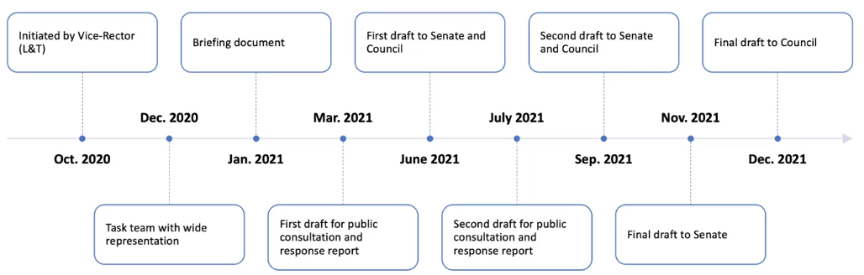
  - The timeline was shared starting at October 2020 and the 12th of April will be the end of the first draft for public consultation. The final draft is due to go to Council in December 2021.

  - Policy is being revised as it is prescribed in the policy that it is part of a five-year revision cycle.
  - The Task Team for this revision process, consists of the following people:
    - Dr Antoinette van der Merwe (Chair) as curator of policy
    - Vice Rector (Learning and Teaching) as owner of the policy
    - 10 Vice Deans (Learning and Teaching)
    - Chair of SRC
    - Chair of AAC
    - Director of Language Centre
    - Registrar
    - Mr Gerhard Lipp and alternative
    - Member nominated by the chair of Institutional Transformation Committee.
    - Senior Director of Corporate Communication and Marketing
    - Deputy Director of Academic Planning and Quality Assurance and the Advisor of Academic Planning.
  - If the essence of the policy would be summarized, it would be “Multilingualism without exclusion”.
  - Dr Van der Merwe ran through the policy, discussing it with all members present and allowed members to comment.
  - Going forward we will have a workshop on the policy to engage with the content and to ensure that we come prepared. That way we can share and discuss the parts of the policy we are okay with, the parts we are confused about etc. This will provisionally happen on the weekend of the 9th of April.

Feedback from Quality Committee & Senate
Philip gave feedback about the Senate meeting and discussed the following points which was discussed in their meeting.
  - Management report by the rector:
    - SunFin is going live in 2021 July. TeraTerm is being phased out to be replaced by SunFin.
  - The Language controversy was discussed.
    - Language policy to be approved by senate and council.
  - Student finances
  - Wim’s goals for the year.
    - Completing the academic year
    - Ensuring institutional sustainability
  - Management report of Vice rector of research and innovation post graduate studies.
    - There is a drop in the masters and doctorate qualifications due to COVID’s effect on finalizing degrees.
  - Branding and marketing
    - Feedback on the university’s rebranding and the costs thereof.
  - Academic planning committee’s recommendations and the approval thereof.
  - Introduction of Prof Deresh.
Feedback on the Quality Committee meeting. The following points were discussed.
  - The duty of the quality committee is to assess all the departments within the university. In this meeting three departments were reviewed. Engineering, Agronomy and the History department.
  - Prof Deresh is taking over for Prof Schoonwinkel.

Feedback from Bursaries & Loans Meeting & Matie2Matie
Matie2Matie
  - Previously known as the financial assistance committee.
  - Used unbudgeted funds to help students who are in financial need.
  - Have received many applications and thus far 3 has been successful.
  - The criteria are set up as we go but it is consistent.
Still investigating going about paying rent.
Bursaries and loans committee
  - This will be discussed in the next meeting.

#Action4Inclusion
Had a meeting last week with the whole team. Got decisions register of who is responsible for what going forward. The SRC is responsible for the rest of the 5 summits.
Each of the summits will have a topic or theme and will be in a different area each time. The following areas will be used for the upcoming summits:
  - Helderberg nature reserve
  - Botmanskop
  - Coetzenburg
  - Del vera winery
  - Still need one more venue
We will have a talk before each summit or when we reach the top. This way we can include personal development to the action4inclusion.
Possible topics we can discuss:
  - GBV
  - Residence relations
  - Financial access
  - Disabilities
  - Mental health
Whoever’s portfolio is most relevant to that theme, will work with Khwezi to develop or plan for that specific day. Summits will usually be on Sundays. Clusters also wants to be involved, therefore, once portfolios are chosen and Prof’s PA has approved the summits, we will send it through to the cluster executives. They will then choose which clusters will collaborate. Therefore, there will be a three way collaboration between SRC, action4inclusion and the clusters.
  - There will be a specific cluster convenor, SRC member and the action4inclusion team who will be responsible to make sure everything happens smoothly for that specific summit.
  - There will be a separate price for students and for the general public. We need to discuss what the price will be.
Kira to suggest the dates. Viwe to create the word document where you can enter your volunteered portfolio and date.
Done by next week Friday: All the summit information (where we are going, how long it will take, the portfolio and who’s responsible for it as well as the topic of discussion).
All proceeds will go to the campaign.
Transport arrangements still to be confirmed.

Prim Committee Feedback
The GBV perpetrator on Tygerberg is re-introduced into the community. He is not going to resign from the residence even though he had the option. They are now discussing the rehabilitation into society at Tygerberg.
  - It was suggested to get a strict rehabilitation programme in order for students to feel comfortable with the perpetrator being back on campus and in the residences.

Acquisition of Boardroom Equipment
There are funds budgeted for upgrading the boardroom through the “Raadsaal” cost centre. The following things was listed to maybe use the funds for.
  - Fixed projector
  - Fixing chairs
  - Trash bin for boardroom
  - Screens
  - Proper wall with past SRC member photos (maybe digitalize photos and show on a screen)
  - Fixed camera (for online meetings)
  - Improvements to make the spaces more accessible for students with disabilities.
Luigia to send the disability list to the SRC by Tuesday. This document highlights the different areas which is not accessible for students with disabilities.

Referendum on Amendments to the Student Constitution
Leoné, Yanga, Vhudi (TSR) and Philip sits on the sub-committee and their purpose is to revise the constitution and amend it as they think applicable. Thus far there has been 345 proposed amendments.
The order of the process will happen as follow: The amendments are proposed to the SRC. The SRC then has the opportunity to engage on the amendments, send in proposals and thereafter they have to approve it. Once the amendments has passed the SRC, it is adopted by the SRC and a referendum has to take place. The referendum is the students’ opportunity to raise their opinions. After the referendum it is proposed to council, who then needs to approve it.
All SRC members has received the amended student constitution and must please engage on it and discuss what they agree with and what not.
The following points were raised with regards to the amendments:
  - It was mentioned that members did not have enough time to go through all the amendments and that more time is needed.
  - The Chairperson suggested to have a specific date to run through the entire document at once so it can get done.
Philip then ran through the proposed amendments, discussing which amendments the Constitutional Review committee did not support. The following points were raised:
  - Within the Referendum document, the Constitutional Review Committee did not support the following amendments: Amendment 8, 9, 11, 23, 24, 49, 89 and 90.
  - Amendment 49, stating that student financial access needs to be a compulsory portfolio, were not supported by the committee.
  - A few SRC members disagreed and mentioned that they believe it has to be a compulsory portfolio since financial need will not go away in the future.
  - Members in favour of the student financial access being a compulsory portfolio were more than the members against, therefore it will be drafted into the amendment document and can be voted in later.
Philip also went through the student constitution document and the parts that were amended (highlighted in yellow).
  - Xola mentioned that we should remove Communications Officer portfolio. It was mentioned that it has to be put into an official proposal at the latest two days before the next meeting.
  - Philip to add description underneath the arts and culture chairperson portfolio.
  - There was a discussion on whether or not Policy officer should be a compulsory portfolio taken up by an elected member rather than having a manager to have the portfolio.
All members are advised and encouraged to go through the constitution and to send through all proposed amendments before the next meeting so that it can be discussed at the next meeting.

Closing
Xola thanked everyone for joining and adjourned the meeting.

