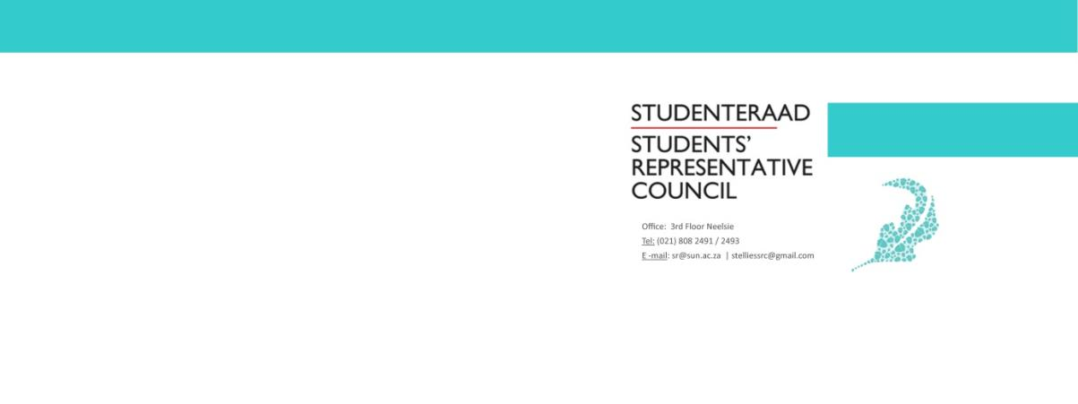
Name and Surname: | Joconde Nsumbu
Portfolio: | SU International Manager
Subject: | First term report
Email: | 20361785@sun.ac.za

Constitutional Responsibilities
According to the Stellenbosch University Student Constitution, 2018, a manager is responsible for:
- Running portfolios that entail mainly organizational or administrative functions.
Portfolio Overview
The role of the SU International manager is to organize and administrate functions concerning the international students registered at Stellenbosch University.
This year, the objective planned out was to unite international students as a whole. This entails, narrowing down the divide between Euro-American and African students. Although both international groups are under the same administration (International Office) these two bodies of students are not united on campus.
This portfolio also aims to represent international students who often feel neglected on campus, and to represent these students who are often left with no representation on campus to turn to in times of crisis.

Other Committees / Task Teams
SRC Executive Committee
African Student Board
Budget Overview
I have still not yet received a budget and as the result of the pandemic all plans for the first term are on hold.
Term Overview
While this report is meant to cover the experiences of one term, due to unexpected conditions, I have nothing to report. This is the result of the late appointment of Managers, and the COVID 19 pandemic.
Owing to the late appointment of managers, no real opening event could have been planned out early in the term and everything planned after has been delayed to the end of the term as the result of the national COVID 19 outbreak.

Plans for Next Academic Term
I plan to engage with international students who went home as they might experience complications if the travelling ban is not lifted.
I also plan to move the events scheduled for term one to term two. This is because most of term one`s events were integrative events and thus are essential in achieving the goals set out for the year.
Recommendations for Portfolio Improvement
For my portfolio:
This is still my first term and I have not yet done much with this portfolio and consequently have no real recommendations to make.

