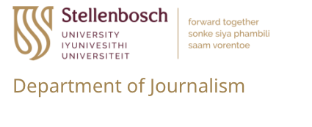

PhD Bursary in Journalism

The successful applicant will conduct research linked to a multinational research project “Resisting Information Disorder in the Global South”, funded by the International Development Research Center (Canada) and led by Prof Herman Wasserman.

The applicant’s PhD project should focus on a research problem relevant to the overall research project’s focus. Topics may relate to disinformation, investigative journalism, media policy and regulation, media literacy, inauthentic influence operations, media trust and similar issues.

The bursary is for full-time study for a maximum of three years, at an amount of R200 000 p.a. (renewable annually upon satisfactory progress). This amount may be supplemented by additional remunerated research assistance on the project.

Candidates should submit:

- A motivation letter
- A brief (2-page) research proposal
- Academic records
- Two letters of recommendation from academic referees

Submit applications (marked ‘IDRC PhD Bursary application’) to journalism@sun.ac.za
Deadline: 15 December 2022

Enquiries: Prof Herman Wasserman, hwasserman@sun.ac.za

