EMBED Word.Picture.8 | STELLENBOSCH UNIVERSITY

HOW TO USE THIS ASSENT FORM:
This document is the standard REC-approved template to assist you with designing a written informed assent form for minors (persons under the age of 18 years old). You may adapt the template as you see fit, but remember that the document must address the child directly, have some information about each heading and include the SU logo at the top. Please write in SIMPLE, NON-TECHNICAL, CHILD-FRIENDLY language. Note that this assent form template is appropriate for use for child participants aged between 8-13 years old. For adolescents (aged between 14-17 years old), please use the adult consent form template.

The text written in [RED] is for guidance only and should be removed before finalising the document. Also, this information box should be deleted before the document is finalised.

ASSENT FORM FOR MINORS

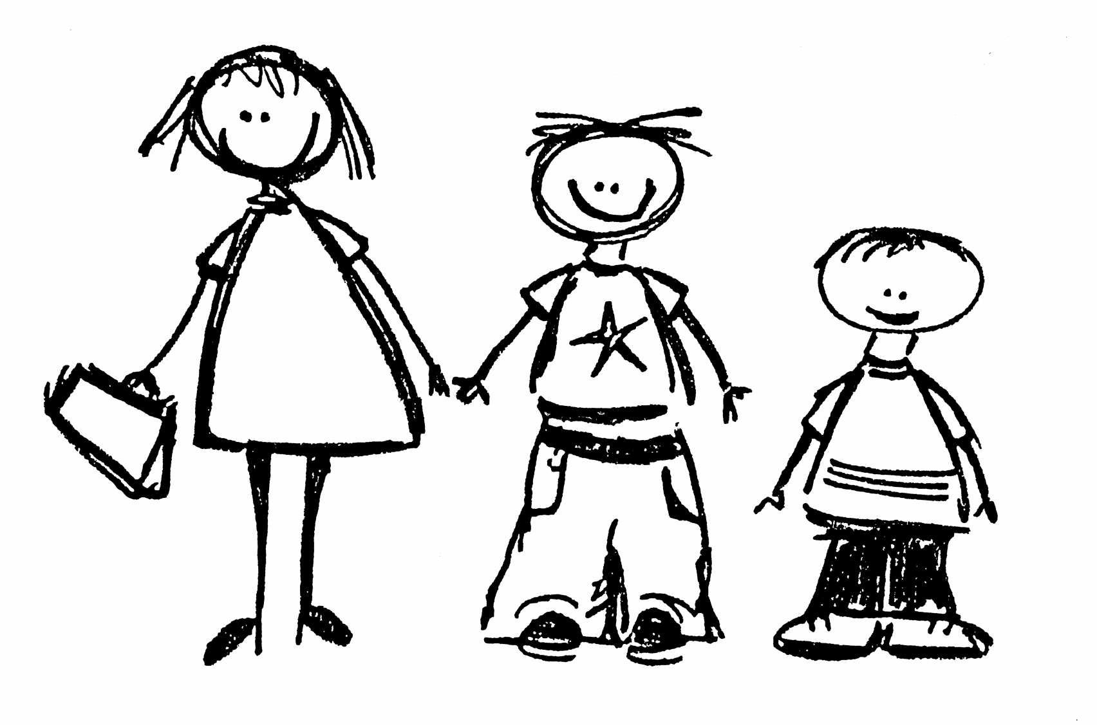

TITLE OF THE RESEARCH PROJECT: Insert the title of your research project in simple, non-technical language.

RESEARCHERS’ NAME(S):

RESEARCHER’S CONTACT NUMBER:

What is RESEARCH?
Research is something we do find NEW KNOWLEDGE about the way things (and people) work. We use research projects or studies to help us find out more about children and teenagers and the things that affect their lives, their schools, their families and their health. We do this to try and make the world a better place!

What is this research project all about?
Explain your project in simple child friendly language. Adapt the information to the age of the children that you plan to include.

Why have I been invited to take part in this research project?

Answer this question in simple language

Who is doing the research?
Identify yourself and explain who you work for and/or why you are doing the project

What will happen to me in this study?
Describe what the participant will be expected to do. Describe all procedures using simple language.

Can anything bad happen to me?
Explain any possible risks to the child, using simple terms. If something might be scary or anxiety provoking state this in the assent form.

Can anything good happen to me?
Only describe known benefits to the participant and don’t overstate the benefits. You may include any possible future benefits to others. If there are no known benefits, state so.

Will anyone know I am in the study?
Explain in simple terms that the child’s participation in the study will be kept confidential, but information about him/her will be given to the study sponsor, or supervisor. (NOTE: This information may not be applicable in assent forms for very young children).

Who can I talk to about the study? List those individuals the child can contact (including their contact details) if he/she has any questions or has any problems related to the study.

What if I do not want to do this?
Explain to the child that he/she can refuse to take part even if their parents have agreed to their participation. Explain that they can stop being in the study at any time without getting in trouble.

Do you understand this research study and are you willing to take part in it?
YES |  | NO

Has the researcher answered all your questions?

YES |  | NO

Do you understand that you can STOP being in the study at any time?

YES |  | NO

_________________________ ____________________
Signature of Child Date

