- Click on the project that you would like to create a sub-form for.

Sub-form refers to all sub-forms; Amendment, Progress/Final, Protocol Deviation, Documentation or Adverse Event Form etc
You will have an option to select the appropriate form once you have clicked on create sub-form.
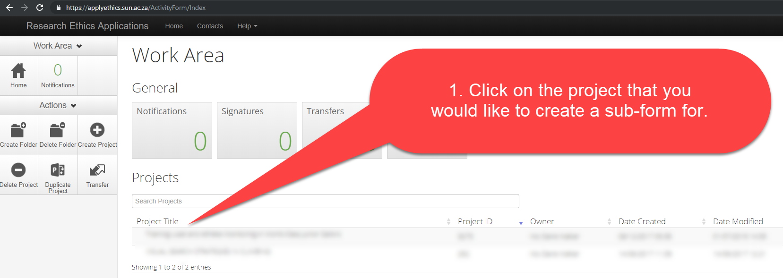

- Click on create sub-form
  - If you see the highlighted message in red, please be informed that you will need to update your form, in order to submit it as a newer version of the application form was released.
  - (Please also take note that their might be a few additional questions that you will need to complete once you have updated your form)
  - If your application has been approved with stipulations, you will first need to respond to the stipulations and submit your initial application form, before you can submit your sub-form.
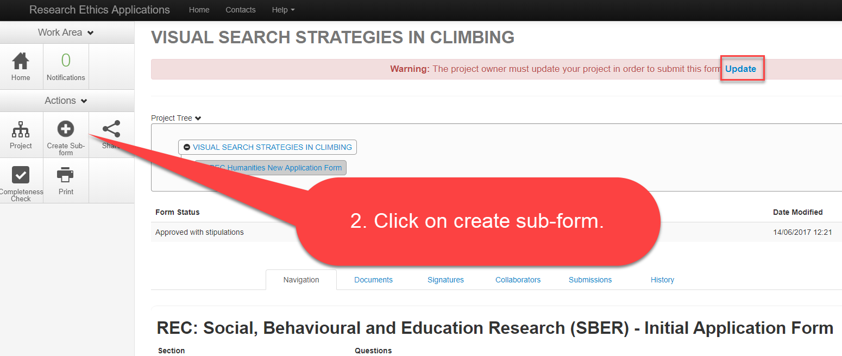

- Click on the drop down list and select the appropriate form
(Please note that the REC Humanities Committee had a name change, therefore, if your form has been updated, the forms will display as REC SBER (name of the sub-form)
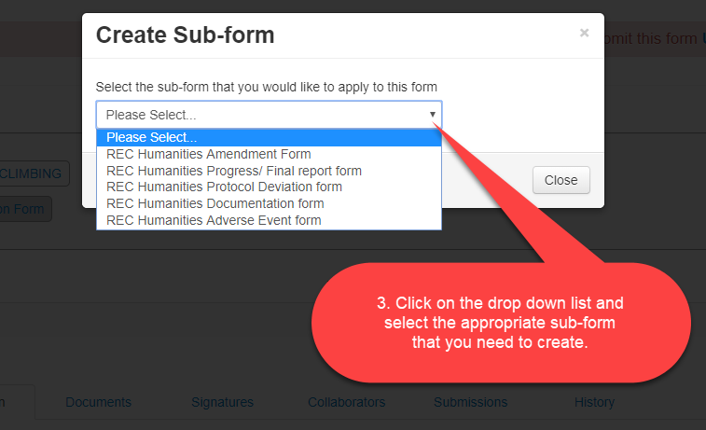
- Click on create once you have selected the correct form
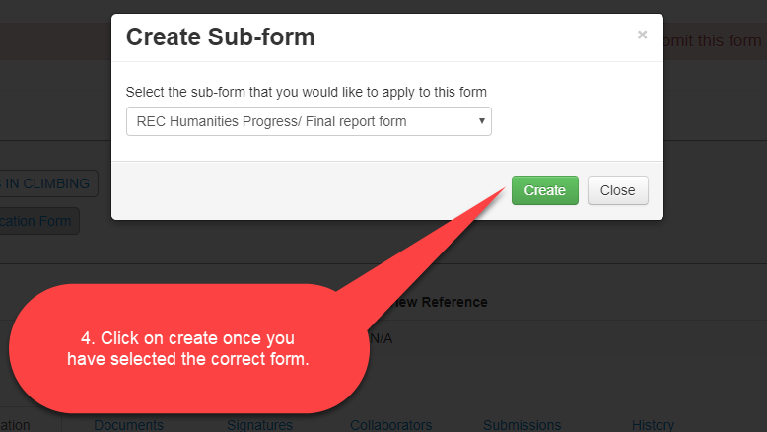
Complete the sub-form you have created and submit the form.
All forms expect the Documentation Form requires a supervisors and applicants signature in order to be submitted.

