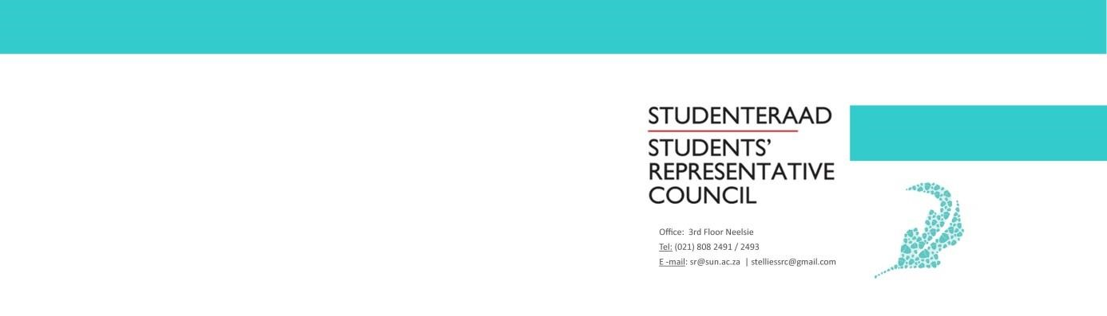

Meeting Minutes
Students’ Representative Council Meeting
Date: 28 April 2020
Time: 14:00-16:00
Venue: Online

- Welcoming Lewis
- Attendance Fadeelah

Lewis
Fadeelah
Wama
Brandon
Yanga
Xola
Tebogo (Ndaba)
Jeff
Ntswako
Chloё
Tebogo (Mphahlele)
Eric
Grace
Micheal
​​​​Joconde
Luigis
Philip
​Ingrid

- Approval of previous minutes Fadeelah
Minutes Approved
- Setting of the Agenda Fadeelah
Jeff adds general point to discuss the issue of access
- Discussions
  - Resolutions to issues raised in Internal Relations document, presented by Lewis and Wama
Lewis concludes that the sharing the document is under discretion of disciplinary committee, however there will be team building event which will assist to resolution of issues raise in internal relations.
  - G2G Task Team Brandon
Brandon Murray, Treasurer presents a full proposal including proof that the G2G Task Team will fulfil constitutional mandates of a Task Team. The task team is assisting in hand based on the circumstances we are in. The task team is planning to distribute hand sanitizers, masks and broachers the budget has been sent out and we have contacted the rectorate for assistance, which we are still waiting for response.
Yanga ask a question that are we disregarding the request for the establishment of G2G task and the task team is moving to a formal adaption of cleaning campaign?
Brandon answers by stating that G2G task team is no longer something that idea is being beneficial to the SRC due to fact that we do already have this cleaning campaign structure which has been establish based on given the circumstances.
Chloё student awareness officer gives her imports by stating that we getting carried away on technicalities, in last few days due to the fact that students who are still on campus, decisions was taken to dissolve the plans for student wellness due to lockdown being implemented and the finances that was allocated to student wellness are now allocated to the cleaning campaign task team to cover certain needs for the productivity of the task team.
Lewis concludes that Brandon has withdrawn proposal to make G2G task team. The clean campaign is still moving forward with the care packages project under student wellness. The budget allocation that was made to G2G task team will be reversed through consultation with sharine. The funds will be put into the short-term strategic.

  - Initiative for Students Online Learning Jeff

Jeff the transformation officer, states that due to differential backgrounds of students with internet connectivity that must be taken into a consideration with the goal is to bring awareness with the significant of online learning. The fist initiate for student to participate in online learning and to give out prices, looking at what can be given as prices based on their commitment. Second is to have a quest speak to bring realisation that we are moving with times and this will happen as an online event which will also address the events that we are facing in Africa relating to COVID19.

Lewis comments that it is important to collaborate with different portfolio and bring important information to student through this kind of initiative.

  - Code of Conduct amendment regarding Meeting Recording Regulation

Fadeelah presents that in the previous executive meeting decision was taken to present proposal to the SRC to potentially amend the code of Conduct as to make provision for SRC members to request SRC meeting records or recordings which includes minutes, audios and videos of any specific meeting.

The proposed armament states in summary that the SRC executive must provide any SRC member ( in a event that they may request that ) for any record of SRC executive meeting and the entire SRC executive reaches the exec vote that certain part of the video is confidential or any records the only limitation to the provision will be only when confidential information is discussed in that recording therefore shortened recording will be made available.

Lewis comments that it will be send to legal department for advices and guidance and will received response in due time. The proposed amendment states in summary that the SRC executive must provide any SRC Member (in the event they request so) any and all records of SRC Executive meetings unless the SRC executive reaches a decision through positive vote that certain parts of the record be restricted due to issues of confidentiality.

- General Point
The issue of access
Jeff raises a point regarding to the issue of access because it happens that few students who happens to not have smartphones to SMS and to connect their phones to their computer so that they can gain access so they won’t be able to use their laptops that has been given to them. Therefore, small smartphone or modem to assists to get access. Therefore, how can this student gain access?
Xola the chairperson of Academic Council comments that the university is looking into the fact that getting modems etc to support students, however they will provide Data so that student can hotspot their phones to their laptops. However, we can get number of students and their contacts so that I can forward their details to relevant people for assistance.
Jeff response by stating that he will forward all details to the chairperson of Academic Council.

- Next Meeting Fadeelah
The next meeting will be on 13th of May 2020
- Closing Lewis

