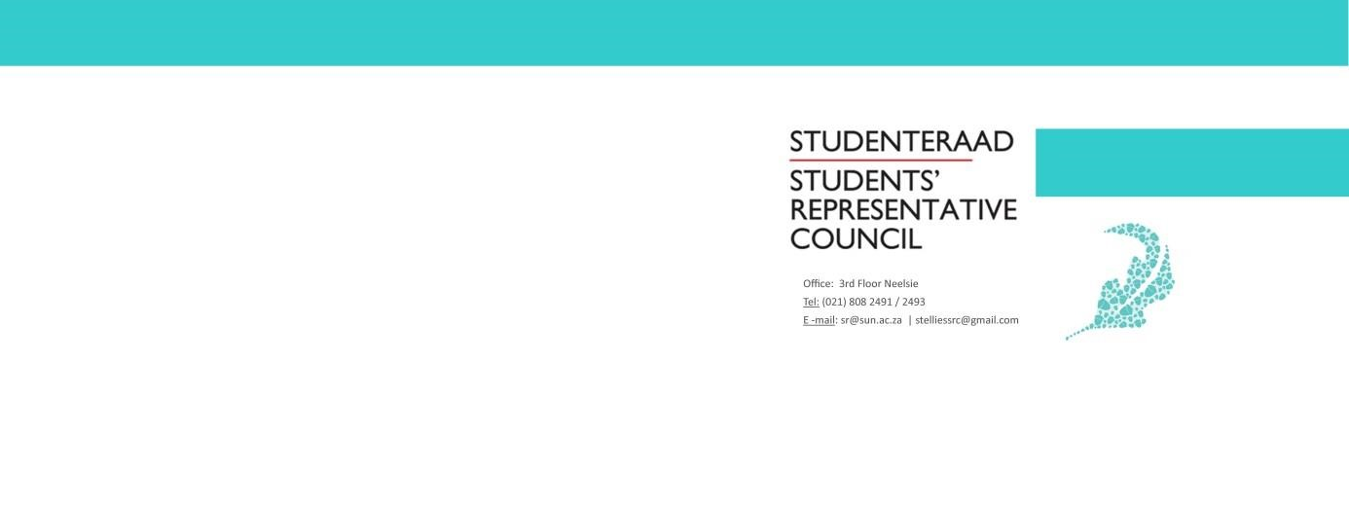
AGENDA
Extra Ordinary Students’ Representative Council Meeting
Date: 20 March 2020
Time: 16:00-18:00
Venue: Microsoft Teams

- Welcoming Lewis
- Attendance Fadeelah
- Setting of the Agenda Fadeelah
- Voting
  - Code of Conduct
- Covid 19
  - Clean Campaign
  - Sub Committees
  - General Points
- Budget Presentation Brandon
- General Points
- Next Meeting Fadeelah
- Closing Lewis

