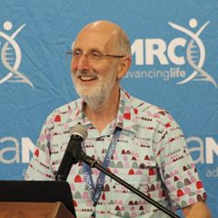

**Day 1: 14 September 2020**

**Academic Panel Discussion:**

**(10:15-11:00)**

Academic panel discussion on students with disabilities and programmes of study: a reflection and way forward

**Prof Leslie Swartz**

Clinical Psychologist and Professor at the Department of Psychology at Stellenbosch University

**Mr Wentzel Barnard**

Sport manager of Maties ParaSport at Stellenbosch University

**Dr Ronel Retief**

Institutional Registrar at Stellenbosch University

**Dr Martha Geiger**

Speech-Language Therapist and Senior Lecturer in Disability and Rehabilitation Studies at Stellenbosch University

**Prof Quinette Louw**

Professor in Physiotherapy and Head of Department of Health and Rehabilitation Sciences at Stellenbosch University

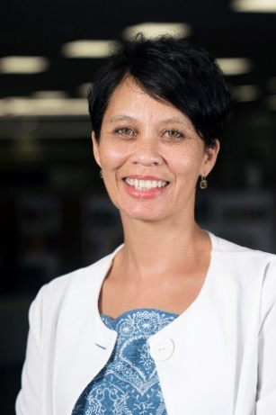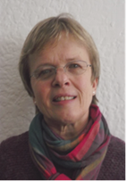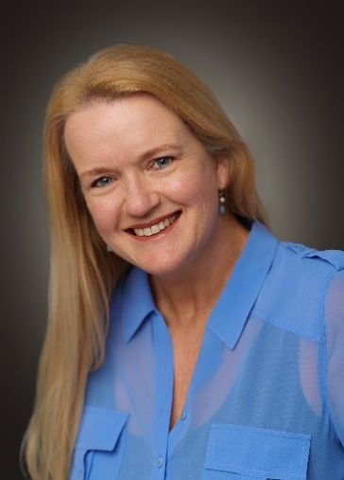

**SEMINAR: SU DECLARATION OF 2020 AS THE YEAR OF PERSONS WITH DISABILITIES: REFLECTIONS AND WAY FORWARD**