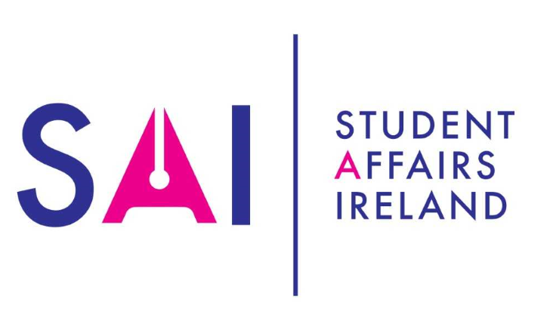
Summit 2019
Student Success: Everybody’s Business
Call for abstracts

The Student Affairs Ireland Summit is Ireland’s best opportunity for Student Affairs professionals to share knowledge, good practice and expertise. The Summit is the ideal forum for nurturing partnerships with colleagues in higher education in Ireland, and beyond.
When:
The Summit will take place on Tuesday the 11 and Wednesday 12 June 2019 in the Radisson Blu Hotel, Cork, Ireland.
About the Summit:
Students are effective learners when they are most engaged, when they trust staff to be honest, respectful, inclusive and supportive. Strong relationships and shared responsibilities between students, student support professionals and academic staff are powerful in planning to support students’ academic success and well-being.
As professionals, we build strong partnerships and actively collaborate to ensure that students are challenged and stimulated to achieve their educational goals. We focus on supporting students to take control of their own well-being and empower them to develop skills which are vital to reach their full potential in life. In doing so, we must ensure that student support professionals and academic staff feel empowered to engage in innovative approaches to ensure that no student is left behind.
The topic of Student Success is shared by many voices with different views on what it means. This Summit will provide a platform for practitioners and researchers to present new developments, initiatives and research in the area of Student Success. Areas of interest for this Summit are:
Student Success Strategy – areas to consider
- Access and widening participation
- Universal Design for Learning
- International students
- Developing data initiatives and indicators
- Progression and Retention
Best Practice in Student Success
- Mental Health and Wellbeing
- Accommodation / working with residences
- The First Year Experience
- Transitions
- Sports
- Scholarships
- Clubs & Societies
- Careers
- Community Engagement
- Volunteering
- Peer Support
- Consent: Boundaries, Respect and Interventions

Getting involved:
SAI welcomes proposals for interactive workshops that encourage delegates to participate in group work, contributing ideas and exchange good practice. You can choose to lead a workshop session lasting for 60 minutes. Workshops presentations should take no longer than 15 minutes as the main content should involve delegate participation. Workshops can also take the form of facilitated discussions.
Presentations – You can propose to make a presentation about an areas of interest related to Student Success. Your presentation session should be 30 minutes long, including at least 10 minutes for questions and answers. The presentation should be engaging and informative, preferably with a slideshow that can be distributed to members later.
Posters: The title should be the same as in the submitted abstract. The poster must be no less than A1 and no larger than A0 size (AO size is 841mm x 1189mm). Orientation of your poster must be in portrait style.

All submissions must include:
- A clear concise abstract of no more than 500 words
- A title
- A list of authors to include title, work area and email address

Abstract deadline: Friday, 8 March
You will know if your abstract has been selected for inclusion in the Summit by Friday 12 April 2019.
Submit your Abstract by completing the attached Abstract Submission Form and email it to Martha Henchion, SAI Administrator. Email: marthahenchion@ucc.ie

Thank you.

