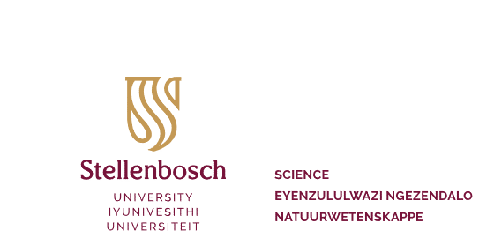

FACULTY OF SCIENCE PhD INCENTIVE

For attention | Departmental chairpersons, supervisors of all students studying for a PhD in one of the Faculty of Science departments, PhD students
Owner | The Dean, Faculty of Science
Purpose | To encourage PhD students to complete their studies within a maximum period of three years by making a financial incentive available
Date of implementation | 1 January 2009
Date of revision | 18 January 2022
Approved by | Faculty Management Committee

Introduction

The Faculty of Science Management Committee has set the strategic objective of increasing the through-flow rate of all the Faculty’s students. Although a significant decrease in the average study period of MSc students has been observed, the length of the average study period of PhD students remains a matter of concern. The Faculty wants to encourage its PhD students to complete their studies within a maximum period of three years by making a financial incentive available. This comprises a once-off amount of R20 000 to those PhD students enrolled in one of the Faculty of Science’s departments who successfully complete their PhD studies within a maximum period of three years from their date of admission and registration.

Determination of study period

The study period is calculated from the date of registration of the student as a PhD student in one of the Faculty of Science’s departments until the official date of submission of the student’s dissertation for examination. The latter date is the date on which the Dean’s division receives the MONITORING OF EXAMINATION ADMINISTRATION form in which the student’s completion of her or his study and the submission of her or his dissertation for examination are confirmed. Payment of the incentive is subject to the examination result being positive without the student still having to make extensive improvements to the dissertation. It is therefore imperative that the supervisor immediately send the examination administration form to the Dean’s division as soon as the dissertation is submitted to the examiners, since this date is deemed to be the only final date.

Upgrading of MSc to PhD

The incentive would also apply should a MSc be upgraded to a PhD. The total duration of the study period would then be deemed to be 3 + 1 = 4 years since the first date of registration for the MSc.

Payment of incentive

The PhD student and supervisor should apply in writing for payment of the incentive should the study be completed within the maximum period of three years. This written request should be submitted to the Dean when the final dissertation documentation is submitted for graduation and must be supported by the supervisor and departmental chairperson. The application should include the personal particulars of the student, namely the student’s full name and surname, student number and course. The amount of R20 000 is paid into the student’s University account as a bursary when the student’s examination result is officially shown on the student-administration system as being successful. The student may then apply for any credit in the University account to be paid out to the student.

