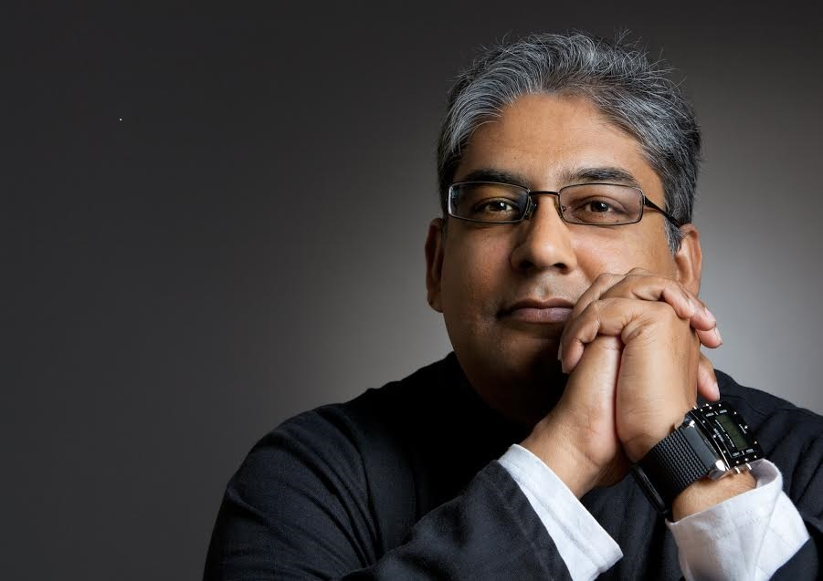

RESUME: HUSSEIN SOLOMON

Dr. Hussein Solomon holds a D.Litt et Phil (Political Science) from the University of South Africa. Currently he is Senior Professor in the Department of Political Science, University of Free State. His previous appointments include being Executive Director of the International Institute of Islamic Studies (2009-2010); Professor and Director of the Centre for International Political Studies, University of Pretoria (2000-2010), Research Manager at the African Centre for the Constructive Resolution of Disputes (1998-2000), Senior Researcher: Institute for Security Studies (1996-1998) and Research Fellow: Centre for Southern African Studies, University of the Western Cape (1993-1995). In 2011, he was Visiting Professor at the Osaka School for International Public Policy (OSIPP). In 2007 and 2010 he was Visiting Professor at the Global Collaboration Centre at Osaka University in Japan and in 2008 he was Nelson Mandela Chair of African Studies at Jawahrlal Nehru University in New Delhi, India. In 1994, he was Senior Visiting Fellow at the Department of War Studies, King’s College, University of London. Currently he is Visiting Fellow at the MacKinder Programme for the Study of Long-Wave Events at the London School of Economics and Political Science in the United Kingdom, a Senior Associate for the Israeli-based think tank Research on Islam and Muslim in Africa, a Visiting Professor at the Osaka School of International Public Policy and a Senior Analyst for New York-based WikiStrat.

In addition, he is Deputy Chair of the Pugwash Conferences on Science in World Affairs (South African Chapter); Member of the Security Council of the Gerhson Lehrman Group of Companies; Member of the International Steering Committee of Global Action to Prevent War, Research Associate of the Centre for Defence Studies, University of Zimbabwe; and a Research Associate of the South African Institute for International Affairs. He is also a Member of the International Advisory Council of the Toda Institute for Global Peace and Policy Research in Hawaii. He is also Vice-President of the African Studies Association (India) and Member of the International Advisory Boards of the Middle East Institute as well as the Research Institute for European and American Studies in Athens, Greece. Since 2014 he became a member of the South African Academy of Science and Arts. Moreover, he is also a Member of the Editorial Board of Politeia; Special Advisor to the Editor of the journal Globalizations; Advisory Editor to the Journal for Contemporary History; Associate Editor of the Southern African Peace and Security Studies journal and a member of the Editorial Boards of Africa Insight, Afro-Eurasian Journal, African Security, Alternatives, Journal of Administrative Sciences, Afro-Arab Social and Economic Review, Journal of African Union Studies and Scientific Journals International as well as Editor of Insight on Africa. He also sits on the Board of Trustees of All Africa Women for Peace. Hussein Solomon also holds the rank of a Captain in the Reserve Force of the South African Air Force.

His research interests include conflict and conflict resolution in Africa; South African Foreign Policy; international relations theory; religious fundamentalism and population movements within the developing world. His publications have appeared in South Africa; Nigeria; the United States; the United Kingdom; Switzerland; The Russian Federation; Greece; The Netherlands; Norway; Denmark; Egypt; Ethiopia; Israel, Lebanon; India; Bangladesh; Spain and Japan.

His most recent books includes Understanding Boko Haram and Insurgency in Africa (with Jim Hentz, Routledge, 2017), Islamic State and the Coming Global Confrontation (Palgrave Macmillan, 2016), Terrorism and Counter-Terrorism in Africa: Fighting Insurgency from Al Shabaab, Ansar Dine and Boko Haram (Palgrave Macmillan, 2015) and Jihad: A South African Perspective (Sun Media, 2013).

He is a member of the South African Academy of Science and Art.

Academic profile: See Google citation index: https://scholar.google.co.za/citations?hl=en&user=Vs1x5AIAAAAJ&view_op=list_works&cstart=0&pagesize=20

Hussein Solomon is also a regular blogger and currently writes for the Israeli-based Research for the Study of Muslims in Africa (RIMA). The website address is http://www.muslimsinafrica.wordpress.com

He is also a regular commentator on Southern African political issues and blogs for the Southern African Centre for Collaboration on Peace and Security Studies. The website address is www.saccps.org

