CONSENT FORM FOR CASE REPORTS/CASE SERIES
[All text in red should be customised or deleted according to the relevant case report/series.
Formatting should then be corrected to non-italic black text. Please delete this paragraph once the form has been customised. Write in plain English and use the active form; avoid passives as far as possible. This applies to all text that you add to this form.]

For your permission, as a patient, or your permission as the caregiver/guardian (in the case where the patient is a minor), to publish medical information in a research project, thesis, journal, or at a research conference presentation

- Please provide the full name of the person who will be described in the case report/case series and/or show in a photo/video/image) here. That is, your name or the name of the person you are responsible for (in the case of a minor):

[Patient/caregiver/guardian to complete relevant name here]
__________________________________________________________________________

- Please provide a brief description of the text, photo, image, or other material (“the Information”) about the patient:

[Researcher/health professional to provide brief details here]
_______________________________________________________________________

- Provisional title of project/ article/ conference presentation in which Information will be included:

[Researcher/health professional to provide title here]
__________________________________________________________________________

- Aim of the case report/case series

[Explain in brief, participant-friendly language what your case report aims to do and why you are doing it. Also explain why you are asking them specifically to provide information for this case report/series and if there will be other patients who participate as well (e.g., in case series)].

- How will my information (“the Information” as outlined above) be used?

[Add a short, simple description in lay terms of how information/photos/media will be used, stored, and shared – where and with whom. Include details on how long the information will be stored for, where the information will be stored, and who will have access to it.]

[Explain that the information collected will be treated as confidential and protected. If it is used in a research report, publication or presentation, the identity of the participant will be de-identified as far as possible (e.g., no names) but, given the unique nature of case reports /case series, there remains a chance that they could be identified by the details given about the case.]

- What will happen if I decide not to participate?

Agreeing to have your Information used for this case report/series is entirely voluntary and you are free to say no. In other words, you may choose to say yes, or to say no, to having your medical history, examination findings, results and/or imaging tests used for the case report/case series. Nothing bad will happen if you say no: it will not affect you or your treatment negatively in any way whatsoever.

You need to be aware that you are also free to withdraw your permission at any time before your Information is used in the case report publication in an academic journal or conference presentation. Once the Information has been submitted and accepted to be published, or has been presented at a conference, it will not be possible to withdraw consent at that stage. For this reason, all reasonable efforts will be made to contact you again once the final draft is ready to be submitted for publication or presented at a conference for you to review the case report/series and to give your final approval that you are happy with the Information that will be published/presented about you. Note that many edits are usually made during the publication or presentation process and the final publication or presentation may be slightly different to the first draft.

- Other important information:
- You can phone the
  - researcher, [insert researcher’s full name here] at [insert researcher’s telephone number and email here], OR [include if relevant]:
  - research supervisor, [insert supervisor’s title and full name here] at [insert supervisor’s telephone number and email here] if you have any further queries or concerns.
- You can phone the Stellenbosch University Health Research Ethics Committee at 021 938 9677/9819 if there still is something that has not been explained to you, or if you have any complaint.
- You will receive a copy of this information and consent form for you to keep safe.

CONSENT

I_________________________________________ [INSERT FULL NAME] give my consent for this Information about MYSELF [OR MY CHILD OR WARD/MY RELATIVE [INSERT FULL NAME]:_________________________], relating to the subject matter above (“the Information”) to be used for the purpose of a research project/ thesis or presentation, or to appear in a published journal article.

I confirm that: (please tick boxes to confirm)
I have seen the photo, image (if applicable), text or other material about me and been given the opportunity to read it and ask questions about it, or to request changes made to it.
I have been given a copy of this completed information and consent form to keep.

I understand the following:
- The Information will be published or presented without my name [/child’s name/relatives name] included and every attempt will be made to ensure that my/my child’s identity is not revealed. I understand, however, that complete anonymity cannot be guaranteed. It is possible that somebody somewhere - perhaps, for example, somebody who looked after me/my child/relative, if I was in hospital, or a relative - may identify me.
- The Information may show or include details of my/my child’s [/the patient’s] medical condition or injury and any prognosis, treatment, or surgery that I/my child has [/the patient has] had or may have in the future up to 12 months from the date of this consent form.
- The Information may be published in a journal which is read worldwide or in an online journal which may also be read worldwide. Journals are aimed mainly at health care professionals and other researchers but may be seen by many non-doctors, including journalists.
- The Information may be placed on a website.
- The Information may be presented at an academic conference where other health professionals, researchers, academics, and people in this field may be present.
- I [/the patient] will not receive any financial benefit from publication or presentation of the Information.
- I can withdraw my consent at any time before online publication or date of conference presentation, but once the Information has been committed to publication or presented it will not be possible to withdraw my consent.
- The researcher will make all reasonable efforts to contact me to review the final draft of this case report/series before it is submitted for publication or presented at a conference for me to review it.
- This consent form will be retained securely and in confidence by the researcher in accordance with the law, for no longer than necessary. Personal data provided in this form will be used and retained in accordance with the Protection of Personal Information Act 4 of 2013 (POPIA).

Signed:__________________________________ Date: ______________________
If you would like the researcher/health professional to make contact with you to review the final draft of this case report/series before it is submitted for publication, please provide contact details:

Telephone number: __________________ Alternative telephone number: ________________

Email: ______________________________

Signature of person who has explained and administered the form to the patient (i.e., health professional/researcher):

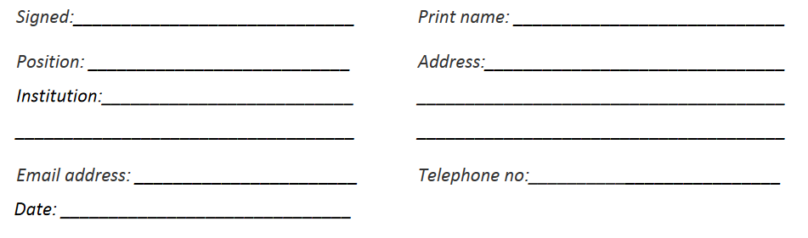

Signature of person who has witnessed this informed consent process and signing of the form by all parties:

Adapted from BMJ Case Reports consent form

