CHILD ASSENT TEMPLATE

NB! DELETE THIS PAGE BEFORE ADAPTING THE TEMPLATE TO YOUR PROJECT!

Please note:

- Children who are able to understand the basic concepts of research should be given the opportunity to assent to a research study. Generally, children between the ages of 7 to 17 should assent to research. This is not a fixed rule and some children younger then 7 may well have sufficient insight and understanding to give assent for a study.
- If they refuse assent then this refusal should be accepted, even if the parents have consented. There may be exceptional cases where this rule may not apply. The HREC should be consulted.
- This template is specifically for 7–12-year-olds and can be adapted to suit adolescents.
- If you are including a wide range of children in your project you well need 2 different versions of assent, one for younger children and a more detailed one for adolescents.
- You can adapt the template to suit the needs of your specific project including deleting sections which are seen as not applicable/appropriate.
- This assent document must be used in conjunction with a parental Information Leaflet and Informed Consent form, which should obviously cover the project in more depth and detail.
- Once your project has been approved and you have a reference number, you should replace the information in the ‘footer’ with your own information e.g. Project No…… Assent template Version 1.1; Date 10.08.2023.

PARTICIPANT INFORMATION LEAFLET AND ASSENT FORM
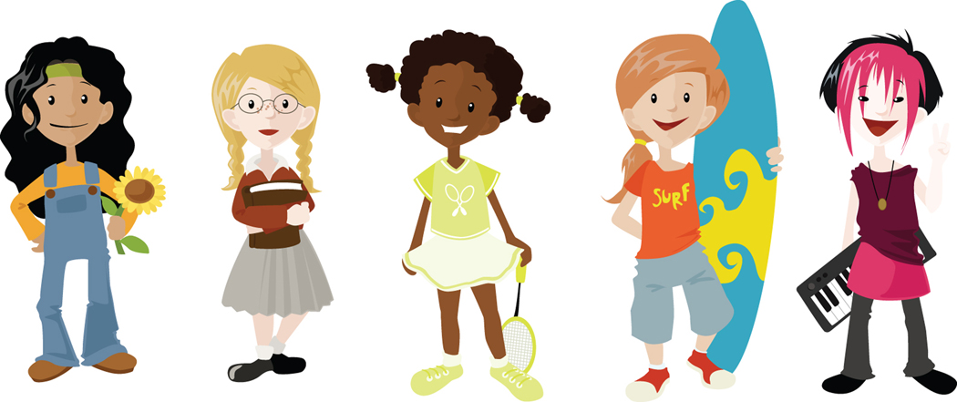

TITLE OF THE RESEARCH PROJECT: Insert the title of your project. Simplify it if necessary.

RESEARCHERS NAME(S):

ADDRESS:

CONTACT NUMBER:

What is RESEARCH?

Research is something we do to find out new information (knowledge) about the way things (and people) work. We use research projects or studies to help us find out more about disease or illness or about people’s lives. Research also helps us to find better ways of helping, or treating children who are sick, or finding answers to questions about things that worry children.

What is this research project all about?
Explain your project in simple child friendly language. Adapt the information to the age of the children that you plan to include.

Why have I been invited to take part in this research project?

Answer this question in simple language

Who is doing the research?
Identify yourself and explain who you work for and/or why you are doing the project

What will happen to me in this study?
Describe what the participant will be expected to do. Describe all procedures using simple terms and explain any technical or medical terms.

Can anything bad happen to me?
Explain any possible risks to the child, using simple terms. If something might be painful, state this in the assent. Explain that the child should inform his/her parents if they are sick or in pain as a result of being in the study.

Can anything good happen to me?
Only describe known benefits to the subject. You may include any possible future benefits to others. If there are no known benefits, state so.

Will anyone know I am in the study?
Explain in simple terms that the subject’s participation in the study will be kept confidential, but information about him/her will be given to the study sponsor. (NOTE: This information may not be applicable in assent forms for very young children).

Who can I talk to about the study? List those individuals the subject can contact (including their contact details) if he/she has any questions or has any problems related to the study.

What if I do not want to do this?
Explain to the participant that he/she can refuse to take part even if their parents have agreed to their participation. Explain that they can stop being in the study at any time without getting in trouble.

What happens to my information after the study?
There are two possibilities:
- My information or samples (blood etc.) can be destroyed; OR
- The researchers can keep (store) the information (data) or samples to use again when there are new tests; OR
- The researchers sometimes share information with other researchers in South Africa or overseas who are also trying to find answers to questions like they are about your illness or treatment.

Do you understand this research study and are you willing to take part in it?
YES |  | NO

Has the researcher answered all your questions?

YES |  | NO

Do you understand that you can pull out of the study at any time?

YES |  | NO

Do you understand that researchers would like to store your samples for future research?

YES |  | NO

Do you understand that researchers might share your data/samples for further research when they are not able to perform certain tests themselves?

YES |  | NO

Do you understand that the researchers with whom your data/samples is shared could be in South Africa or overseas?

YES |  | NO

_________________________ ____________________
Signature of Child Date

With thanks to Anel Kirsten for graphics and layout.

