Dr. Sylvia Riedel-van Heerden
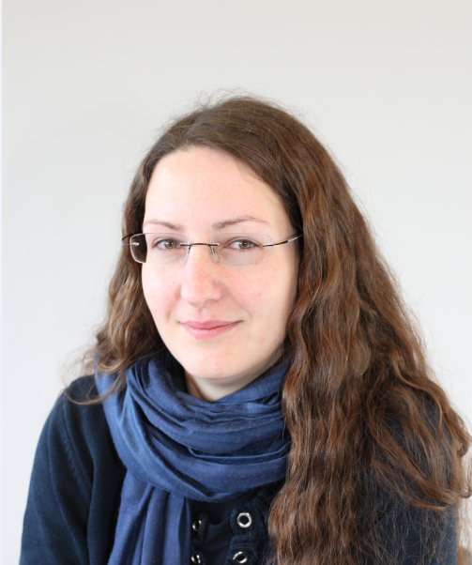
Qualification: Dr. rer. nat. (Food Chemistry)
Position: Senior Scientist, Biomedical Research and Innovation Platform (BRIP)
Experience: Dr. Riedel-van Heerden graduated from the University of Muenster, Germany, in April 2012. Her doctoral studies focused on the preventive properties of omega3 fatty acids against the induction of precancerous rat liver lesions by the mycotoxin fumonisin B₁. Methodology on cellular antioxidant status, cell culture and image analysis was established and refined as part of the study. From 2009 to 2013 she coordinated projects on anticancer properties of Rooibos and Honeybush herbal teas, including effects on apoptosis and inflammation in a variety of human cell culture models. Since her transfer to BRIP at the beginning of 2014, new projects involved investigation of preventive effects of South African plant extracts on insulin resistance in cell cultures representing target tissues, such as liver, skeletal muscle and adipose tissue. To establish a research niche, a new project will investigate anti-inflammatory effects of rooibos and rooibos-derived phenolic compounds in models of intestinal inflammation, which was identified as an early event in the pathogenesis of metabolic diseases.
RESEARCH FOCUS AREAS
Cell culture and animal models to investigate cancer chemoprevention, potential amelioration of insulin resistance as well as models investigating anti-inflammatory properties by South African herbal teas of plant extracts with focus on the gastrointestinal tract.

