# *Towards Strengthening Visual Impairment Rehabilitation Practice in South Africa: Mapping the practitioner landscape and centring service user perspectives*

**Investigators:**

Dr Michelle Botha

Prof Brian Watermeyer

Although rehabilitation services for persons experiencing vision loss provide important practical skills and tools to adapt to life with visual impairment, emerging work in critical disability and critical rehabilitation studies suggests that an overwhelming focus on these practical aspects overlooks concerns related to psycho-emotional wellbeing, social belonging and citizenship. Our previous work in this area suggests that rehabilitation practitioners are seldom enabled to reflect on their role in shaping the sense of self, belonging and citizenship of newly blind persons, and that practitioner training may lack a focus on “relational” aspects of rehabilitation. However, we currently have no comprehensive picture of available practitioner training, or practitioner experiences in training in South Africa.

Building on previous work, this research aims to identify gaps in current visual impairment rehabilitation practitioner training and expertise, and to explore, in collaboration with visually impaired persons, ways in which practitioner training could be enhanced towards developing rehabilitation services that are responsive to the material, social and psycho-emotional needs of newly blind persons.

**Funded by:**

SU FHMS Sub-committee C

Harry Crossley Foundation

**Visual Impairment, Discourse and Critique in South Africa: Breaking Silence and Disrupting Inequality**

**Investigators:**

Prof Brian Watermeyer

Dr Michelle Botha

In South Africa, disability research has tended to focus, and understandably so, on the material circumstances of persons with disabilities, and not on the discursive mechanisms that perpetuate these circumstances, nor on the internal lives of disabled persons who are exposed to negative discourses and persistent exclusion. In order to gain a full picture of the operation and impact of disablism in South Africa, these areas require research focus.

This study takes as its starting point the understanding that cultural and institutional discourses regarding the purported nature, needs and potentials of persons with visual impairment (VI) are key factors that underpin and maintain the educational, economic and social exclusion of VI persons in South Africa. Through examining the enactment of these discourses in South African educational and rehabilitation institutions, as well as in community and family life, our strategy is to build local knowledge of previously silenced voices, and critical insight into the ideological mechanisms that maintain inequality.

The aim of this study is to create knowledge regarding the cultural and institutional discourses about VI which underpin, and are enacted within, engagements surrounding VI in South African society, with a particular focus on the key spaces of education and rehabilitation.

Such knowledge brings impact at various levels, including: 1) personal, in the lives of persons with VI, through the debunking of oppressive, internalised assumptions about place and potential; 2) public, through critical interrogation of the assumptions underpinning health and social service provision in the state and NGO sector; 3) academic, through strategic cross-disciplinary dissemination of findings which distribute critical, transformation-oriented disability thinking to fields where it is needed.

Publications:

Botha, M., & Watermeyer, B. (2024). Metanarratives of visual impairment rehabilitation: the discursive positioning of disabled service users in South Africa. Disability & Society, 39(2): 381–399. DOI: <https://www-tandfonline-com.ez.sun.ac.za/doi/full/10.1080/09687599.2022.2071232>

Botha, M., & Watermeyer, B. (2024). “Somebody did some work in your life”: a personal reflection on blindness, and being a grateful, silent creation of rehabilitation. Journal of Literary and Cultural Disability Studies, 18(1): 1–16. <https://muse.jhu.edu/pub/105/article/918882/summary>

Watermeyer, B., & Botha, M. (2023). Disability, trauma and the place of affect in identity: examining performativity in visual impairment rehabilitation. Feminism & Psychology. Online. DOI: <https://journals-sagepub-com.ez.sun.ac.za/doi/full/10.1177/09593535231200728>

Botha, M., & Watermeyer, B. (2022). Tradeoffs in visual impairment rehabilitation: hearing service user accounts of rehabilitative relationships and organisation culture in South Africa. Scandinavian Journal of Disability Research, 24(1).

DOI: <http://dx.doi.org.ez.sun.ac.za/10.16993/sjdr.859>

**Funded by**: NRF Competitive Programme for Rated Researchers

**Health system COVID-19 responses and experiences of people with disabilities and of disability and rehabilitation practitioners in the Eastern Cape province.**

Researchers: A/Prof Lieketseng Ned and Dr Madri Engelbrecht

This project is set against the backdrop of healthcare access of people with disabilities that is compromised despite their experiences of having poorer health than the general population. Additionally, this minority group is often excluded from emergency responses during crises situations, such as the one created by COVID-19. The pandemic is likely to have deepened disparities in healthcare access, and disability data about South Africa's COVID responses is needed to plan future disability-inclusive emergency responses.

This study surveyed all nine provinces in the country to find out what the experiences of persons with disabilities were, in relation to healthcare access, during the pandemic. Few responses were forthcoming from more rural, under-resourced areas, such as the Eastern Cape Province, resulting in under-representation of potentially diverse, heterogeneous experiences of people with disabilities.

Subsequently, the researchers are investigating the implications for healthcare service provision to persons with disabilities in the Eastern Cape during the pandemic, and recording both the perspectives of rehabilitation practitioners and persons with disabilities at community level.

The study is aimed at informing inclusive healthcare responses (including budgeting responses) that leave no-one behind during instances of health emergencies. The findings will be used to contribute to rapidly improve policy and practice pertaining inclusive health systems as part of efforts to contribute to health systems strengthening.

Publications: Engelbrecht, M., Ngqangashe, Y., Mduzana, L., Sherry, K. & Ned, L. (2023). Disability inclusion in African health systems' responses during COVID-19: A Scoping review, African Journal of Disability, 12(0), a1284. https://doi.org/10.4102/ajod.v12i0.1284

Funded by the South African Medical Research Council under Self-Initiated Grants (SIR).

**Evaluation of inclusivity of alumni with disabilities and Mastercard Foundation Scholars with disabilities by the African Leadership Academy**

Researchers: A/Prof Lieketseng Ned, Dr Madri Engelbrecht and Prof Theresa Lorenzo

The African Leadership Academy (ALA) facilitates young graduates, who have come through their programme, and Mastercard Foundation Scholars into high potential jobs on the African continent. Their Africa Careers Network was established in 2012 to, in particular, assist alumni and scholars to transition successfully into internships and jobs through a range of available offerings. Since 2019 they have strengthened their focus on including youth with disabilities in their Network programme, and commenced with documenting disability-related data to inform their design of inclusive efforts.

Following the need to centre disability inclusion, ALA contracted and commissioned the researchers to evaluate how the Academy has been able to include and assist its Alumni with disabilities and Mastercard Foundation scholars with disabilities in and through their programme offerings. The perspectives and experiences of this group of youth are sought through mixed methodologies, as well as experiences of employer and university partners. The study also considers the potential role and use of technology in enhancing programme offerings to youth with disabilities.

Study findings will inform ALA's approaches and mechanisms for enhanced inclusion of young people with disabilities in their programme elements, and enable the Academy to promote a mission towards Sustainable Development Article 27. A report and a policy brief will be produced.

Funded by the African Leadership Academy

**The Chaeli Campaign Therapists' Journal Club and Writing Project**

SU Contacts: (Martha Geiger mgeiger@sun.ac.za or Rosemary Luger rluger@sun.ac.za )

Since 2012, the Division for Disability and Rehabilitation Studies (DDRS) has been partnering with an NPO, the Chaeli Campaign (www.chaelicampaign.co.za ), to develop this project.

The purpose is collaborative knowledge development with rehabilitation professionals working in vulnerable populations. Regular HPCSA accredited journal clubs offer opportunities for the development of critical reading and evidence-based decision making in practice. Writing support offers opportunities to write and publish evidence from local practice.

DDRS staff involvement has included:

- organising journal clubs (including the process of applying for HPCSA accreditation) for the Chaeli Campaign (and Bhabisana Baby Project) Therapists and a satellite group at St Joseph's Intermediate Paediatric Care.

- writing workshops and writing mentoring

- motivating and supporting the rehabilitation professionals involved in the project to engage in post-graduate studies (3 team members have attained additional qualifications)

Outcomes to date include:

International Conference presentation:

Geiger, M, Bullen A, Luger R & Phillips D 2016. ‘Clinician to researcher-writer: It’s working!’ Rehabilitation practitioners developing evidence informed practice & contributing to practice-based evidence. Poster presented at the ICED/HELTASA Conference, UCT, 23-25 November 2016.

Publications by team members

1. Bullen, A., Luger, R., Prudhomme, D. & Geiger, M., 2018, ‘Simple ideas that work: Celebrating development in persons with profound intellectual and multiple disabilities’, African Journal of Disability 7(0), 273. https://doi.org/10.4102/ajod.v7i0.273

2. Geiger, M., 2012, ‘Communication training for centre-based carers of children with severe or profound disabilities in the Western Cape, South Africa’, African Journal of Disability 1(1), Art. #10, 7 pages. https://ajod.org/index.php/ajod/article/view/10/20

3. Luger, R., Prudhomme, D., Bullen, A., Pitt, C. & Geiger, M., 2012, ‘A journey towards inclusive education: A case study from a ‘township’ in South Africa’, African Journal of Disability 1(1), Art. #15, 5 pages. http://dx.doi.org/10.4102/ajod.v1i1.15

4. Luger, R., Geiger, M. & Lyner-Cleophas, M. (2021) Students’ voices: reflections of three young adults with cerebral palsy on factors facilitating their completion of mainstream schooling in South Africa, International Journal of Inclusive Education, 25:13, 1475-1491, https://doi.org/10.1080/13603116.2019.1619850

5. Luger, R., Geiger, M., Nqevu, O., Bullen, A. and Toefy, F., 2022. The Chaeli Campaign Journal Club: Strengthening evidence-based practice and contributing to practice-based evidence in under-resourced South African communities. African Journal of Disability, 11, p.943. https://ajod.org/index.php/ajod/article/view/943/1787

6. Pitt, C., Luger, R., Bullen, A., Phillips, D. and Geiger, M., 2013. Parents as partners: Building collaborations to support the development of school readiness skills in under-resourced communities. South African Journal of Education, 33(4), pp.1-14. Art. #774, 14 pages, http://www.sajournalofeducation.co.za

**Trends of disability research in AfriNEAD affiliated countries**

Researchers: Dr Callista Kahonde & Professor Gubela Mji

The African Network for Evidence to Action in Disability (AfriNEAD) has been in existence since 2007. It is a network that brings together academic researchers, persons with disabilities, civil society, government representatives, business entities and other interested parties to share research on disability in Africa and its impact. The network facilitates dialogue and debates on the research and mapping a way for the research to be implemented into policy and practice. Through its endeavours, AfriNEAD aims to promote research that prioritises the realisation of the principles of the United Nations Convention on the Rights of Persons with Disabilities (UNCRPD) in Africa.

Realising how AfriNEAD has influenced the increase in disability research in Africa through its ongoing activities, especially triennial conferences, the project aimed to explore the current trends in disability research across the countries that are affiliated to the network. Main areas of analysis were the distribution of research across AfriNEAD’s thematic areas that are informed by the UNCRPD, the trends across the years up to the year 2023, affiliations of authors and trends of collaborations within and across countries.

Three posters and an oral presentation were presented at the 7th AfriNEAD Conference in December 2023 and an article is in progress for publication in the upcoming special issue of the African Journal of Disability.

***Special Olympics International’s Rosemary Collaboratory Initiative***

Investigators: A/Prof Lieketseng Ned and Dr Nomvo Dwadwa-Henda

**Project Summary:**

The 2022 WHO global report on health equity for persons with disabilities highlighted that persons with intellectual and developmental disabilities (IDD) are six times more like to dies from preventable health conditions that the general population. Special Olympics International’s Rosemary Collaboration Initiative, that aims to promote health systems that are more accessible, affordable, and able to provide appropriate, high-quality care for persons with IDD, has awarded local experts in eight countries and three US states to gather data on IDD inclusion in health systems.

The Division of Disability and Rehabilitation Studies in collaboration with colleagues from UCT, Cape Mental Health, the Western Cape Forum for Intellectual Disability and Special Olympics South Africa are gathering data for South Africa. We are using the Missing Billion Initiative tool, which contains a set of intellectual or developmental disability specific criteria, to look at inclusion of people with IDD in South Africa’s health system. The study seeks to know to what extent people with IDD are included in the South African health system. This will cover how systemic factors influence service delivery, and health outcomes relevant to people with IDD. This information will be useful to help plan and improve health systems that are available to and inclusive of people with IDD.

An advocacy plan, based on the study findings, will be developed to facilitate the transformation of a health system that can improve health access of persons with intellectual disability in South Africa. By this, strong relationships between the Division of Disability and Rehabilitation Studies at Stellenbosch University and the S.A. government’s relevant ministries will be strengthened.

This collected country data will be included in the global report (led by SOI) on health of persons with IDD in 2025 to highlight some good country practices and share policy recommendations. The outcomes will also be published in collaboration with SOI in accredited scholarly journals and be used to advocate for inclusive health systems.

**Funded by: Special Olympics International**

**Prosthetic users’ functionality and experiences with a magnetorheological microprocessor knee**

**Researcher: Dr Surona Visagie**

Human limbs are complex, not easily replaced by prosthetics. High-end prosthetic products ensure high level function but are costly and seldom funded in South Africa. South Africa`s geography, climate, infrastructure, and the clustering of prosthetic services in metropoles as well as users who are often employed in the primary sector, doing work that require physical strength and agility, place unique requirements on prosthetic products. There is little evidence on what constitutes an appropriate range of prosthetic products for South Africa. South African. Currently, the prescription process lack transparency. Inconsistencies, over, and under prescription are real concerns.

**Social impact:**  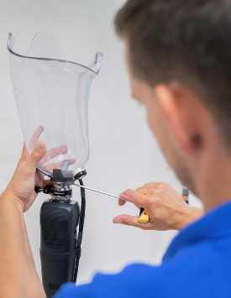

* Evidence on the appropriateness and effectiveness of prosthetic products may help to achieve the Sustainable Development Goals.
* The evidence can assist selection and prescription of appropriate components and might be useful in motivating for inclusion of the specific product on government tender and in funding plans of medical insurance companies.
* At the person level the study findings might assist to enhance user function, satisfaction, and quality of life, which benefits society as it enables community and economic participation.

**Aim:** To explore and describe users` functionality and experiences with a MPK which generates knee joint resistance through a magnetorheological clutch mechanism.

**Methodology and methods:** An explanatory sequential mixed methods design is used. A quantitative pre-test post- test is followed by a descriptive qualitative study. Five users have completed the pretest post-test phase and a further five is in process.

**Proposed end date:** February 2025.

**HREC Reference No**: N22/08/097 **SU Contract NO**: S008448

**African community of assistive technology (ACAT)**

**Lead Researcher: Dr Surona Visagie**

The African Community on Assistive Technology (ACAT) is a community of practice that connects AT users, researchers, practitioners, suppliers, and supporters in the African region. Founded during the GReAT summit in 2017 in Geneva, ACAT is hosted by The Division for Disability and Rehabilitation Studies, Stellenbosch University. The community has 100+ members from 26 countries. ACAT provides communication through an email list serve under WHO`s GATE.

Link: [(Global Cooperation on Assistive Technology (GATE) : African Community on Assistive Technology (ACAT) : All Conversations (yammer.com)](https://eur03.safelinks.protection.outlook.com/?url=https%3A%2F%2Fwww.yammer.com%2Fwho-gate%2F%23%2Fthreads%2FinGroup%3Ftype%3Din_group%26feedId%3D168868356096%26view%3Dall&data=05%7C02%7C%7Cbd9b636635924f4800d108dc0d2a9c20%7Ca6fa3b030a3c42588433a120dffcd348%7C0%7C0%7C638399723900945167%7CUnknown%7CTWFpbGZsb3d8eyJWIjoiMC4wLjAwMDAiLCJQIjoiV2luMzIiLCJBTiI6Ik1haWwiLCJXVCI6Mn0%3D%7C3000%7C%7C%7C&sdata=zRrYXwGo66c8dfDexHzRt2Um9mqa9Ox50hf59IpOSw8%3D&reserved=0)

**International Activities:**

Hosted a webinar by the International Society of Wheelchair Professionals on training (2023)

<https://wheelchairnetwork.org › resource-library › trai...>

Participated in the second global consultation for WHO-UNICEF Global Report on Assistive Technology (GReAT) 27-28th October 2021.

Presented an assistive technology workshop at the AfriNEAD conference in December 2021. The topic was “Promoting regional coherence and cohesion amidst multiple assistive technology initiatives in Africa.” Workshop proceedings has been summarised in a paper that is currently under review for publication.

A survey on ACAT members education and training needs was done (June, July 2021). The ACAT team is currently developing webinars and discussion groups to address some of the training and education needs. And to share good practice examples throughout the community.

Supporting the Global Alliance of AT Organisations (GAATO) in facilitating a consultation in the African region on the question: “What is needed to be able to measure assistive technology outcomes and impact at the individual, community, local, national, and global level?”

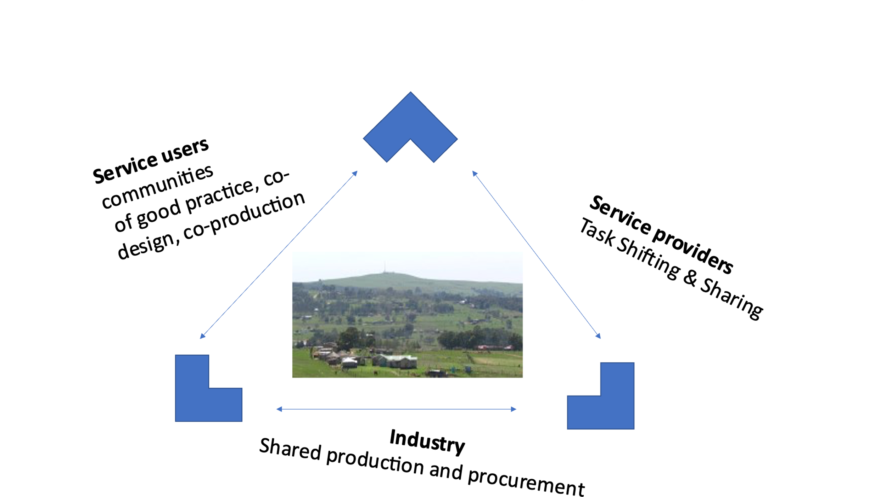

**Going forward:** Select a government body and register with GAATO