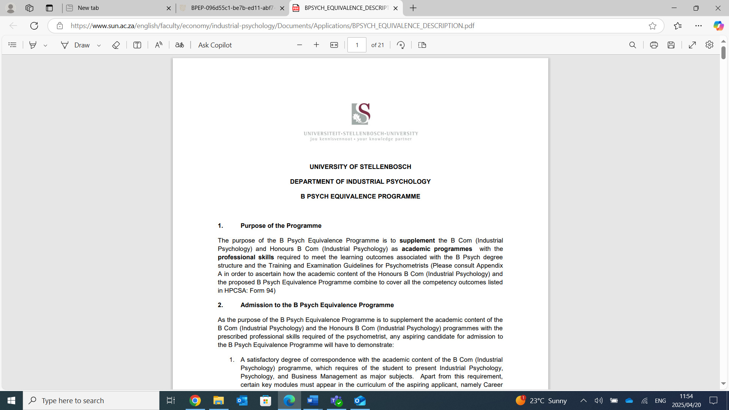

UNIVERSITY OF STELLENBOSCH
DEPARTMENT OF INDUSTRIAL PSYCHOLOGY
B PSYCH EQUIVALENCE PROGRAMME

- Strategic alignment of the programme
The BPsych Equivalence Programme, offered by the Department of Industrial Psychology at Stellenbosch University, is firmly aligned with the strategic goals of the University and the vision and mission of the Faculty of Economic and Management Sciences (EMS). At its heart, the programme is committed to advancing a transformative student experience by developing graduates who are professionally competent, ethically grounded, and equipped with the applied psychological skills necessary for effective psychometry practice in South Africa.
The programme fosters personal and professional growth through a rigorous selection process, structured internship placements, and reflective workshops. These components are purposefully designed to shape academically prepared students into confident, ethical professionals who are ready to contribute meaningfully in diverse organisational and societal contexts.
In support of networked and collaborative teaching and learning, the programme adopts a co-creative educational approach that engages multiple stakeholders - including academic staff, registered supervising psychologists and psychometrists, host organisations, and students. This collaborative model ensures exposure to high-quality, real-world psychological practice aligned with HPCSA standards, enriched by ongoing mentorship, feedback, and formative evaluation.
Aligned with Stellenbosch University’s commitment to research for impact, the programme nurtures a scientific mindset by embedding key areas such as psychometric theory, test development, measurement equivalence, and evidence-based assessment practices into the curriculum. Through case studies and reflective workshops, students are encouraged to think critically and apply research in practice, including evaluating and adapting psychological instruments for South Africa’s multicultural and multilingual population.
The programme also exemplifies purposeful partnerships and inclusive networks by working with host supervisors and partner organisations who uphold the highest standards of professional and ethical practice. These partnerships are inclusive by design, offering students practical experience with diverse populations and in a range of organisational settings, thereby contributing to societal transformation through broader access to psychological services.
Finally, the programme contributes to the university’s aspiration of being an employer of choice by producing graduates who are not only technically skilled, but also professionally prepared and highly employable in both public and private sectors. Its mission - to cultivate engaged, ethical, and innovative professionals - mirrors the EMS Faculty’s commitment to developing graduates who will drive economic growth and societal transformation across the African continent.
Through its focus on inclusive education, engaged learning, and meaningful professional partnerships, the BPsych Equivalence Programme embodies Stellenbosch University’s strategic intent and the EMS Faculty’s mission and vision, while making a tangible contribution to the development of the psychological profession and broader society.

- Purpose of the programme
The purpose of the B Psych Equivalence Programme is to supplement the B Com (Industrial Psychology) and Honours B Com (Industrial Psychology) as academic programmes with the professional skills required to meet the learning outcomes associated with the B Psych degree structure and the Training and Examination Guidelines for Psychometrists (Please consult Appendix A in order to ascertain how the academic content of the Honours B Com (Industrial Psychology) and the proposed B Psych Equivalence Programme combine to cover all the competency outcomes listed in HPCSA: Form 94).
- Admission requirements
As the purpose of the B Psych Equivalence Programme is to supplement the academic content of the B Com (Industrial Psychology) and the Honours B Com (Industrial Psychology) programmes with the prescribed professional skills required of the psychometrist, any aspiring candidate for admission to the B Psych Equivalence Programme will have to demonstrate:
1. A satisfactory degree of correspondence with the academic content of the B Com (Industrial Psychology) programme, which requires of the student to present Industrial Psychology, Psychology, and Business Management as major subjects. Apart from this requirement, certain key modules must appear in the curriculum of the aspiring applicant, namely Career Psychology, Psychometrics, Human Resource Development/Personnel Development, Human Resource Management/ Personnel Psychology, and Labour Relations.
2. A satisfactory degree of correspondence with the Honours B Com (Industrial Psychology) academic programme, which is presented as an academic foundation programme for the professional B Psych Equivalence Programme. Specific modules are regarded as essential modules, namely Career Psychology, Applied Psychological and Performance Assessment and Professional Ethics, and Psychometrics, Measurement Theory, Test Construction and Decision-making.
3. Applicants who do not comply with the academic criteria for admission to the B Psych Equivalence Programme will be required to supplement their academic records with the identified critical modules by means of an academic bridging programme.
4. Qualifying candidates will be subjected to a psychometric assessment in order to ensure compatibility with the internship placement opportunity and to identify any obstacles to the successful completion of the B Psych Equivalence Programme.
- The Management of the B Psych Equivalence programme
The B Psych Equivalence Programme will be under the management of the Department of Industrial Psychology of the University of Stellenbosch. The Department will appoint a programme co-ordinator (monitoring psychologist) who is a registered senior psychologist with the HPCSA. The Department will receive the applications of aspiring candidates and will admit qualifying candidates to the programme in collaboration with the programme co-ordinator. A qualifying candidate will be placed in an internship at a suitable organisation or independent private practice under the supervision of a registered senior psychologist or psychometrist as supervising psychologist. The supervising psychologist/psychometrist is required to be available for personal supervision over the intern for an hour on a weekly basis or two hours every 2nd week. The duration of the programme is 6 months full time and will consist of two elements, namely 720 hours of practical psychometric training under the guidance of an appointed supervising psychologist, as well as compulsory attendance of a series of workshops presented/organised by the programme co-ordinator. Both the content of the practical training and the workshops are informed by the desired competencies listed in Form 94 (HPCSA).
The candidate intern must submit a detailed practical training programme in collaboration with the supervising psychologist, which meets the approval of the Department of Industrial Psychology of the University of Stellenbosch. The practical training may only commence once the training programme has been officially approved by the Department. The intern will submit an interim and a final progress report, which has been endorsed by the supervising psychologist, to the programme co-ordinator. The progress report will reflect the specific activities and exposure to the various competency categories, as well as the duration of these activities. In case of failure to perform satisfactorily, the supervising psychologist and the programme co-ordinator will come to an agreement with the intern psychometrist with respect to the strategy to be followed in order to fulfil the requirements of the equivalence programme. After successful completion of the Equivalence Programme, the intern psychometrist will apply to write the Board examination.
- Content of the B Psych Equivalence programme
The content listed below lists the topics to be covered during the practical training by the intern:
5.1 Different intakes and calendar dates
The programme will offer two annual intakes. The first cohort will commence in January and conclude in June, while the second cohort will begin in July and conclude in December.
5.1 Candidate selection
- All applicants who meet the eligibility requirements for the BPsych Equivalence Programme (BPEP) are initially screened based on their academic performance.
- From this group, the top 40 candidates are shortlisted for interviews.
- These interviews are conducted by both the programme coordinator and assistant coordinator, using a structured interview guide.
- Interview performance is formally rated, and the top 30 candidates are progressed to a second shortlist.
- Candidates on the second shortlist complete a comprehensive psychometric assessment battery. This battery will be used to assess candidates against competency requirements of the psychometrists role.
- Each candidate’s assessment results are evaluated to determine overall suitability for the Psychometrist role.
- The top 25 candidates with the highest fit scores are admitted to the BPEP.
5.2 Host placement
Supervisors and host organisations for the BPsych Equivalence Programme are carefully selected to ensure that interns are placed in environments that reflect the highest standards of professional psychological practice. Host supervisors must meet the following criteria:
- Be registered with the Health Professions Council of South Africa (HPCSA) for a minimum of three years.
- Preferably have prior experience in supervising interns or students within the field of psychometry.
- Demonstrate best practices in the delivery of psychological services.
- Operate within facilities that are adequately resourced, including access to a broad range of psychological instruments and tools.
- Provide appropriate and diverse exposure aligned with the required practicum competencies.
- Be recognised and respected within their professional communities for ethical conduct and service excellence.
The programme prioritises partnerships with supervisors and organisations that are committed to mentoring and developing future psychometrists within a supportive and ethically sound environment.

5.3 The prescribed content of the practical training
General orientation
- Selection of instruments based on the purpose of testing
- Preparation for testing, scheduling of assessments
- Use of test manual
- Administration, paper-pencil vs. internet-based
- Scoring and using non-test observations
- Analysis of test results
- Interpretation of test results (general principles)
- Integration of test results (general principles)
- Contingency management skills
Psychometric theory and principles
- Myths and realities of tests in assessment
- Classification of tests
- Ways to evaluate measures
  - Reliability
  - Validity
  - Normative sample
  - Theory and Factor Analysis
  - Standard error of measurement
  - Bias and fairness
  - Item analysis
  - Test development
  - Characteristics of a good test
Cognitive ability, style and aptitude
- Occupational and work performance instruments (WAIS III; Raven’s Progressive Matrices, CPP)
- Testing for cognitive potential (LPCAT; APIL)
Interest, motives, values
- Instruments to measure interest (SDS; OIP+, 19-FII)
Personality
- Cross-cultural personality assessment
- Measures of personality (16PF; 15FQ+, Hogan HPI, Hogan o HDS, Jung/MBTI; Big Five measures; sentence-completion,
- Clinical and other instruments (Stress, depression, anxiety, self-concept, psychopathology, etc.), within scope of practice, MMPI/MCM, Beck Depression Inventory, administer & score
Simulations
- Situational judgment tests
- E-tray, in-baskets
- Role play simulations
Perceptual and Psychomotor tests
- Group Embedded Figures (GEFT)
- Psycho-motor Vienna Test System
Basic interviewing and counselling skills
- Welcoming and preparing test-takers
- Interaction with relevant others
Intake interview
- Collecting information
- Verbal reporting and feedback
- Interpersonal skills
Interpretation of test results (context)
- Impact of contextual factors and disability
- Identification of contextual factors
- Test bias and fairness
- Cross-cultural use of tests
Feedback of assessment results
- Verbal and written communication of test results
- The principles and practice of feedback (Ability and Personality feedback)
Report writing
- Report writing for feedback
Ethics
- Ethical code, conflicts between ethics, client and organisational demands, ethical violations, impairment
- Scope of practice
- Confidentiality, limits of confidentiality, disclosure
- Multiple relationships
Legislation
- Constitution: (Chapter 2)
- Policies pertaining to test use and use of test results in organizations o Establishment of own test policy
HPCSA documents
- Scope of practice (Form 94)
- List of tests classified as being psychological tests (Form 207)
- Policy on the classification of psychometric measuring instruments, methods and techniques (Form 208)
- Rules of conduct pertaining specifically to psychology (Form 223)
Practice management
- Test suppliers, acquisition and requirements of use
- Advertising, accuracy in professional representation
- Independent business practice, undesirable business models
- Invoicing, fee structure, records o Indemnity insurance
- Referrals, third-party requests for service
5.4 Content of the workshops
The following section represents the themes covered during the 10 learning opportunities/workshops. It should be noted that the themes are generally presented seamless over the 10 opportunities.
Theme 1: Orientation
General information on the internship, and the intern’s roles, responsibilities and rights.
Theme 2 Psychological constructs and measurement
Task and contextual performance; CWB; Dark side of traits; link between personality and performance; computer and internet-based testing (equivalence and faking; policy on psychological testing in organisations; Disabilities – symptoms and facts.
Theme 3: Bias and measurement equivalence
Differential item functioning, Different types of equivalence, Computer-Adaptive-Testing, Maximum versus Typical performance measures, Ipsative versus Normative measures, Social desirability, ethics and response styles.
Theme 4: Legal aspects pertaining to psychometry
Labour Relations Act, Children’s Act, POPIA, Employment Equity Act, Affirmative action, unfair and fair discrimination, HIV disclosure, medical testing, HPCSA ethical code (confidentiality).
Theme 5: Report writing
Psychological act relation, 4 types of interpretations, purpose and audience, focus and style, basic report formats, components of a report, technical aspects, wording, pitfalls, ethical considerations, computerised reports
Theme 6: Test Administration
Test environment set-up, use of digital vs paper-based assessments, dealing with technical difficulties and interruptions, accommodations for disabilities, language considerations, importance of standardisation, working with children, adolescents, or adults with unique needs, time management and pacing.
Theme 7: Providing feedback
The required attitude, knowledge, and skills, active listening, how to act, communication skills, Reflective relation technique, opening phrases, acceptance techniques, feedback to line managers.
Theme 8: Ethics
Scope of the profession, Annexure 12 (HPCSA), ethical dilemmas and case studies.
Theme 9: Practice Management
Undesirable business practices, Health Professions Act, fees, ownership, continued development, benefits, drawbacks, billing clients, networking, referrals, self-care.
Theme 10: Exam preparation
General information on the Board exam, how to prepare, and what to expect.
Range of activities employed in the tutorial and workshop sessions:
- Directed readings
- Homework assignments (questions to answer with independent research)
- Multiple choice exercises (psychometrics) for group discussion
- Development and evaluation of an instrument: Case study: Development of scales, factorial validity, normative and reliability data, convergent and criterion-related validity, cross-cultural validity [Thompson, E. R. (2007).
- Development and validation of an internationally reliable short-form of the Positive and Negative Affect Schedule (PANAS). Journal of Cross-Cultural Psychology; 38; 227-242].
- Focused case work for group discussion (disabilities, ethical dilemmas and transgressions)
- Workshop: Skill practice exercises (administration of tests, standardization, interpretation, report writing)
- Workshop: Role play (assessment feedback rehearsal and role play)

5.5 Evaluation
Mastery of the BPsych Equivalence Programme is assessed through a combination of structured feedback and integrated evaluation processes. Specifically, candidates are evaluated based on input from key stakeholders - including supervising psychologists, and the programme coordinator - as well as their performance in an integrated assessment framework.
This framework includes both written assignments (homework tasks requiring independent research) and in-class practical skills demonstrations or simulations (e.g., administering assessments, delivering client feedback). Over the course of the programme, students complete 10 summative assessments, each contributing 10% towards the final programme mark. To qualify for certification, candidates must successfully complete the full 720-hour practicum and obtain a minimum final mark of 70%. Candidates who do not meet these requirements - either by failing to complete the practicum appropriately or by achieving below the required academic threshold - will not be issued a certificate of completion.

