**elmien Lesch**

**Interest area: close relationships**

It is well established that human beings’ general well-being is promoted by close, caring and supportive relationships with others throughout the human lifespan. Close personal relationships refer to a range of relationships, including family, friend and committed, lasting romantic relationships. Research has convincingly established that an attuned and responsive caregiver is pivotal to a child’s overall healthy development, and his or her ability to establish and maintain healthy close relationships in adulthood. This need for attuned and responsive caregiving continues across human development. In adulthood, spouses or romantic partners often become the primary attachment figure for many adults and the primary sources from whom comfort and security is sought. It is therefore not surprising that adults in various developmental phases tend to rate satisfying love relationships as the single most important life goal. These relationships play a crucial role in people’s general resilience and their ability to overcome physical and mental difficulties. Conversely, problematic or unsupportive close relationships can be a source of severe psychological distress and relationship problems are often indicated as the single most frequent presenting problem in people seeking counselling and psychotherapy. Furthermore, a lack of or unsatisfactory close relationships have been linked to mental disorders such as depression. Due to the evidence of both the enhancing and impeding impact of close relationships on general health, it is argued that a health and social policy focus on close relationships is likely to be a “cost-effective strategy for enhancing health and well-being at the population level” and can even be viewed as “preventative medicine” (Umberson & Montez, 2010, p. S60) It is therefore important, especially in a developing country like South Africa with a strained government health budget to nurture and safeguard close relationships that promote health and provide interventions for those that undermine health.

Despite the importance of close relationships for human physical, social and mental health, we know relatively little about the quality of and processes in the broad range of close relationships in the diverse South African population. Most of what we know about close relationship dynamics and processes is based on research conducted in the global northern hemisphere. For example, although attachment theory is prominently used in international research on adult intimate relationships, the relevance of this theory for the South African population has not yet been investigated. Furthermore, very limited research has been conducted on effectiveness of relationship interventions for South African populations.

**Recent and current research topics:**

Maternal-fetal attachment in low-income pregnant women who use alcohol

Non-residential father and daughter relationships

South African Moslem couples’ constructions of gender in their marital relationships

Men, friendships and alcohol: a study in one low-income South African community

Women’s lived experience of singlehood

Fathers’ and sons’ communication about sex

Student couples’ constructions of gender in intimate heterosexual relationships

Sexuality constructions of Black tertiary educated women

**Possible research foci for future students:**

Any component of father-daughter relationships

Exploring the relationships of gay sons and straight fathers

Any component of committed, same-sex relationships

Single women and intimate/close relationships

**Articles in peer reviewed journals**

Meyer, N. & Lesch, E. (2000). The effectiveness of a behavioural programme for bullying boys in a socio-economically deprived community*.* *Southern African Journal of Child and Adolescent Mental Health*, 12 (1), 59-69.

Lesch, E. & Kruger, L-M. (2004). Reflections on the sexual agency of young women in one low-income rural South African community. *South African Journal for Psychology,* 34(3), 464-486.

Lesch, E. & Kruger, L-M. (2005).Mothers, daughters and sexual agency in one low-income rural South African community. *Social Science and Medicine,* 61, 1072-1082.

Lesch, E. & Bremridge, C. (2006). Safe sex and constructions of young male sexuality in one semi-rural Western Cape community. *South African Review of Sociology,* 37(2), pp.128-142.

Lesch, E. & Anthony, L. (2007). Mothers and sex education: An exploratory study in a low-income semi-rural South African community. *Acta Academica, 39*(3), 129-15.

Lesch, E. & Engelbrecht, S-K. (2008). The usefulness of relationship satisfaction measures in one low-income semi-rural South African Community. *Journal of Psychology in Africa, 18(2),245-248.*

Rabie, F. & Lesch, E. (2009) “I am like a woman”: Constructions of sexuality of a group of gay men in one low-income South African community. *Culture, Health & Sexuality,* 11(7), 717-729.

Lesch, E. & Engelbrecht, S-K. (2011). Relationship Satisfaction and Gender Differences in a South African Farm-worker Community. *South African Review of Sociology*, 42: 1, 58 — 77

Lesch, E. & Furphy, C. (2013). South African adolescents’ constructions of intimacy in romantic relationships. *Journal of Adolescent Research, 28*(6), 619-641. doi: 10.1177/0743558413480835.

Lesch, E., Deist, M., Booysen, L., & Edwards, C. (2013). South African social workers' knowledge of attachment theory and their perceptions of attachment relationships in foster care supervision. *Children and Youth Services Review*, 34(7), 1101-1109. <http://dx.doi.org/10.1016/>j.childyouth. 2013.04.025

Lesch, E. & De Jager, N. (2014). Positive and negative qualities of South African adolescents' parent and peer relationships. *Journal of Child & Adolescent Mental Health, 25*(2), 1-14. doi: 10.2989/17280583.2013.825620

Wessels, S. & Lesch, E. (2014). Young adult South African daughters’ perceptions of paternal involvement and nurturance. *Interpersona: An International Journal on Personal Relationships*, 8(2), 128-143.

Lesch, E. & Ismail, A. (2014). Constraining Constructions: Low-Income Fathers’ Perceptions of Fathering their Adolescent Daughters*. The Open Family Studies Journal*, 6, 39-46.

Lesch, E. & Scheffler, F. (2015). Fathers, adolescent daughters and gender in a low-income South African community. *Journal of Gender Studies.* [http://www.tandfonline.com/doi/full/10.1080/ 09589236.2015.1051521](http://www.tandfonline.com/doi/full/10.1080/%2009589236.2015.1051521).

Lesch E and Scheffler F (2015) “I want a better life for her”: Father-adolescent daughter relationships in a minority, low-income South African community. *Marriage and Family Review, 51(5), 441-465.*

Lesch, E. & Kelapile, C. (2015). “In my dreams she finds me… and she wants me just the way I am”: Unmarried fathers’ experiences of fatherhood. *Men & Masculinities, 1-22.* doi: 10.1177/1097184X15601476

Lesch, E. & Casper, R. (2015). “Drinking with respect”: Drinking constructions of men who live in a Cape Winelands farm community in South Africa. *Journal of Health Psychology.* doi: 10.1177/1359105315603476

Lesch, E. & Adams, A. R. (2016). Sexual intimacy constructions of heterosexual couples living in a low-income, "Coloured", farm worker community in South Africa. *Journal of Sex Research.* doi: 10.1080/00224499.2016.1144170

# Lesch, E. & Adams, A. R. (2016). Couples living with and around alcohol abuse: A study of a farmworker community in the Cape Winelands, South Africa. *Social Science & Medicine.* doi: 10.1016/j.socscimed.2016.03.030

Lesch, E., Casper, R., & Van der Watt. (in press). Romantic relationships and loneliness in a group of South African postgraduate student. *South African Review of Sociology*

**Manuscripts in review:**

Lesch, E., Brits, S., & Naidoo, N. T. (in review). “Walking on eggshells”: Experiences of same-sex student couples on a South African university campus. *South African Journal of Higher Education.*

**Chapter in book:**

Lesch, E. & Scheffler, F. (2016). The importance of father-daughter relationships in South Africa. In Makiwane, M, Nduna, M, & Khalema, N. E. (Eds). *Children in South African Families: Lives and Times.* Cambridge Scholars.



**TRAINING RELATIONSHIP PRACTITIONERS IN EMOTIONALLY FOCUSED COUPLE THERAPY:**

**A COMMUNITY INTERACTION PROJECT**

The objective of this community interaction and research project is the development of a close relationship research network in the Western Cape consisting of relationship intervention researchers, trainers, local relationship practitioners, and non-profit organisations - specifically utilising the Emotionally Focused Relationship Therapy (EFT) model. This model is one of very few relationship therapy models that has provided evidence of its effectiveness in various overseas populations. EFT is usually a short term (8-20 sessions), structured approach to couples therapy formulated in the 1980's and has developed alongside the science on adult attachment and bonding to expand our understanding about the processes in intimate relationships and to guide therapists.  This experiential therapy model is built on principles of family systems and attachment theory. Studies have found that 70-75% of couples move from distress to recovery and approximately 90% show significant improvements. These distressed couples include partners suffering from disorders such as depression, post-traumatic stress disorders and chronic illness. (Visit the website of the International Centre of Excellence in Emotionally Focused Therapy <http://www.iceeft.com> for articles, chapters and books on EFT). We, however, have no research on the effectiveness of this model in South African contexts.

In order to conduct such effectiveness studies, we need to train local practitioners in the EFT model to participate in future relationship and EFT effectiveness studies. I have therefore been collaborating with Kathryn de Bruin (an EFT trainer living in San Diego, USA) and Prof James Furrow (Chair of the Department of Marriage and Family Therapy at the Fuller Graduate School of Psychology, Pasadena, California) to make the extensive training available and affordable for South African relationship therapists, including those in government and non-government organisations. The training consist of the various levels indicated in the figure below:

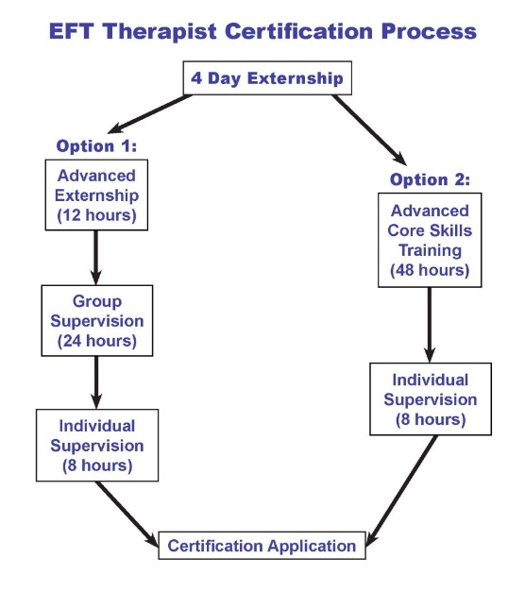

The first 4-day externship was hosted in the Psychology Department in 2013:

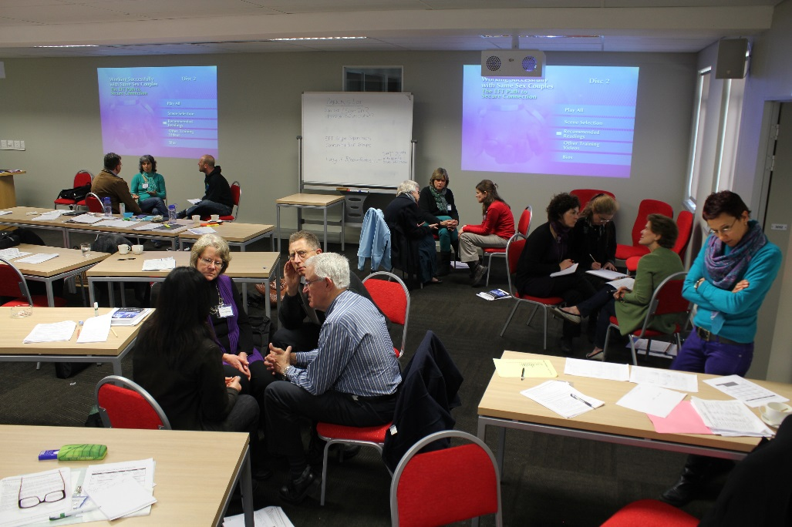

In subsequent years, multiple trainings were presented in Johannesburg, Bloemfontein and Cape Town.

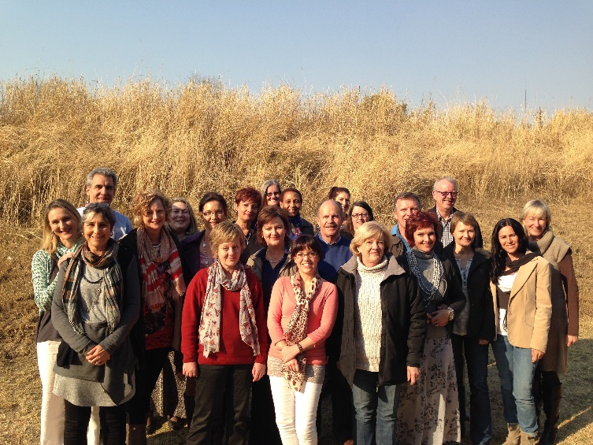

This year we have presented a four-day externship in Durban and other level trainings in Port Elizabeth, Johannesburg and Cape Town.

A couple enhancement workshop based on the principles and process of EFT has been developed (the Hold Me Tight (HMT) Marital Enhancement Workshop), with the aim of making the benefits of EFT more accessible to couples who desire to improve or enrich their relationships. The workshop aims to increase emotional responsiveness in non-distressed couples by facilitating accessibility, responsiveness and engagement of partners to each other. Given the lack of research on adult attachment theory and EFT in African contexts, the objective of this study was to explore the relevance of the Emotionally Focused Couple Therapy (EFT) model for a group of Black South African couples by (i) exploring the usefulness of EFT principles to conceptualise these couples’ relationship functioning; and (ii) exploring South African low-income couples’ experiences of the HMT relationship enhancement psycho-education workshop.

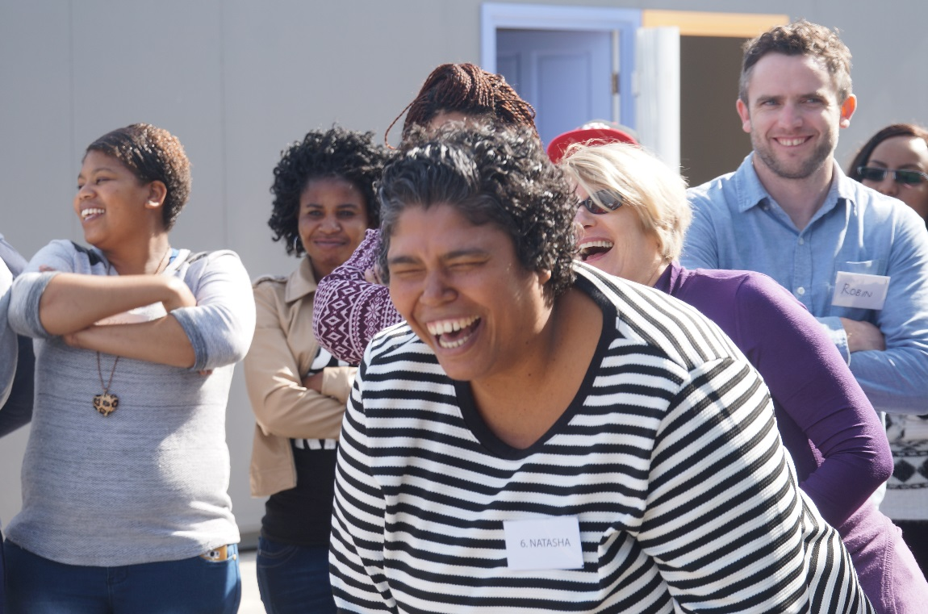

We used a qualitative method in which experienced couple therapists conducted in-depth interviews with 13 Black South African couples before and after they attended a HMT workshop. Their relationship dynamics and their experience of the HMT workshop were explored in the interviews and generated approximately 26 hours of interview material. Thematic analysis was used to analyse the transcribed interviews. Overall the results indicate that the EFT principles were useful in conceptualising the couples’ relationship dynamics and that they could relate to and apply these principles in their relationships.

