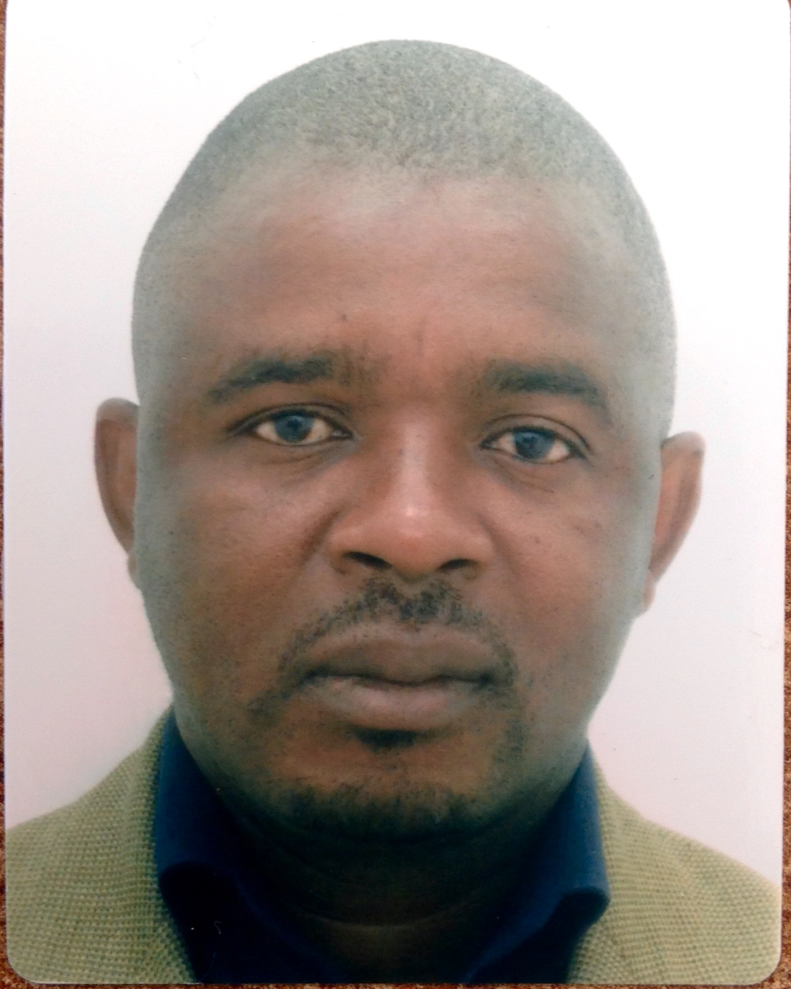 CURRICULUM VITAE
Gerald Chikozho Mazarire
Contacts
Dr G.C Mazarire
Dept of History, Midlands State University
P. Bag 9055, Gweru, Zimbabwe
Email: gmazarire@yahoo.com
mazarireg@msu.ac.zw
Mobile: +263772344876
Skype: gerrymazarire
_________________________________________________________________________

Personal Information

Surname: Mazarire
Name(s): Gerald Chikozho
Date of Birth: 6 October 1976
_________________________________________________________________________

Key Competencies
- Research: Principally written projects using archival records and field work in oral History, Politics, Ethnography, Archaeology and related fields; Supervision of academic research at Bachelors, Masters and Phd levels.
- Training (including teaching)- practical training for organizations such as Universities, Archives, Electoral Bodies, Museums, Military Colleges, Seminaries,
- Academic writing: Production of high-impact academic papers, articles, book chapters and books
- Consultancies: Scenario Analyses, Traditional Chieftaincies Claims, Community Beneficiation and Dispute Resolutions, Political and Economic Assessments
- Facilitation: Conferences and academic workshops for Universities, Professional Associations, NGOs and UN agencies
- Editing: Professional editorial and refereeing work for academic journals and book publishers

Experience

- Senior Lecturer (12 years’ experience)

a. History Department, Midlands State University, Zimbabwe (2012 to date)
- Adjusting the course curriculum to meet the current needs of the Zimbabwean, Regional and International community and industry.
- Teaching Regional, Methodological and Conceptual Courses in History, Development and International Studies
- Supervision of Research Dissertations at Honours, Masters and PhD levels
- Assisting students during consultations
- Administrative work at Departmental, Faculty and Senate Level involving Examination, Planning and Curriculum Review

- History Department, University of Zimbabwe (Senior Lecturer 2005-2011)
- History Department, University of Zimbabwe (Lecturer 2001-2004)
- History Department, University of Zimbabwe (Teaching Assistant 1998-2000)

- Senior Research Associate SAPES Trust, Harare (Current)

- Research Fellow 3 Years’ Experience

- American Council for Learned Societies, African Humanities Programme (Admitted as Fellow since October 2013)
- NRF Post-Doctoral Fellow in History, Stellenbosch University (January 2012-December 2013)
- Visiting Research Fellow, Centre of African Studies, University of Edinburgh, UK March-July 2007

- Part-Time Lecturer: Aruppe Jesuit College for Philosophy and Humanities (Harare), 2001-2007
- Teacher at Chivi High School, (Masvingo), 1997.

_______________________________________________________________________________

Research/Academic Responsibilities

- Editorial Board Member: Kronos: Journal of Southern African History
- Editorial Board Member: Oxford Research Encyclopaedia on African History: Oxford University Press
- Advisory Board Member: Critical African Studies
- Advisory Board Member: Journal of Globalisation Studies
- Advisory Board Member: National University of Science and Technology (NUST) Records and Archives Management Programme
- Founding Trustee: Zimbabwe Oral History Trust
- Chairman: Department of History, University of Zimbabwe (2010 -2012)
- Vice Chairman: University of Zimbabwe Research Board (2011-2012)
- Reviews Editor: H Net Humanities and Social Sciences Online
- Country Chairperson: Aluka (JSTOR) Project for the Digitisation of Liberation Documents in Southern Africa.
- Country Associate Researcher: SADC Secretariat-Hashim Mbita Project on the History of Liberation and Democracy in Southern Africa
- Assistant Country Researcher: Southern African Development Education Trust (SADET) African Regional Solidarity Project
- National Facilitator: UNDP/ Zimbabwe Organ on National Healing Reconciliation and Integration (ONHRI)

______________________________________________________________________
Qualifications

DPhil in History (University of Zimbabwe) (2010). Title of Thesis: ‘A Social and Political History of
Chishanga: South-Central Zimbabwe c.1750-2000’

MA In African History (University of Zimbabwe) (1999). Thesis Title:-‘Religion, Protest and War in South-Central Zimbabwe: The Case of Chivi 1900-1980’

BA Honours In History (University of Zimbabwe) (1997), Thesis Title:-‘An Oral Historiography of the Chivi People from Earliest Times to 1900’

Certificate in Teaching and Learning in Higher Education (University of Zimbabwe 2001)

Conference and Workshop Papers

G.C. Mazarire, ‘Landscape and Memory In Shona Oral Traditions; The Past as Perceived by Mhari and Hera People of Southern Zimbabwe up to 1900’ Paper Presented to the International Conference on ‘A View of the Land,’ Bulawayo 4 July 2000.

___________‘Changing Landscape and Oral Memory: Towards a Historical Geography of Chishanga South-eastern Zimbabwe’ Paper Presented to the Historical Geographies of Southern Africa Symposium, University of Sussex at Brighton, 4-5 April 2002.
___________ ‘Oral Traditions as Heritage: The History and Future of Oral
Historical Research on the Shona Communities of Zimbabwe: Some Methodological Concerns’ Paper Presented to the Conference on Heritage Creation and Historical Research, Rand Afrikaans University, Johannesburg, South Africa, 24-27 June 2002

____________‘An Act of Madness’: Reconsidering the Post-Matabeleland Conflict in the Context of the Zimbabwean Crisis’ Paper Presented to the Re-Construction of War-torn Communities in the Middle East and North Africa (RWCMEA) Workshop, Ahfad University for Women, Omdurman, Khartoum, Sudan, April 2003.

_____________ ‘Precolonial History as Historiography of Nationalism’ Paper Presented to The Britain Zimbabwe Society Research Workshop on ‘Which history? For Which Zimbabwe? St. Antonys College, Oxford, June 2004

G.C. Mazarire & N.M. Bhebe, ‘Zimbabwe’s Liberation Heritage: A Survey’ Paper Presented to the SADC Secretariat Hashim Mbita Project Launch, Dar es alam, 1-5 August 2005

G.C. Mazarire, ‘The Chishanga Waters have their Owners’: Water, Politics and Development in Southern Zimbabwe’ Paper Presented to the CAS Annual Conference on ‘The Power of Water, Landscape, Water and State in Southern and Eastern Africa’, University of Edinburgh 28-29 March 2007.

__________ ‘The Warrior Tradition and Zimbabwe’s Historical (Re)Construction’ Paper Presented to the AEGIS Conference, Leiden, The Netherlands, July 14-17, 2007

__________‘Collecting and Processing Liberation War Memories in Contemporary Zimbabwe: Reflections on A Growing Corpus’, Paper Presented to the Conference on ‘Liberation Struggles in Southern Africa: New Perspectives’ University of Cape Town 4-6 September 2008.

___________‘Rescuing Zimbabwe’s “Other” Liberation Archives’, Paper Presented to the Nordic Africa Documentation Project Workshop, University of South Africa, 26-27 November 2009

___________ Russia and the Liberation of Zimbabwe 1960-1980’, Paper Presented to the International Conference on “The Year of Africa-Fifty Years After. The Destiny of the National Lliberation Movements: A View from Africa, Russia and Western Europe”, Russian Academy of Sciences, Moscow, Russia March 30-31, 2010.

__________ ‘Discipline and Punishment in ZANLA, 1964-1979’ Paper Presented to the ASAUK Annual Conference, Oxford, 16-17 September 2010.

__________‘Terence Ranger and Zimbabwean History: A Critical Appraisal’ Paper Presented to the Conference ‘Making History: Terence Ranger and African Studies’, University of Illinois at Urbana-Champaign, Illinois, USA, 14-15 October 2010.

__________ ‘Interpreting African Bodies in Colonial Zimbabwe: Medical Anthropology and Local Histories’ Keynote Paper Presented to the British Academy Workshop: The (Un)Healthy Body in Southern Africa, Wits Reproductive Health and HIV Institute, Johannesburg, 2-4 April 2012.

__________ ‘Carl Mauch and Some Karanga Chiefs Around Great Zimbabwe, 1871-72: Re-Considering the Evidence’ Paper Presented to the University of Stellenbosch, History Department Staff Seminar Series, 8 May 2012.

___________ ‘Towards a Historical Research Agenda for the Zimbabwean Midlands’ Keynote Paper Presented to the 25th Anniversary of the National Archives of Zimbabwe, Gweru Records Centre, 9 September 2013.

_____________’The Congress System: Towards a Biography of ZANU (PF) 1977-2014’ Paper Presented to the “Legacies of Struggle in Southern and Eastern Africa Conference, British Institute in East Africa, Nairobi, 18-20th March, 2015.
_____________ ‘ZANU’s External Networks: An Appraisal’ Paper Presented to the JSAS Biennial Conference: Southern Africa Beyond the West: Political, Economic and Cultural Relationships with BRICS Countries and the Global South, Livingstone, Zambia, 7-11 August 2015

_________________________________________________________________________

Publications

1. G.C. Mazarire: ‘Of Spelling Errors and Historical Distortions Oral Traditions Concerning the Identity of Maziriri. The Svikiro of the Chivi People’ Zimbabwea No. 11 (December 1999).

2. G.C. Mazarire: ‘Where Civil Blood Made Soldiers Hands Unclean; Rethinking, War-time coercion in Rural Rhodesia: Reflections on The Chivi Experience 1976-1980’ Journal of African Conflict and Development, Vol.1, No. 1, (2000).

3. G.C. Mazarire & M.R. Rupiya ‘Two Wrongs Do not Make A Right: A Critical Assessment of Zimbabwe’s Demobilization and Reintergration Policies Since 1980’. Journal of Peace, Conflict and Military Studies, Vol. 1, No. 1, 2000

4. G.C. Mazarire ‘Ethical Considerations for Zimbabwean Archives and the Digital Challenge’ Innovation no.24, June 2002

5. G.C. Mazarire ‘The Politics of the Womb: Women Politics and the Environment in Pre-Colonial Chivi: Southern Zimbabwe c. 1840-1900’, Zambezia vol. XXX, no.1 2003
.
6. G.C. Mazarire ‘The Social basis of ‘Evil’ in Pre-Colonial Zimbabwe With Particular reference to the Practice of Killing Twins among the Karanga’ Chiedza: Arrupe College Journal vol.5 no.2 December 2002

8. G.C. Mazarire ‘Oral Traditions as Heritage: The Historiography of Oral Historical Research on the Shona Communities of Zimbabwe’ Historia vol.47 no.2 November 2002

9. G.C. Mazarire: ‘Changing Landscape and Oral Memory: Towards a Historical Geography of Chishanga, South-eastern Zimbabwe’ Journal of Southern African Studies vol. 29 No.3 September 2003

10. G.C. Mazarire, ‘Defence Consciousness as Way of Life: ‘The Refuge Period’ and Karanga Defence Srategies in the 19th Century’, Zimbabwean Prehistory no. 25, 2005.

11. G.C. Mazarire, ‘Memories and Contestations of the Scramble for Zimbabwe: Chivi (Mashonaland) c.1870-1892’, in Femi J. Kolapo and Kwabena Akurang-Parry eds. African Agency and European Colonialism: Latitude of Negotiation and Containment (University Press of America, Inc., Forbes Boulevard, August 2007)

12. G.C. Mazarire, ‘The Dutch Reformed Church in the Victoria Circle: Mashonaland 1874-1956’, Heritage of Zimbabwe, no. 26, (2007)

13. G.C. Mazarire, ‘A Little England in Chishanga’: The Fate of a British Empire Leprosarium at Ngomahuru, Southern Rhodesia 1925-1946’, African Historical Review 39, no. 2 (2007).

14. G.C. Mazarire, “The Chishanga Waters Have Their Owners’: Water, Politics and Development in Southern Zimbabwe’ Journal of Southern African Studies vol. 34 no. 4 (2008)

15. G.C. Mazarire, ‘Reflections on Pre-Colonial Zimbabwe, c.850-1880s’ in B. Raftopolous & A. Mlambo (eds.) Becoming Zimbabwe: A History from the Pre-colonial Period to 2008 (Weaver Press, Harare, 2009), p.1-38.

16. G.C. Mazarire, ‘Rescuing Zimbabwe’s “Other” Liberation Archives’ in C. Saunders (ed.) Documenting Liberation Struggles in Southern Africa (Nordiska Afrikainstutet, Uppsala, 2010), p. 95-106.
17. G.C. Mazarire, ‘Discipline and Punishment in ZANLA 1964-1979’, Journal of Southern African Studies vol. 37 no. 3 (2011) p. 571-591.

18. G.C. Mazarire; ‘Reading Chishanga: Some issues of Process and Method’ in P. Ngulube (ed.) National Archives 75@ 30:&5 Years of Archiving Excellence at the National Archives of Zimbabwe (Harare, National Archives of Zimbabwe, 2012)

19. G.C. Mazarire & N. M. Bhebe, ‘Paying the Ultimate Price’: Zimbabwe and the Liberation of South Africa 1980-1994’ in South Africa Road To Democracy: Regional Solidarity Volume (SADET/Unisa Press, Pretoria, 2013)

20. G.C. Mazarire, ‘The Gadzingo: Towards a Karanga Expansion Matrix in 18th and 19th Century Southern Zimbabwe’ Critical African Studies 5: (1) (2013) 4-16.

21. G.C. Mazarire, ‘ZANU PF and the Government of National Unity 2009-2012’ in B. Raftopolous (ed.) The Hard Road to Reform: The Politics of Zimbabwe’s Global Political Agreement (Weaver Press, Harare, 2013), p.71-116.

22. G.C. Mazarire, ‘Carl Mauch and Some Karanga Chiefs Around Great Zimbabwe, 1871-72: Re-Considering the Evidence’ South African Historical Journal 65 (3) (2013) 337-364.

23. G.C. Mazarire & S.Swart, ‘The Pots on Our Roads: The Diaspora Fleet and Harare’s Urban Commuter System’ African Diaspora (7) (2014) 63-88.

24. G.C. Mazarire, ‘Doing Zimbabwean History with Terence Ranger: A Personal Note’ Journal of Southern African Studies 2015

Forthcoming Publications

G.C. Mazarire & S.Swart, ‘The Burrowed Earth: Rodents and the 1992 Drought in Zimbabwe’ Critical African Studies (Special Issue on Animals and Humans in Southern Africa forthcoming Sept. 2015)

G.C. Mazarire & S.Swart ‘Mandimba-ndimba Taxi Wars in Harare: The Political Economy of Rent-Seeking in Zimbabwe’s Transport Sector’ (In Preparation)

G.C. Mazarire, ‘Harald von Sicard and the Early History of Mberengwa: Southwestern Zimbabwe’ In preparation.

G.C. Mazarire, ‘A Veritable Imbroglio: The State and Land Restitution in Early Independent Zimbabwe: Masvingo Province 1981-1987’ in Preparation

G.C. Mazarire Returning Chishanga: Memory, History and Restitution in South-Central Zimbabwe c. 1750-2000 (Forthcoming, Unisa Press)

Work in Progress

- Updating the Historical Dictionary of Zimbabwe (commissioned by Scarecrow Press due 2015)
_________________________________________________________________________

Referees

Professor Sandra Swart
Associate Professor of History
University of Stellenbosch
P Bag X1 Matieland
Phone+27 21 8082390 Fax: +27 21 808 2389
sss@sun.ac.za

Professor Sabelo J. Ndlovu-Gatsheni
Head, Archie Mafeje Research Institute
University of South Africa
College of Graduate Studies
Vista Building, Room 205
263 Nana Sita (Skinner) Street
Tel: +2712 337 6186
ndlovs2@unisa.ac.za

Dr Ibbo Mandaza
Executive Director
SAPES Trust
4 Deary Avenue, Belgravia, Harare, Zimbabwe
Tel. +263-4- 252961/252963
Fax: 252964
ibbo@sapes.org.zw

