FUSARIUM WILT OF BANANA: FIELD IDENTIFICATION

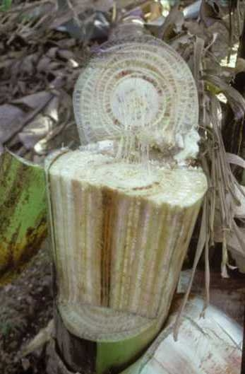
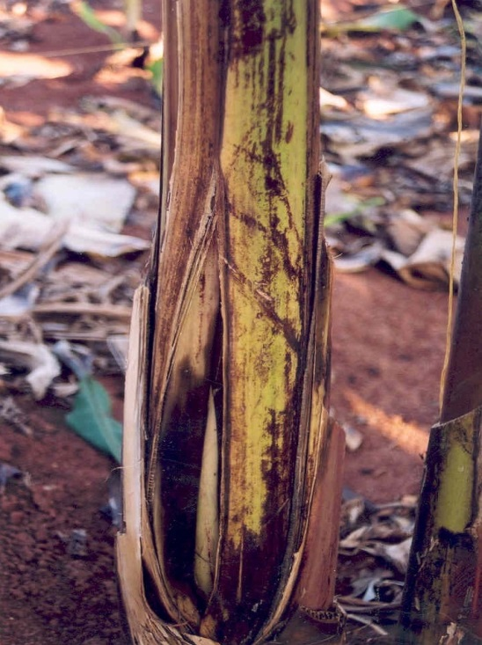
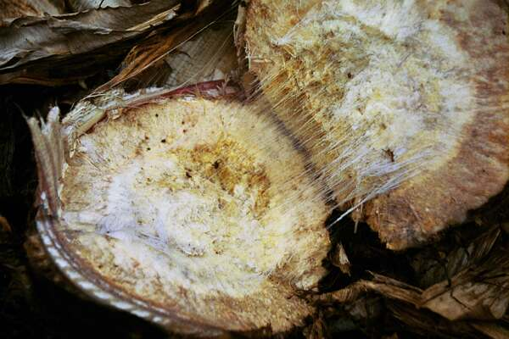
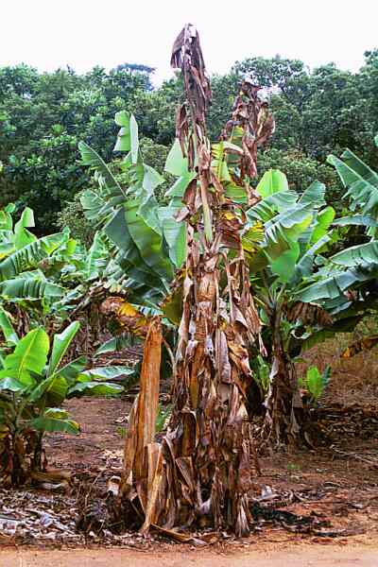
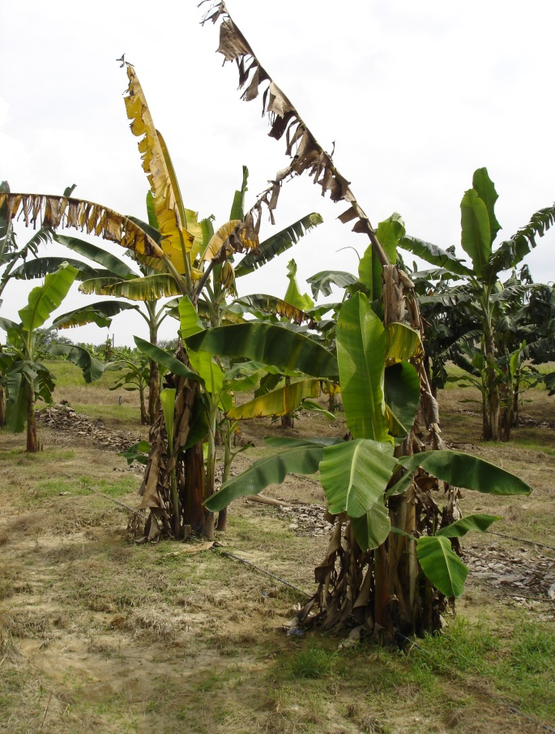
A
D
C
B
E

Figure 1. Disease symptoms of Fusarium wilt of banana caused by ‘subtropical’ race 4 of Fusrium oxysporum f. sp. cubense (Foc) in South Africa (A) and ‘tropical’ race 4 in Malaysia (B). Affected plants wilt rapidly, older and then younger leaves become yellow and brown, and plants eventually die. In some cases, the base of pseudostems split (C). Internally, a deep golden discoloration of the inner rhizome develops (D), while the vascular bundles in the pseudostem will turn yellow to reddish-brown (E).
SAMPLE PREPARATION FROM DISEASED PLANTS (Courtesy N. Moore)

Preparing a sample from the diseased host plant
The sample should consist of a section from the pseudostem of the wilted banana plant where typical continuous discoloured vascular strands are evident. The sample should be taken from as low in the pseudostem as is possible but not from areas where decay is advanced. Also, the sample should be taken from as close to the centre of the pseudostem as is possible, as opposed to the outermost leaf bases. As banana tissue is very wet, the risk of bacterial contamination of samples is high, particularly in warm weather and samples can deteriorate rapidly. The chance of recovering healthy cultures of Fusarium oxysporum f. sp. cubense (Foc) decreases as the sample deteriorates. Samples should be kept in heavy paper bags or wrapped in paper until the strands can be excised. Avoid plastic bags as this causes the samples to sweat and promotes growth of bacteria. Accurate notes must be taken for each sample including:
- Sample number (one sample number per plant)
- Date
- The variety of the host plant, including local names (and uses if known)
- Genomic constitution of host if known (e.g. AA, AAB, ABB etc.).
- Age of plant/plantation.
- Whether plants sampled are grown in a garden, commercial plantation, village or the wild.
- Size of the diseased area where the plant was collected, with photos.
- Location (eg. name of province/state, how far in what direction from nearest town, name of road, name of property if sample is from a commercial plantation etc.) A map with sample numbers marked on it and GPS coordinates essential.
- Collectors names, and the required phytosanitory certificate/importation permit
- Other useful observations might include the source of the planting material, whether the plant is growing in water-logged soil, how many plants are affected, what other varieties are growing in the vicinity and are these diseased or healthy?

A small (5cm x 5cm) piece of rhizome tissue showing typical discoloured vascular strands may also be used as a sample, but this is not recommended if decay in the rhizome is advanced. This piece of rhizome tissue should also be wrapped in paper or placed in a paper envelope to dry.
NOTE: When looking for wilt-affected plants, it is better to take samples from established plantings of bananas rather than recently planted young plants.

Dissecting discoloured vascular strands from sample
Ideally, the discoloured vascular strands should be dissected from the sample on the same day that it is collected, or as soon as possible after collection. The use of sterile blotting papers is recommended and aseptic technique should be applied to the dissection of strands. Samples should first be surface-sterilised by wiping with 70% alcohol or surgical spirits. Where several samples are being prepared, a fresh piece of blotting paper should be used for each sample, and scalpel blades should be flamed if possible or at least wiped with 70% alcohol between samples. The excised strands should then be placed between sterile blotting papers in a paper envelope to dry naturally. A few days are usually sufficient. Do not let the strands get too hot (eg. in direct sunlight or in the boot of a car) as this may kill the fungus. Do not dry them in an oven! Fusarium wilt specimens do not need to be kept in the fridge – room temperature is OK. They do not need to be wrapped in moist paper like leaf specimens – dry paper is best.

Posting of samples

If posting the strands for isolation and analysis, please post in a paper envelope as soon as the strands are dry enough with sample numbers and details clearly written on or with each sample envelope. Please include a copy of the relevant quarantine import permit inside the package if this is required.

Note: If there is any possibility that samples have been mixed up and the details for some samples may be incorrect, discard the samples concerned.

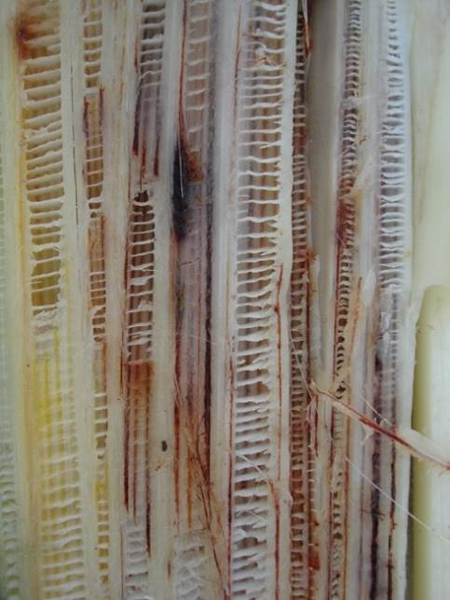

Figure 2. Sample collections from bananas with Fusarium wilt symptoms. (A) Dissect the discoloured vascular strands from inner banana pseudostem. (B) At least 5-6 strands should be collected from each diseased plant, and (C) placed into sterile blotting paper and paper towel for transport to the laboratory.

ISOLATION OF Foc FROM COLLECTED MATERIAL (Courtesy N. Moore)

Isolating the fungus from discoloured vascular strands
Isolation can be attempted when the strands have dried. Small sections (3-6 mm long) of dry discolored vascular strands are submerged into plates of ¼ strength potato dextrose agar (PDA) medium amended with an antibacterial agent (e.g. streptomycin @ 1.2 mL/240 mL PDA). If present, Fusarium growth will appear from the strands in 2 to 4 days. However, if the sample is badly contaminated with bacteria this may mask fungal growth. Let samples dry further if this occurs and increase the strength of the antibacterial amendment in the media. A high rate of recovery of Fusarium should be expected from correctly prepared samples. Single-spore (monoconidial) cultures should be prepared from an isolate from each specimen.

Single-sporing of isolates
Single-spore isolates of F. oxysporum are obtained by either dilution plating or streaking (demonstrated below). For both methods, a small scrape of sporulating hyphae are collected from cultures grown on ¼-strength PDA plates, and dissolved in 10 ml sterile distilled water in test tubes. From the initial spore suspension, a series of dilutions can be prepared. One ml of each of the dilution series is then either pipetted or streaked onto water agar, and the water agar plates incubated with the lid up overnight at 25ºC. The plates are viewed for germination of conidia under a dissecting microscope the following morning, and single-conidia cut from the water agar with a surface-sterilized scalpel and transferred to new 90-mm ¼-strength PDA plates. Additionally, single-spore cultures can also be obtained by dissecting the very tip of single growing hyphae from an older culture grown on CLA.

Maintenance of healthy cultures
Healthy (sporodochial-type) cultures of Fusarium oxysporum f. sp. cubense (Foc) from single spores are maintained on carnation leaf agar (CLA) (Burgess et al., 1994) to prevent mutation (Nelson et al. 1983). Cultures can be initiated on weak-strength PDA medium (e.g. ¼ strength) (Ainsworth, 1971) to check the morphology of cultures for taxonomic purposes or for spore production. Healthy (sporodochial-type) cultures of Foc growing on PDA medium exhibit abundant fluffy aerial mycelium after 2 days and produce abundant microconidia. Some macroconidia may also be produced on PDA although this type of spore is more commonly produced on CLA medium. Cultures of Foc should NOT be kept on PDA medium for longer than 4 or 5 days as mutations can rapidly occur and these cannot be reversed (Nelson et al. 1983, Windells 1992). Mutated cultures (e.g. slimy pionnotal mutants) should be discarded. Cultures are normally maintained in an incubator at 25ºC. Black light is generally not required for cultures of Foc to sporulate. Various methods are used for long-term (e.g. lyophilisation), medium-term (e.g. colonised filter paper in cold storage) and short-term (e.g. CLA) storage of cultures of Foc.

References:
Ainsworth, G.C. (1971) Ainsworth and Bisby’s Dictionary of the Fungi. 6th ed. Commonwealth Mycological Institute, Kew, Surrey, England. 663 pp.
Burgess, L.W. et al. (1994) Laboratory Manual for Fusarium Research. 3rd ed. University of Sydney, Sydney, Australia. 133 p.
Nelson, P.E. et al. (1983) Fusarium species: an illustrated manual for identification. Pennsylvania State University Press, University Park. 193 pp.
Foc isolation and analysis procedure – diagrammatic representation
(Natalie Moore and Dean Beasley)

- Isolation from plant material.
Blotting paper
Streptomycin PDA

Infected vascular strands from the pseudostem in sterile blotting paper
Blotting paper

- Sub-culture small areas of good fusarium
growth onto Streptomycin PDA. Use these
cultures for single sporing (need to grow
for 2 to 3 days to be sure of healthy
culture).

Streptomycin PDA

- Streak spore suspension onto water agar.
Infected vascular strands from the pseudostem in sterile blotting paper

Small cube of
agar with fungal
mycelium

Streptomycin PDA

If isolation plates are not heavily contaminated, a shortcut can be taken by using fusarium growth from the isolation plate for the spore suspension.

- After 24 hours take at least 2 single germinated spores and place back onto Streptomycin-PDA.

Water agar

Small cube of agar with a single germinated spore

- Once single spore cultures exhibit normal fusarium growth (should
Example of a 16 streak plate
Single spore culture
Streptomycin PDA
be visible after 4 to 5 days), chose only 1 single spore culture to
represent each isolate and discard all other cultures. Assign unique
accession number. Subculture onto CLA, which becomes the source
for VCG, DNA and volatile production tests and filter paper culture
for storage, and for extra CLA cultures if required for freeze drying/lyophilisation.
Steps involved in laboratory diagnosis of Fusarium wilt of banana
1 rice culture
1 filter
paper culture

- Receive specimen, log details and observations from grower/inspector.
- Isolate from symptomatic tissue (usually 2 x Strep’ PDA with 4 pieces per plate).
- Check morphology of resultant growth (macro and microscopically).
- Subculture Fusarium growth to make spore suspension and streak onto water agar.
- Select 2 x germinated single spores to initiate monoconidial cultures.
- Assign unique accession number to isolate and record in specimen book and Fusarium isolate database.
- The monoconidial culture is used to:
- Inoculate 1 x rice culture for volatile production.
- Inoculate 3 x KPS plates to generate nit mutants for VCG tests.
- Inoculate 1 x PD broth for DNA analysis.
- Initiate 1 x filter paper culture for medium term storage.
- Initiate 1 x CLA plate for short-term storage.
- If necessary arrange for lyophilisation of isolate for long-term storage in collection.
- If necessary, prepare CLA cultures for lodging in a herbarium.
- Conduct and record results of volatile and VCG analysis in database.
- Return written reply to grower/inspector concerned using Plant Disease Report form, recording the date and details of reply in specimen book (usually phone results also).
- Maintain isolate collections and records in database.

Characteristics of F. oxysporum f.sp. cubense

- Produce abundant microconidia that are single celled, oval to kidney-shaped.
- Microconidia are produced in false heads on branched and unbranched monophialides.
- Macroconidia are abundant, slighly sickle-shaped with an attenuated apical cell and a foot-shaped basal cell.
- Chlamydosphores are present and formed singly or in pairs.
- No perfect stage of F. oxysporum is known.
- On PDA, fungal colonies produce white aerial mycelia that may turn purple in the centre. Isolates may differ in their cultural morphology.
- Cream to orange sporodochia are formed on carnation leaves on CLA.
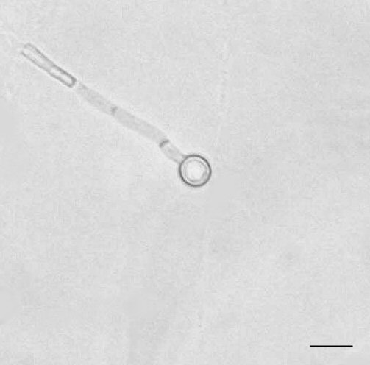
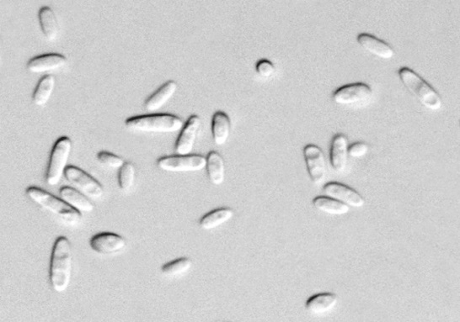
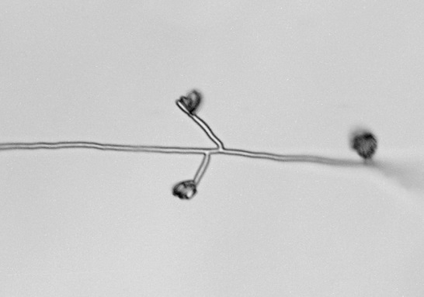
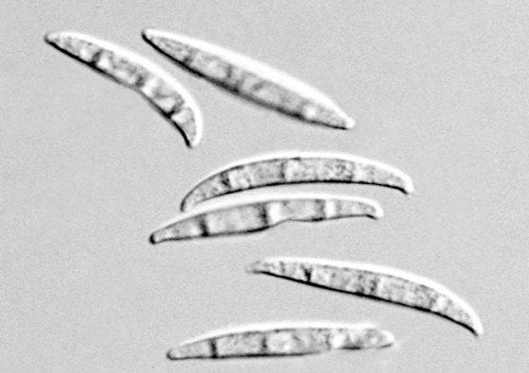

ANALYTICAL TECHNIQUES FOR IDENTIFICATION OF Foc
(Linda Smith)

Several analytical techniques have been used to study the variation in populations of Foc. These techniques include volatile production and vegetative compatibility.

VOLATILE PRODUCTION

Brandes (1919) found that isolates of Fusarium oxysporum f.sp. cubense (Foc) grown on steamed rice either produced or did not produce a characteristic volatile odour. Stover (1962) also used volatile compounds to differentiate strains of this pathogen. Stover assigned isolates to either the 'odoratum' or 'inodoratum', group based on the presence or absence of volatile substances. This technique has been used to characterise Australian and Asian isolates of Foc (Moore et al., 1991; Pegg et al., 1993, 1996). These studies indicated that the production of volatile compounds on rice medium could be used to differentiate between strains of Foc. There was absolute correlation between the production of volatile substances and VCG in the Australian isolates; race 1 and race 2 isolates did not produce detectable volatile odour, while race 4 isolates produced easily detectible volatile odours. Volatile analysis is a simple and inexpensive method of characterising isolates of Foc based on the biochemistry of cultures in vivo.

Method
Prepare rice medium as described below. Media for the isolation and culturing of F. oxysporum. Aseptically inoculate rice with two large squares of Fusarium culture grown on streptomycin PDA. Flasks can be left on the benchtop at room temperature. Assess cultures after 2 weeks for production of volatiles.

Rice medium:

Reference:
Moore, N.Y., Hargreaves, P.A., Pegg, K.G. and Irwin, J.A.G. (1991) Characterisation of strains of Fusarium oxysporum f. sp. cubense by production of volatiles. Australian Journal of Botany 39: 161-166.

Method:
- Add approximately 30 mL of rice and 90 mL of distilled water to each 250 mL Erlenmeyer flask.
- Plug with cotton wool and cover with alfoil before steaming for 1 hour on each of two consecutive days eg. in autoclave on free steaming cycle at 103⁰C.
- Allow medium to cool before inoculation.

MEDIA FOR THE ISOLATION AND CULTURING OF F. oxysporum

Quarter strength potato dextrose agar (PDA) medium

Reference:
Ainsworth, G.C. (1971) Ainsworth and Bisby’s Dictionary of the Fungi. 6th ed. Commonwealth Mycological Institute, Kew, Surrey, England. 663 pp.

Ingredients per litre of distilled water:
100 g peeled and diced potatoes
10 g dextrose
20 g agar

Method:
Steam potatoes in the distilled water for one hour then strain through eight layers of cheesecloth. Discard the solid portion. Add dextrose and agar to the liquid portion, stir well and return to the steamer until agar dissolves (approx 40-50 min). Remove media from steamer and immediately dispense 240 mL into 250-mL glass bottles; cap with autoclavable caps (vented). Sterilise in an autoclave (wet cycle: 100 kPa at 121ºC for 20 min). When cool, tighten caps and label bottles with PDA and the date.

PDA medium amended with streptomycin:
Melt the required number of bottles of 240 mL PDA medium in a steamer. When melted, place bottles in a water bath at 50ºC for 20 minutes or until media reaches 50ºC. To each 240 mL media add 1.2 mL streptomycin solution (1g streptomycin sulfate powder per 100 mL sterile distilled water) just before dispensing into Petri dishes.

Carnation Leaf Agar (CLA)

Reference:
Burgess, L.W., Liddell, C.M. and Summerell, B.A. (1988) Laboratory Manual for Fusarium Research. 2nd ed. University of Sydney, Sydney, Australia. 156 pp.

Method:
Four to ten pieces of sterilised carnation leaf are placed onto the surface of freshly poured water agar plates just before the agar sets. When set, the CLA plates are stored upside down in a refrigerator or cold room at 4ºC.

Preparation of Carnation leaves:
Fresh, healthy carnation leaves, which have not been treated with fungicides or other chemicals, are cut into pieces approximately 10 x 3 mm before placing in paper bags to dry. When dry, place leaf pieces in containers suitable for Gamma-irradiation (eg. glass or hard polystyrene containers with lids or polyethylene Petri dishes sealed with Parafilm). Note that Gamma radiation will degrade plastics after repeated exposure. The containers are placed in a Gamma cell for a total dose of 2.5 Mega Rad. Store containers of Gamma-sterile leaf pieces in refrigerator or cold room at 4ºC until required.
VEGATATIVE COMPATIPILITY GROUP (VCG) ANALYSIS USING NITRATE NON-UTILISING MUTANTS

1. Generating nitrate non-utilising (nit) mutants
This technique was originally used by Cove (1976) for Aspergillus nidulans and was then modified by Puhalla (1985) and Correll et al. (1987) for use with Fusarium oxysporum. Cultures growing on CLA or PDA medium are used to inoculate plates of a medium containing potassium chlorate. Potassium chlorate is an analogue of nitrate and is taken up and processed through the nitrate reductase pathway (Correll et al. 1987). This process results in the production of chlorite which is toxic to the fungus (instead of nitrite which is useful to the fungus) and characteristically slow-growing colonies with restricted, ‘knotted’ mycelial growth result.

After 5 to 12 days, fast-growing sectors begin to emerge from the restricted colonies (Figure 3). The mycelium in these fast-growing sectors has sustained a mutation which enables the fungus to resist chlorate (and therefore also the toxic chlorite). However, the mutation also renders the fungus unable to reduce nitrate. Thus, these sectors are known as nitrate non-utilising mutants or nit mutants for short.

To test if the fast-growing sectors are unable to use nitrate, a small piece (2 × 2 mm) of mycelium is taken from the advancing edge of the sector. This is then transferred to a medium which contains nitrogen only in the form of nitrate, such as Minimal Medium (Puhalla, 1985). If the sector is a true nit mutant it will not be able to reduce the nitrate in the medium and characteristically sparse, nitrogen-deficient growth will result. If the growth that results is not sparse on MM, discard this culture, as it will be of no use in VCG tests.
1 plate of CLA
1 PD broth if DNA analysis is required
3 plates of KPS to generate mutants for VCG testing
KPS
23532
1.
2.
3.
23532-1
23532-2
23532-3

Figure 3. Fast-growing sectors emerge from a restricted colony of Foc on KPS medium. Mycelium from the advancing edge of each sector is transferred to Minimal Medium to test its ability to reduce nitrate.

It is advantageous to let the sectors grow for two to three days after emerging on the KPS plates so that the fast-growing mycelia grows clear of any non-mutated mycelia which may be underneath. Each restricted colony growing on KPS medium may yield up to 5 separate sectors. When each of the sectors is transferred to MM, the sector should be numbered to identify it. This becomes particularly important if the tests need to be repeated or the mutants are needed for other tests. For example, if the isolate being tested has the accession number 23532 the sectors can be sequentially numbered as 23532-1, 23532-2, 23532-3 and so forth (Figure 3).

2. Determining the phenotype of nit mutants
Some nit mutants are more reliable than others for use in VCG tests. The phenotype of the nit mutant can be determined by the type of growth (sparse, nitrogen-deficient or dense, nitrogen-sufficient) which is produced when the nit mutant culture is transferred to media that has nitrogen present in only one of four forms (Correll et al. 1987). For further explanation of the phenotypes and which combinations are best to use in VCG tests refer to Correll et al. (1987). It is advantageous to generate several (at least four or five) nit 1 or nit 3 mutants from each isolate to pair in combinations with the Nit M testers (mutants of known VCG). Mutants of the nit 1 or nit 3 phenotypes are the most commonly generated type of mutant. Mutants of the Nit M phenotype are less commonly generated and are best used as the ‘testers’ of known VCG.

3. Pairing nit mutants in VCG tests
A small (2 × 2 mm) piece of colonised agar from a culture of a Nit M mutant of known VCG is placed in the centre of a plate of MM. The bottom of the plate is labelled with number of the VCG that this Nit M represents. Similar small pieces of culture of the nit mutants that have been generated from the isolate of unknown VCG are then placed at least 10 to 15 mm away from the piece of Nit M culture around the edge of the plate (Figure 4). These must also be labelled on the bottom of the plate (using permanent ink that will not dissolve!). Labelling the base of the plate before transferring the nit mutants saves time and avoids confusion. If you think you have placed a mutant in the wrong position or mis-labelled a plate, discard it and start again.

If the isolate of unknown VCG has the accession number 23532, the nit mutants which are generated from this isolate would be numbered 23532-1, 23532-2, 23532-3 and 23532-4. If these mutants are paired with Nit M testers representing VCGs 0120, 0124 and 0129 on MM plates, the finished VCG test plates would look like this:
MM
MM
MM
23532-1
23532-3
0120
(Date)
23532-4
23532-2
23532-1
23532-3
0124
(Date)
23532-4
23532-2
23532-1
23532-3

Figure 4. Pair-wise arrangement of four nit mutants from an isolate of unknown VCG (isolate number 23532) with Nit M testers representing VCGs 0120, 0124 and 0129. Nit M testers are placed in the centre of the plate with the nit mutants around the edge.

The paired plates are kept in an incubator at 25°C and checked every 2 days for the formation of heterokaryon growth. If a heterokaryon is going to develop (i.e. if the isolate is vegetatively compatible with one of the Nit M testers) a line of dense nitrogen-sufficient growth will start to form in 7 to 12 days where the hyphae of the nit mutants meet the hyphae of the Nit M mutant representing the VCG to which that isolate belongs. If no line of heterokaryon growth is evident by 12-14 days the isolate is said not to belong to that VCG. For example, isolate 23532 belongs to VCG 0124 and in seven days the paired plates would look typically like this:

Figure 5. Example of a positive VCG test. Heterokaryon formations between the nit mutants of isolate 23532 and the Nit M tester representing VCG 0124 indicate that isolate 23532 belongs to VCG 0124.
0129
(Date)
23532-4
23532-2
23532-1
23532-3
0120
(Date)
23532-4
23532-2
23532-1
23532-3

Please keep an accurate, centralised record of all VCG tests performed including the dates and which of the nit mutants tested produced heterokaryons with which Nit M testers. Grids for recording the results of VCG tests can easily be drawn up and copied for use. VCG test results along with accurate information on the host variety, location, the grower’s and specimen collector’s names and other information can be easily maintained in an electronic database (eg. Microsoft Access) which is easy to set up and add information to as specimens are received and VCG tests are performed.

Useful references for working with Fusarium

Ainsworth, G.C. (1971) Ainsworth and Bisby’s Dictionary of the Fungi. 6th Ed. Commonwealth Mycological Institute, Kew, Surrey, England. 663 pp.
Burgess, L.W., Liddell, Summerell, B.A., Bullock, S., Gott, K.P., and Backhouse, D. (1994) Laboratory Manual for Fusarium Research. 3rd Ed. University of Sydney, Sydney, Australia. 133 pp.
Correll, J.C., Klittich C.J.R. and Leslie, J.E. (1987) Nitrate non-utilising mutants of Fusarium oxysporum and their use in vegetative compatibility tests. Phytopathology 77, 1640-1646.
Cove, D.J. (1976) Chlorate toxicity in Aspergillus nidulans: the selection and characterisation of chlorate resistant mutants. Heredity 36, 191-203.
Nelson, P.E., Toussoun, T.A. and Marassas W.F.O. (1983) Fusarium species: an illustrated manual for identification. Pennsylvania State University Press, University Park. 193 pp.
Puhalla, J.E. (1985) Classification of Fusarium oxysporum on the basis of vegetative compatibility. Canadian Journal of Botany 63, 179-83.
Windells, C.E. (1992) Fusarium. In: Methods for research on soil borne phytopathogenic fungi. L.L. Singleton, J.D. Mihail and C.M. Rush (eds.) APS Press, St. Paul, Minnesota. 115-128.

KPS medium

Puhalla, J.E. (1985) Classification of Fusarium oxysporum on the basis of vegetative compatibility. Canadian Journal of Botany 63: 179-83.

Cook 200 g peeled and diced potatoes in 1 L of distilled water in a steamer for 50 minutes. Pass the liquid through 8 layers of cheesecloth and discard the solid portion. Make the liquid volume up to 1 L with distilled water and add:
20.0 g sucrose
15.0 g KClO₃
20.0 g agar

Return the media to the steamer until agar has dissolved. Remove media from steamer and immediately dispense 240 mL into 250 mL glass bottles; cap with autoclavable caps (vented). The capped bottles of media are then sterilised in an autoclave (wet cycle: 100 kPa at 121ºC for 20 min). When cool, tighten caps and label bottles with KPS and the date.

Minimal Medium

Puhalla, J. E. and Speith, P.T. (1983) Heterokaryosis in Fusarium moniliforme. Experimental Mycology 7, 328-335.

Ingredients per litre of distilled water

30 g | Sucrose
20 g | BBL agar (or similar analytical grade agar)
0.5 g | KCl | Potassium chloride
2 g | NaNO₃ | Sodium nitrate
1 g | KH₂PO₄ | Potassium dihydrogen orthophosphate
0.5 g | MgSO₄.7H₂O | Magnesium sulphate heptahydrate
10 mg | FeSO₄.7H₂O | Ferrous sulphate
0.2 mL | Sterile trace elements solution (add this after medium has melted and before autoclaving)

Method
Place in steamer until agar has dissolved (approximately 1 hour), shaking occasionally. Add trace element solution (this is pre-made and kept in 1 mL containers in the freezer). Dispense approximately 240 mL of medium into media bottles. Cap (with caps vented) and autoclave to sterilise (e.g. wet cycle: 100 kPa at 121ºC for 20 min.). When cool, tighten caps and label bottles with MM and the month and year (in blue).

Trace element solution

Ingredients per 95 mL of sterile distilled water

5.0 g | Citric acid
5.0 g | ZnSO₄.7H₂O | Zinc sulphate
1.0 g | Fe(NH₄)₂(SO₄)₂.6H₂O | Ferrous ammonium sulphate
0.25 g | CuSO₄.5H₂O | Copper sulphate
50 mg | MnSO₄.H₂O | Manganous sulphate tetrahydrate
50 mg | H₃BO₄ | Boric acid
50 mg | NaMoO₄.2H₂O | Sodium molybdate

Nitrite Medium

Correll, J.C., Klittich, C.J.R. and Leslie, J.F. (1987) Nitrate nonutilising mutants of Fusarium oxysporum and their use in vegetative compatibility tests. Phytopathology 77, 1640-1646.

Ingredients per litre of distilled water

30 g | Sucrose
20 g | BBL agar (or similar analytical grade agar)
0.5 g | KCl | Potassium chloride
0.5 g | NaNO₃ | Sodium nitrate
1 g | KH₂PO₄ | Potassium dihydrogen orthophosphate
0.5 g | MgSO₄.7H₂O | Magnesium sulphate heptahydrate
10 mg | FeSO₄.7H₂O | Ferrous sulphate
0.2 mL | sterile trace elements solution (add this after medium has melted and before autoclaving)

Method
Place in steamer until agar has dissolved (approximately 1 hour), shaking occasionally. Add trace element solution (this is pre-made and kept in 1 mL containers in the freezer). Dispense approximately 240 mL of medium into media bottles. Cap (with caps vented) and autoclave to sterilise (e.g. wet cycle: 100 kPa at 121ºC for 20 min). When cool, tighten caps and label bottles with Ni and the month and year.
Hypoxanthine Medium

Correll, J.C., Klittich, C.J.R. and Leslie, J.F. (1987) Nitrate nonutilising mutants of Fusarium oxysporum and their use in vegetative compatibility tests. Phytopathology 77, 1640-1646.

Ingredients per litre of distilled water

30 g | Sucrose
20 g | BBL agar (or similar analytical grade agar)
0.5 g | KCl | Potassium chloride
0.2 g | Hypoxanthine
1 g | KH₂PO₄ | Potassium dihydrogen orthophosphate
0.5 g | MgSO₄.7H₂O | Magnesium sulphate heptahydrate
10 mg | FeSO₄.7H₂O | Ferrous sulphate
0.2 mL | sterile trace elements solution (add this after medium has melted and before autoclaving)

Method
Place in steamer until agar has dissolved (approximately 1 hour), shaking occasionally. Add trace element solution (this is pre-made and kept in 1 mL containers in the freezer). Dispense approximately 240 mL of medium into media bottles. Cap (with caps vented) and autoclave to sterilise (e.g. wet cycle: 100 kPa at 121ºC for 20 min. When cool, tighten caps and label bottles with HX and the month and year (in red).

Ammonium Medium

Correll, J.C., Klittich, C.J.R. and Leslie, J.F. (1987) Nitrate nonutilising mutants of Fusarium oxysporum and their use in vegetative compatibility tests. Phytopathology 77, 1640-1646.

Ingredients per litre of distilled water

30 g | Sucrose
20 g | BBL agar (or similar analytical grade agar)
0.5 g | KCl | Potassium chloride
1 g | Ammonium tartrate
1 g | KH₂PO₄ | Potassium dihydrogen orthophosphate
0.5 g | MgSO₄.7H₂O | Magnesium sulphate heptahydrate
10 mg | FeSO₄.7H₂O | Ferrous sulphate
0.2 mL | sterile trace elements solution (add this after medium has melted and before autoclaving)

Method
Place in steamer until agar has dissolved (approximately 1 hour), shaking occasionally. Add trace element solution (this is pre-made and kept in 1 mL containers in the freezer). Dispense approximately 240 mL of medium into media bottles. Cap (with caps vented) and autoclave to sterilise (e.g. wet cycle: 100 kPa at 121ºC for 20 min. When cool, tighten caps and label bottles with Am and the month and year (in blue).

Uric Acid Medium

Correll, J.C., Klittich, C.J.R. and Leslie, J.F. (1987) Nitrate nonutilising mutants of Fusarium oxysporum and their use in vegetative compatibility tests. Phytopathology 77, 1640-1646.

Ingredients per litre of distilled water

30 g | Sucrose
20 g | BBL agar (or similar analytical grade agar)
0.5 g | KCl | Potassium chloride
0.2 g | Uric acid
1 g | KH₂PO₄ | Potassium dihydrogen orthophosphate
0.5 g | MgSO₄.7H₂O | Magnesium sulphate heptahydrate
10 mg | FeSO₄.7H₂O | Ferrous sulphate
0.2 mL | sterile trace elements solution (add this after medium has melted and before autoclaving)

Method:
Place in steamer until agar has dissolved (approximately 1 hour), shaking occasionally. Add trace element solution (this is pre-made and kept in 1 mL containers in the freezer). Dispense approximately 240 mL of medium into media bottles. Cap (with caps vented) and autoclave to sterilise (e.g. wet cycle: 100 kPa at 121ºC for 20 min. When cool, tighten caps and label bottles with UR and the month and year (in blue).

Table 1. Vegetative compatibility groups, races and origins of strains of Fusarium oxysporum f. sp. cubense.

Table 1: The vegetative compatibility among strains of Fusarium oxysporum f. sp. cubense
VCG | Race | Origins
0120/01215 | 1, 4 | Australia, Brazil, Costa Rica, France (Guadeloupe, Guiana), Honduras, Indonesia (Java), Jamaica, China, Malaysia (Sarawak), Nigeria, Portugal (Madeira), South Africa, Spain (Canary Islands), Taiwan, USA (Florida)
0121 | 4 | Indonesia (Sumatra, Kota), Taiwan
0122 | 4? | Philippines
0123 | 1 | Malaysia (peninsular and Sarawak), Philippines, Taiwan, Thailand, China
0124/  0125/  0128/  01220/  01222 | 1, 2 | Australia, Brazil, Burundi, China, Cuba,  Democratic Republic of Congo, Haiti,  Honduras, India, Jamaica, Malawi,  Malaysia, Mexico, Nicaragua, Rwanda,  Tanzania, Thailand, Uganda, USA (Florida), Zanzibar, Kenia
0126 | 1? | Honduras, Indonesia (Irian Jaya, Sulawesi), Papua New  Guinea, Philippines, China
0129/  01211 | 1, 2 | Australia
01210 | 1 | Cayman Islands, Cuba, USA (Florida)
01212 | ? | Tanzania
01213/  01216 | 4 | Australia, Indonesia (Agam, Dharmasraya, Halmahera, Irian Jaya, Java, Solok Sulawesi, Sumatra, Pariaman, Tanag Datar), Malaysia (peninsular),Taiwan, Jordan, Oman, Mozambique, China, Philippines
01214 | None | Malawi
01217 | None | Malaysia
01218 | None | China, Indonesia (Java, Sumatra), Malaysia (peninsular), Thailand
01219 | None | Indonesia (Java, Sumatra)
01221 | None | Thailand, China
01223 | None | Malaysia
01224 | None | Malaysia
Sources: Jones (2000); Ploetz (2005b); Lodwig et al. (1999).
¹Vegetative compatibility groups (VCG) a phenotypic marker used to characterize fungal isolates based on heterokaryon formation (Puhalla 1985).
²isolates in a VCG are compatible with isolates in different VCG, forming a VCG complex.
³4? Possible race 4.
⁴? Race undetermined.
⁵T4 Tropical race 4

METHODOLOGIES FOR MOLECULAR STUDIES:

DNA Isolation

Method

- Cultures are grown at 25°C in liquid Potato dextrose broth or half potato dextrose agar for approximately 1 week.
- Mycelia are harvested by filtration and are ground with a mortar and pestle with the use of liquid nitrogen.
- Dried mycelia are immediately placed into 1.5 ml Eppendorf tubes and 500 μl of DNA extraction (Reador and Broda, 1985) buffer is added to each tube.
- Samples are heat shocked by either placing isolates in a 60°C water bath for 5 minutes or incubation for 30 minutes at 37°C.
- 700 μl of 1:1 Phenol-chloroform (see addendum) is added to the eppendorf tubes and samples are centrifuged at 14 000 rpm at 4°C for 7 minutes.
- The supernatant is transferred to a new tube and the washing step is repeated until the interphase disappears (at least 3 times).
- The DNA is precipitated by adding 0.1 volume of 3 M NaAc and 3 volumes of cold absolute ethanol and centrifugation at 14 000 rpm for 10 min.
- The supernatant is discarded and the pellet is washed by adding 1 ml of cold 70% ethanol. The tube is inverted five times until the white ball appears.
- The samples is left for 5 minutes and then centrifuged at 10 000 rpm for 5 minutes. After washing, the 70% ethanol is removed and the samples are vacuum dried.
- The DNA pellet is resuspended in sterile Sabax H₂O.
- An RNase treatment are performed by adding 5 μl RNase (10 μg/μl) to the resuspended DNA and placing the samples into a water bath at 37ºC for 3 hours.
- DNA is visualized by agarose gel electrophoresis and ethidium bromide staining.

Solutions

- DNA extraction buffer
250 mM Tris-HCL (pH 8)
250 mM NaCL
25 mM EDTA
0.5% SDS
Autoclave

- 1M Tris-HCL, pH8
121.1g Tris in 800 ml H₂O
Adjust the pH 8
Fill up to 1 liter
Autoclave

- 0.5M EDTA, pH8
186.1 g disodium ethylenediaminetetra-acetate H₂O
Adjust the pH 8
Fill up to 1 liter

- 10% SDS
100 g sodium dodecyl sulfate
Fill up to 1 litre

- Half potato dextrose agar
20 g potato dextrose agar
20 g agar
1 litre water
Autoclave

- 3M NaAc (Sodium acetate)
246.09 g NaAc
800 ml water

Calculation example:
Preparation of 500 ml DNA extraction buffer:
200 mM Tris.HCl
C₁V₁= C₂V₂
1 x X = 0.2 x 500 ml
X = 100 ml
Note: 200 mM = 0.2 M

150 mM NaCl
C₁V₁= C₂V₂
1 x X = 0.15 x 500 ml
X = 75 ml
Note: 150mM = 0.15 M

25mM EDTA
C₁V₁ = C₂V₂
0.5 x X = 0.025 x 500 ml
X = 25 ml
0.5% SDS
C₁V₁ = C₂V₂
10% x X = 0.5% x 500 ml
X = 25 ml

Total: 500 ml
Tris.HCL: 100 ml
NaCl: 75 ml
EDTA: 25 ml
SDS: 25 ml
Water: 275 ml

Additional information

Deoxyribonucleic acid (DNA) consist mainly of four nucleotide bases namely adenine (A), thymine (T), guanine (G) and cytosine (C). DNA forms a double-stranded helix with two individual strands running in opposite directions bound together at the core with hydrogen bonds between the nucleotide bases and an outer negatively charged phosphate backbone. Adenine and thymine are joined together with two hydrogen bonds and guanine and cytosine with three. This double helix structure was first observed by Watson and Crick in the 1950s.

DNA isolation can be subdivided into four major steps: (1) isolation of cells; (2) cell lysis (3); removal of protein and RNA (3) and isolation of pure DNA.

Step 1 and 2:
Cells are isolated and lysis takes place by both physical and chemical actions. Physically the cells are disrupted with grinding of mycelia in liquid nitrogen as well as heat shocked. Chemically the cells are disrupted by the addition of SDS that lyses the nuclear membrane. SDS is also added to avoid cleavage of DNA by magnesium-independent nucleases that might be present. EDTA is added as a chelating agent to exclude magnesium ions that serve as a cofactor for all common deoxyribonucleases.

Step 3:
Phenol and chloroform are used to denature and remove proteins form nucleic acid solution. RNase is added to digest RNA

Step 4:
DNA is concentrated by precipitation with absolute ethanol and NaAc. The resuspended DNA is lastly washed with 70% ethanol to remove excess salts. This is a very important step in the DNA isolation method because excess salts might interfere with further utilization of DNA for example with PCR and restriction enzyme digestions. This is because many of these enzymes used in these techniques are salt sensitive.

Agarose gel electrophoresis

Method

Preparation of a 1% gel
- Weigh off 0.6 g of agarose for a 60 ml gel.
- Add 60 ml 1 x TAE and swirl to mix.
- Bring to boil; microwave for approximately 2-3 min or use a hot plate.
- Make sure that the agarose is properly dissolved.
- Let the gel stand for about 5 min or until the solution is cooled to 60°C.
- Add 5 μl of ethidium bromide (see addendum) or 0.5 μg/ ml, swirl to mix.
- Slowly add to gel tank and leave until it is set.
- Remove the gel comb.
- Pour 1 x TAE into the gel tank to submerge the gel.
- Prepare the DNA sample; mix with the appropriate loading dye and load the mixture into the wells. Always use one part of dye to five parts of DNA.
- Load the appropriate DNA ladder.
- Close the gel tank and switch on the power-source. Run for approximately 20 min. DNA is negatively charged and will run towards the anode. Always make sure the gel tank is set up in the correct orientation.
- View gel under UV light or you could say: visualise the DNA under UV light.

Preparation of a 2% gel
- Weigh off 1.2 g of agarose for a 60 ml gel.
- Add 60 ml 1 x TAE and swirl to mix.
- Bring to boil; microwave for approximately 2-3 min or use a hot plate.
- Make sure that the agarose is properly dissolved.
- Let the gel stand for about 5 min or until the solution is cooled to 60°C.
- Add 5 μl of ethidium bromide (see addendum) or 0.5 μg/ ml, swirl to mix.
- Slowly add to gel tank and leave until it is set.
- Remove the gel comb.
- Pour 1 x TAE into the gel tank to submerge the gel.
- Prepare the DNA sample; mix with the appropriate loading dye and load mixture into the wells. Always use one part of dye to five parts of DNA.
- Load the appropriate DNA ladder.
- Close the gel tank and switch on the power-source. Run for approximately 20 min. DNA is negatively charge and will run towards the anode. Always make sure the gel tank is set up in the correct orientation.
- View gel under UV light.

Preparation of a 3% gel
- Weigh off 1.8 g of agarose for a 60 ml gel.
- Add 60 ml 1 x TAE and swirl to mix.
- Bring to boil; microwave for approximately 2-3 min or use a hot plate.
- Make sure that the agarose is properly dissolved.
- Let the gel stand for about 5 min or until the solution is cooled to 60°C.
- Add 5 μl of ethidium bromide (see addendum on lab safety) or 0.5 μg/ ml, swirl to mix.
- Slowly add to gel tank and leave until it is set.
- Remove the gel comb.
- Pour 1 x TAE into the gel tank to submerge the gel.
- Prepare the DNA sample; mix with the appropriate loading dye and load mixture into the wells. Always use one part of dye to five parts of DNA.
- Load the appropriate DNA ladder.
- Close the gel tank and switch on the power-source. Run for approximately 20 min. DNA is negatively charge and will run towards the anode. Always make sure the gel tank is set up in the correct orientation.
- View gel under UV light.

Solutions

- 50 x TAE
242 g of Tris base
57.1 ml acetic acid
100 ml of 0.5 M EDTA (pH 8)
Make up to 1 litre

- Ethidium bromide
Prepared as 10 mg.ml in H₂O

- Bromophenol blue
0.25% bromophenol blue
15% ficol
1 x TAE

- Xylene
0.25% xylene
15% ficol
1 x TAE

- λ DNA marker
200 μl λ DNA
23 μl buffer B
1 μl EcoRI
1 μl HindIII
Incubate overnight at 37°C
Add 600 μl H₂O and 170 μl 6x loading dye

Additional information:

- Agarose is a polysaccharide isolated from seaweed and is used as a matrix in gel electrophoresis. Movement through the matrix is dependent on both charge and size of the fragment.
- The percentage agarose gel that needs to be prepared depends on the approximate size of the fragment that needs to be viewed or separated. The lower the gel percentage the bigger the pore sizes of the gel and the larger the fragments that can be separated. The amount of gel that will be prepared will depend on the size of the gel tank.
- Loading dye is mixed with DNA samples before the samples are loaded into the wells. The loading dye has three distinct purposes: it increase the density of the sample, it ensure that the DNA sink to the bottom and it add colour to the sample so that it can be monitored. Two types exist namely bromophenol blue and Xylene. The choice of loading dye once again depends on the approximate size of the DNA sample. Bromophenol blue is used for samples 800 bp and bigger and Xylene is used for samples 800 bp and smaller.
- Ethidium bromide is a chemical that fluoresces under UV light and intercalates between the bases of DNA and is, therefore, ideal to use for staining DNA so that it will fluoresce under UV light.
- DNA ladders are loaded to determine DNA size and approximate concentration. The appropriate ladder that will be used depends on the approximate size of the DNA fragment. λ DNA ladder are used when we run total genomic DNA or other large fragments and 100 bp ladders are used when samples are less than a 1500 bp.

PCR Method

Amplification of partial IGS
- Each PCR reaction contain:
2 μl of 2.5 μM dNTPs
2.5 μl 10x PCR buffer
1-2 Units taq polymerase
0.5 μl of 10 μM solution of each primer
1 μl of 20 μM concentration DNA
- PNFo (CCC GCC TGG CTG CGT CCG ACT C) and PNF22 (CAA GCA TAT GAC TAC TGG C) (Edel et al. 1995) are used as forward and reverse primers for the amplification of the intergenic spacer region of the rRNA operon.
- All reactions are made up to a final volume of 25 μl with sterile Sabax H₂O.
- A negative control, containing water instead of DNA template as well as a positive control, a DNA template the will amplify needs to be included in the experiment.
- A hot start PCR reaction is performed
- Programme: initial denaturation step of 5 minutes, followed 35 cycles of denaturation for 45 seconds at 94°C, annealing at 50°C for 45 seconds and elongation at 72°C for 90 seconds. The PCR is ended off with a final extension step at 72°C for 5 minutes.
- Successful amplification is confirmed with 2% agarose gel electrophoresis in 1x Tris Acetic acid EDTA (TAE, pH 8.0) and ethidium bromide staining.

Calculation example
Taq polymerase
5000 U/ml thus 5 U/μl
There are 5 units in 1 /μl
Therefore 2 units is 0.4 μl
We will, therefore, add 0.4 μl to each PCR reaction if there is approximately 50 –100 ng of DNA

Additional information:

What are the essential components of a PCR:
- A thermostable DNA polymerase. The polymerase is responsible for the template dependent synthesis of DNA.
- A pair of synthetic oligonucleotides to prime DNA synthesis. The correct design of primers is very important for amplification of the target DNA and to suppress the amplification of unwanted sequences. The primers will bind to the target fragment at opposite ends and amplification will follow in both directions.
- Deoxynucleoside triphosphates (dNTPs). The dNTPs mixture consists of equal amounts of dATP, dTTP, dCTP and dGTP and it serves as the building blocks for DNA synthesis.
- Divalent cations (Mg²⁺). The taq polymerase requires free divalent cations in order to function, adding from 1 – 5 mM. In many instances the Mg²⁺ is already included in the PCR buffer, if not we need to add it separately.
- PCR buffer, which is added to maintain the pH
- DNA template
Programming the polymerase chain reactions:

A PCR programme consists of three elements: denaturation of the usually double stranded DNA template by heat; annealing of the oligonucleotide primers to the single stranded target sequence followed by primer extension and therefore template synthesis
- Denaturation of the template is dependent on the G+C content of the target sequence. The higher the G+C content the higher the denaturation temperature that is required and the longer the sequence, the more time for denaturation is required. If denaturation is not completed, the sequence will reanneal when the temperature is lowered. Denaturation of linear DNA is usually carried out at 92-94°C for 45 seconds which is the highest temperature the Taq polymerase enzyme can endure and also efficient temperatures because the average G+C content of linear DNA is 55%. An initial denaturation step is carried out and the time of this initial step is dependent on the length of the target sequence.
- The annealing temperature that is used to anneal the primers to the target sequence is critical. If the temperature is to high, the primers will not anneal, however if the temperature is to low, non-specific primer annealing will take place. Annealing is usually 3-5°C lower than the melting temperature of the primers (T_{m} = 2(A+T) + 4(G+C)).
- Extension is usually carried out at temperatures ranging from 72-78°C; this is the optimal temperature for DNA synthesis, catalyzed by Taq polymerase.
- Number of cycles required for amplification is dependent on the amount of template DNA that is added to the reaction mixture. Any amount of cycles between 25 and 45 can be used. Optimisation is required and is dependent on the target sequence and ultimate DNA concentration.

  - Proteinase K, phenol and EDTA are common culprits that can inhibit PCR reactions. This problem can be easily overcome by cleaning of the DNA template. (See standard DNA isolation method and start from the DNA precipitation step.)
  - When one designs PCR primers there are a few universal rules that needs to be followed, however, even if all the rules are adhered to it does not necessarily ensure the design of successful, usable primers.

Property | Optimal design
Base composition | G+C content should be between 40 – 60%
Length | 18 – 25 base pairs
Repeated and self-complementary sequences | No inverted repeats or self-complementary sequences of more that 3 base pairs should be used. These sequences could form hairpin structures that will prevent the primer from annealing.
Complementarity between primers | The 3’ terminal should not be able to bind to any site on the other primer.
Melting temperature | The melting temperatures of the two primers should not differ more than 5°C. This is important in order to use an annealing temperature that will be effective for both primers.

Restriction enzyme digestion and gel electrophoresis

Method
- Each restriction enzyme was set up as an individual digestion.
- Restriction enzymes HaeIII, HinfI, MspI, RsaI, ScrFI and HhaI were used to produce the PCR-RFLP pattern
- Each reaction consists of 2 Units of enzyme, 1 x restriction buffer and 10 μl of PCR product. The final reaction volume of 20 μl was obtained by adding sabax water.
- The samples were placed in a water bath at 37°C for 3-4 hours.
- Digested fragments were run on an ethidium bromide stained, 3-4% agarose gel for about 2 hours at 60V.
- Each unique pattern was assigned to a letter and all the letters of the different restriction enzymes combined made up the genotype of that specific individual.

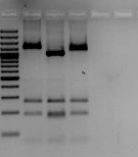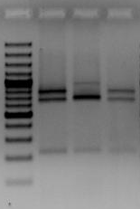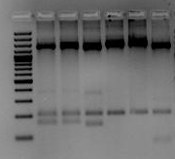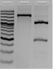
0124
(Date)

Calculation example

RsaI
10 000 U/ml thus 10 U/μl
There are 10 units in 1 μl
Thus 2 units is 0.2 μl
HhaI
20 000 U/ml thus 20 U/μl
There are 20 units in 1 μl
Thus 2 units is 0.1 μl

PCR buffer
C_{1.}V₁ = C_{2.}V₂
10 x X = 1 x 20
X = 2 μl

Figure 6. RFLP fingerprints of the rRNA intergenic spacer PCR amplicons of the eight Foclineages digested with restriction enzymes AvaI (A), BbvI (B), BceAI (C), Csp6I (D),BsrDI (E). A. Lane 1: 100-bp marker, lane 2: Lineage I, lane 3: Lineage II, lane 4: Lineage III, lane 5: Lineage IV, lane 6: Lineage V, lane 7: Lineage VI, lane 8: Lineage VII, lane 8: Lineage VIII. B. Lane 1: 100-bp marker, lane 2: Lineage VI, lane 3: lineage VII, lane 4: Lineage VIII. C. Lane 1: 100-bp marker, lane 2: lineage I, lane 3: lineage II, lane 4: Lineage III, lane 5: Lineage IV, lane 6: Lineage V, lane 7: Lineage VI, lane 8: Lineage VII, lane 8: Lineage VIII. C. Lane 1: 100-bp marker, lane 2: Lineage I, lane 3: Lineage II, lane 4: Lineage III, lane 5: Lineage IV, lane 6: Lineage V. D. Lane 1: 100-bp marker, lane 2: lineage I, lane 3: lineage II, lane 4: Lineage III, lane 5: Lineage IV. E. Lane 1: 100-bp marker, lane 2: Lineage III, lane 3: Lineage VI.

PCR amplification with Foc TR4 molecular markers:

To rapidly identify isolates of Foc TR4 (VCG 01213/16) in the Asian population, DNA of all isolates were amplified on an Eppendorf Mastercycler Gradient PCR machine using two sets of primers. These included FocTR4-F (CACGTTTAAGGTGCCATGAGAG) and FocTR4-R (GCCAGGACTGCCTCGTGA) developed by Dita et al. (2010), as well as VCG01213/16 F1 (ACG TTT AAG GTG CCA TGA GAG) and VCG01213/16 (CCT CGT GAG CCA CTT TTT AT) developed by Li et al. (2014). The PCR assay was conducted using 20 ng of fungal DNA in a total volume of 25 μl containing 0.8 times Buffer, 3.5 mM MgCl₂, 3 U Taq DNA polymerase, 0.26 mM dNTPs each, 80 ng.µl⁻¹ BSA and 0.2 μM of each primer. PCR cycle conditions for the Foc TR4 primer set consisted of 25 cycles at 94°C for 45s, 62°C for 45s and 72°C for 1 min. Each PCR was preceded by an initial denaturation step at 94°C for 5 min and concluded by a final extension step at 72°C for 5 min. The cycling conditions for the VCG 01213/16 primer set consisted of 35 cycles at 94°C for 45 sec, 64°C for 45 sec and 72°C for 60 sec. Each PCR was preceded by an initial denaturation step of 94°C for 5 min and concluded with a final extension step of 72°C for 5 min. As a positive control, a known VCG 01213/16 isolate (CAV 789) was included, as well as a non-template control. As a positive control, a known VCG 01213/16 isolate (CAV 789) was included, as well as a non-template control.

23532-4

1
2
3
4
5
6
7
8
9
10
11
12
13
14
15
16
17
18
19
20
21
22
23
24
25
26
27
28
29
30
31
32
33

Figure 7: PCR amplification of Fusarium oxysporum f. sp. cubense vegetative compatibility groups with the primer set VCG 01213/16 F1 and VCG 01213/16 R2. Lines 1. Ladder; 2. VCG 01213/16; 3. VCG 0120; 4. VCG 01215; 5. VCG 0120/15; 6. VCG 0121; 7. VCG 0122; 8. VCG 0123; 9. VCG 0124; 10. VCG 0125; 11. VCG 0124/5; 12. VCG 0126; 13. VCG 0128; 14. VCG 0129; 15. VCG 01210; 16. VCG 01211; 17. VCG 01212; 18. Ladder; 19. Ladder; 20. VCG 01213/16; 21. VCG 01213; 22. VCG 01216; 23. VCG 01217, 24. VCG 01218; 25. VCG 01219; 26. VCG 01220; 27. VCG 01221; 28. VCG 01222; 29-34. Non-pathogenic F. oxysporum; 30. No template control; 36. Ladder.

Additional information:

- The success of this technique relies on the fact that restriction endonucleases recognize specific DNA sequences (tetra-, penta-, hexa- or hepta-nucleotides) and then cleaves the DNA, either at a specific site or more random.
- There are two types of restriction enzymes namely type I and type II. Type I restriction enzymes recognise the specific target site and cleave the DNA several kilo bases upstream from this site. Type II restriction enzymes recognise the specific site and cleave the sample within or very near to the site. The results of restriction digestion with type II enzymes are then DNA fragments of defined length and sequence.
- Digestion of DNA with restriction enzymes will produce fragments with blunt ends or strands with overhanging ends also known as sticky ends.
- Each restriction enzyme functions at an optimal temperature and are inactivated once the temperature increases or decreases from the optimal temperature. Optimal usage temperature, as well as other important product information, is supplied by the company that sells the enzyme (see addendum).
- Methylation of host/target DNA can prevent DNA digestion.

References
Edel, V., Steinberg, C., Avelange, I., Laguerre, G., Alabouvette, C. (1995). Comparison of three molecular methods for the characterization of Fusarium oxysporum strains. Phytophatholoy 85: 579-205.
Old, R.W., Primrose, S.B. (1994) Principles of Gene Manipulation. Blackwell Science Ltd, Osney mead, Oxford, United Kingdom.
Reader, U. & Broda, P. (1985). Rapid preparation of DNA from filamentous fungi. Letters in Applied Microbiology 1: 17-20.
Sambrook, J., Fritsh, E.F. & Maniatis, T. (1989) Molecular cloning: A laboratory Manual. Cold Spring Harbour Laboratory Press, Cold Spring, Harbour, New York, USA.

METHODS FOR STORAGE OF F. oxysporum CULTURES

Storage on sterile filter paper

Method:
Filter papers disks (5 cm in diameter) are autoclaved in glass petri dishes. The disks are then aseptically placed on ¼-strenth PDA in petri dishes. Fusarium isolates are then cultured on CLA for 7-10 days. Rectangular agar pieces colonized by F. oxysporum (3 mm in diameter) are then placed on the sterile filter papers, and grown for 7-10 days, until the entire filter paper is covered by mycelia. The filter paper with fungal growth is lifted off the PDA, placed in sterile petri dishes, and left for 1 day to dry. It is then cut into smaller pieces (5 mm in diameter) and placed in cryovials. The cryovials are all clearly labelled with the isolate number, and stored at 5ºC until use.

Recommended period of storage: 3 months – 1 year

Storage on CLA slants

Water agar (WA) is prepared by dissolving 20 g agar in 1 L distilled water. The WA is then autoclaved at 121ºC for 20 minutes. After autoclaving, aliquots of 10 ml of the WA are poured into sterile 20-ml bottles under sterile airflow. The bottles are placed in a tray, and the tray kept at an angle of 45º untill the WA is solidified. A single sterile carnation leaf is placed on top of the agar. The isolate is then placed next to the carnation leaf on the water agar, and grown at 25ºC for 1 week. All cultures are clearly marked with the isolate number, and stored at 5ºC until further use.

Recommended period of storage: 3 months – 2 years

Deep-freezing

Method:
A 15% glycerol stock solution is first prepared and autoclaved. The F. oxysporum isolates are then grown on ¼-strength PDA plates at 25ºC for 7-10 days. Ten ml of the 15% glycerol are then pipetted onto the fungal growth in the petri dishes in a sterile flow cabinet. The spores and some hyphae are carefully dislodged with a surface-sterilised scalpel. One-ml-aliquots of the spore suspension are then pipetted from the petri dishes into 2-ml cryovials. Each of the cryovials are carefully labelled, placed into cryovial boxes and stored at –80ºC. When the isolate needs to be recovered, small quantities of the frozen susenspion is scraped from the cryovial with a sterile scalpel, and placed onto the culture medium.

Recommended period of storage: Up to 5 years

Storage in soil

Method:
Soil is first sterilized in small glass bottles or tubes. The cultures are then grown on ¼-strength PDA plates for 7-10 days. Sterile distilled water (20 ml) is poured onto each culture in a flow cabinet, and the spores discretely dislodged with a surface-sterilized scalpel. Ten ml of the fungal spore suspension is then pipetted from the petri dishes, and aseptically transferred onto the soil in the glass pottles and the tubes. All the glass tubes and bottles are clearly marked with the isolate number, and stored at room temperature. The isolate is recovered by placing a small amount of soil onto culture medium.

Recommended period of storage: Up to 5 years

Lyophilization of Fusarium cultures

Reference:
Nelson, P.E., Toussoun, T.A. and Marasas, W.F.O. 1983. Fusarium species: An illustrated manual for Identification. The Pennsylvania State University Press, University Park, PA, USA.

Method:
Isolates to be lyophilized are grown on carnation-leaf agar in petri dishes for 7-10 days. Several colonized carnation-leaf pieces are then transferred to each of five replicte sterile 5-ml glass vials labelled with the isolate number. A 0.5-ml aliquot of sterile skim milk is added to each vial. The vials are then stoppered with split rubber stoppers, which allow for evacuation of air. The stoppered vials are placed in a tray and quickly frozen by pouring liquid nitrogen into the tray. A Lucite plate slightly larger than the tray is placed on top of the partially stoppered vials.

A drying chamber on a refrigerated freeze-dryer is used for lyophilization. He tray is placed on the pre-cooled shelf in the drying chamber, and a vacuum is pulled. When refrigeration is completed, the heat is turned on, while the samples dry gradually. After lyophylization, the vials are sealed under vacuum by inflation of the rubber diafragm in the chambers over the tray, which presses down the Lucite plate and forces the rubber stoppers to seal the vials. After lyophylization, vials are capped and labelled, and the vials stored at –20ºC.

Recommended period of storage: Up to 20 years
CULTURE MITES AND MYCOLOGY LABORATORY HYGIENE

The following notes have been adapted from “Fungi and Food Spoilage” by John Pitt and Ailsa Hocking, CSIRO Division of Food Research, Sydney. 1985. Academic Press.

Culture mites

A major hazard in growing and maintaining fungal cultures is the culture mite. Many species of mites live on fungal hyphae as their main or sole diet in nature, and find culture collections an idyllic environment. Mites crawl from culture to culture, contaminating them with fungi and bacteria as they go, or, given long enough, eat them entirely.

Mites are very small (0.05 to 0.15mm long), usually just visible to the observant naked eye. They are arachnoids, related to spiders. Each mite leaves a trail of eggs about half-adult size as it moves. Eggs hatch with 24 hours, and reach adulthood within 2 or 3 days. The damage an unchecked mite plague can do to a bacterial or fungal culture collection is enormous and they represent and real threat to culture collections.

The most common sources of mites are plant and soil specimens, contaminated fungal cultures and mouldy foodstuffs left in laboratories and near incubators. Mites can also be carried on large dust particles. Building work near a laboratory almost always induces a mite infestation – be on the look out!

The avoidance of losses due to mites requires constant vigilance. Always watch for telltale signs, such as contaminants growing around tile edges of a Petri dish, a ‘moth-eaten’ appearance to colonies or ‘tracks’ of bacterial colonies across agar. Examination of suspect material or cultures under the stereomicroscope will readily reveal the presence of mites and mite eggs.

Freezing rapidly kills adult mites, and mite eggs will only survive 48 to 72 hours at -20°C. Cultures contaminated by mites can often be recovered by freezing for 48 hours, and then subculturing from uninfected portions of the culture with the aid of the stereomicroscope.

Infestation by mites can be minimised by hygienic laboratory practices (eg. avoiding accumulation of dust or old cultures in the laboratory). It is also good practice to handle and store food, plant and soil samples in a separate area to where fungi are inoculated and incubated. Subculture all plates at least every 2 weeks (eg. your Nit M tester and CLA culture collections).

To control a mite plague, remove all contaminated material, including cultures. Freeze Petri dishes and culture tubes; autoclave, steam or add alcohol to all others. Clean benches thoroughly with sodium hypochlorite (approximately 3%) or 70% ethanol. Incubators can be disinfested with aerosol insecticides or a solution of thymol in alcohol (alcohol alone does not kill mites).

Hygiene in the mycological laboratory

Like any other microbiological laboratory, a mycological laboratory should be kept in a clean condition. Discard unwanted cultures frequently, and dispose of them by steaming or autoclaving- practical plant pathologists are in the business of controlling diseases, not spreading them around! Wipe bench tops regularly with ethanol (70% to 95%). Laboratory floors and associated walkways should be frequently wet-mopped, or polished only with machines equipped with efficient vacuum cleaners and dust filters. Where possible, store food, plant and soil materials away from the laboratory. Open Petri dishes carefully. Transport Petri dishes to the stereo microscope stage before removing lids. Transport culture plates in sturdy containers with lids and wipe with ethanol (70% to 95%) before and after each use.

Contrary to popular belief, a well-run mycological laboratory is not a source of contamination to bacteriological laboratories. The air in a mycological laboratory should not carry a significant population of fungal spores if correct procedures are followed. The reverse problem can occur, however, because bacteria multiply much more rapidly than do fungi. Bacterial spores are often present in food laboratories, readily infect fungal plates, and can rapidly outgrow and inhibit the formation of fungal colonies in vitro.

If for any reason fungal spore concentrations do build up in a laboratory and cause an unacceptable level of contamination, the air should be purified. The simplest technique is to spray with an aerosol before the laboratory is closed in the evening. Any aerosol spray, such as a room deodoriser or air freshener, is effective. Aerosol droplets entrain fungal spores very efficiently and carry them to the floor. A more drastic and effective treatment in cases of severe contamination is to spray a solution of thymol in ethanol around the room, and close it for a weekend. The spray is rather pungent, and while not harmful to humans, it effectively kills fungal spores (and mites).

VALUABLE ADDITIONAL READING

Beckman, C.H. 1987. The nature of wilt disease of plants. The American Phytopathology Society, St. Paul, MN.
Booth, C. 1971. The Genus Fusarium. Commonwealth Mycological Institute, Kew, Surrey, England.
Nelson, P.E., Toussoun, T.A. and Marasas, W.F.O. 1983. Fusarium species: An illustrated manual for identification. The Pennsylvania State University Press, London.
Ploetz, R.C. 1990. Fusarium wilt of bananas. ASP Press, St. Paul, Minnesota, USA.
Nelson, P.E., Toussoun, T.A. and Cook, R.J. 1982. Fusarium: Disease, Biology and Taxonomy. Pennsylvania State University Press.
Snyder, W.C. and Hansen, H.N. 1940. The species concept in Fusarium. American Journal of Botany 27: 64-67.
Stover, R.H. 1962. Fusarial wilt (Panama disease) of bananas and other Musa species. Commonwealth Mycological Institute, Kew, Surrey, UK.

