HOW TO REVISE YOUR ONLINE REC FORM

Below is a table of contents which shows you all the steps you need to follow to revise and resubmit your online application.
READ THE INSTRUCTIONS CAREFULLY TO AVOID UNNECESSARY DELAYS.
Contents
1. Sign into the online system: https://applyethics.sun.ac.za 2
2. Scroll down to Projects and click on the project title you want to edit 2
3. Scroll down to the form’s section list and click on the sections you need to edit (also see screenshot below) 2
4. Attach your Response/cover letter to section 9.2 of the online form 3
5. Final step: Submit your form for review (also see screenshot below) 4
6. How do I know my form has been submitted? 4

Sign into the online system: https://applyethics.sun.ac.za
If you experience issues logging in or need a reminder on how to log in, please download the Sign-in Troubleshoot guide available here: [DOWNLOAD]

Scroll down to Projects and click on the project title you want to edit

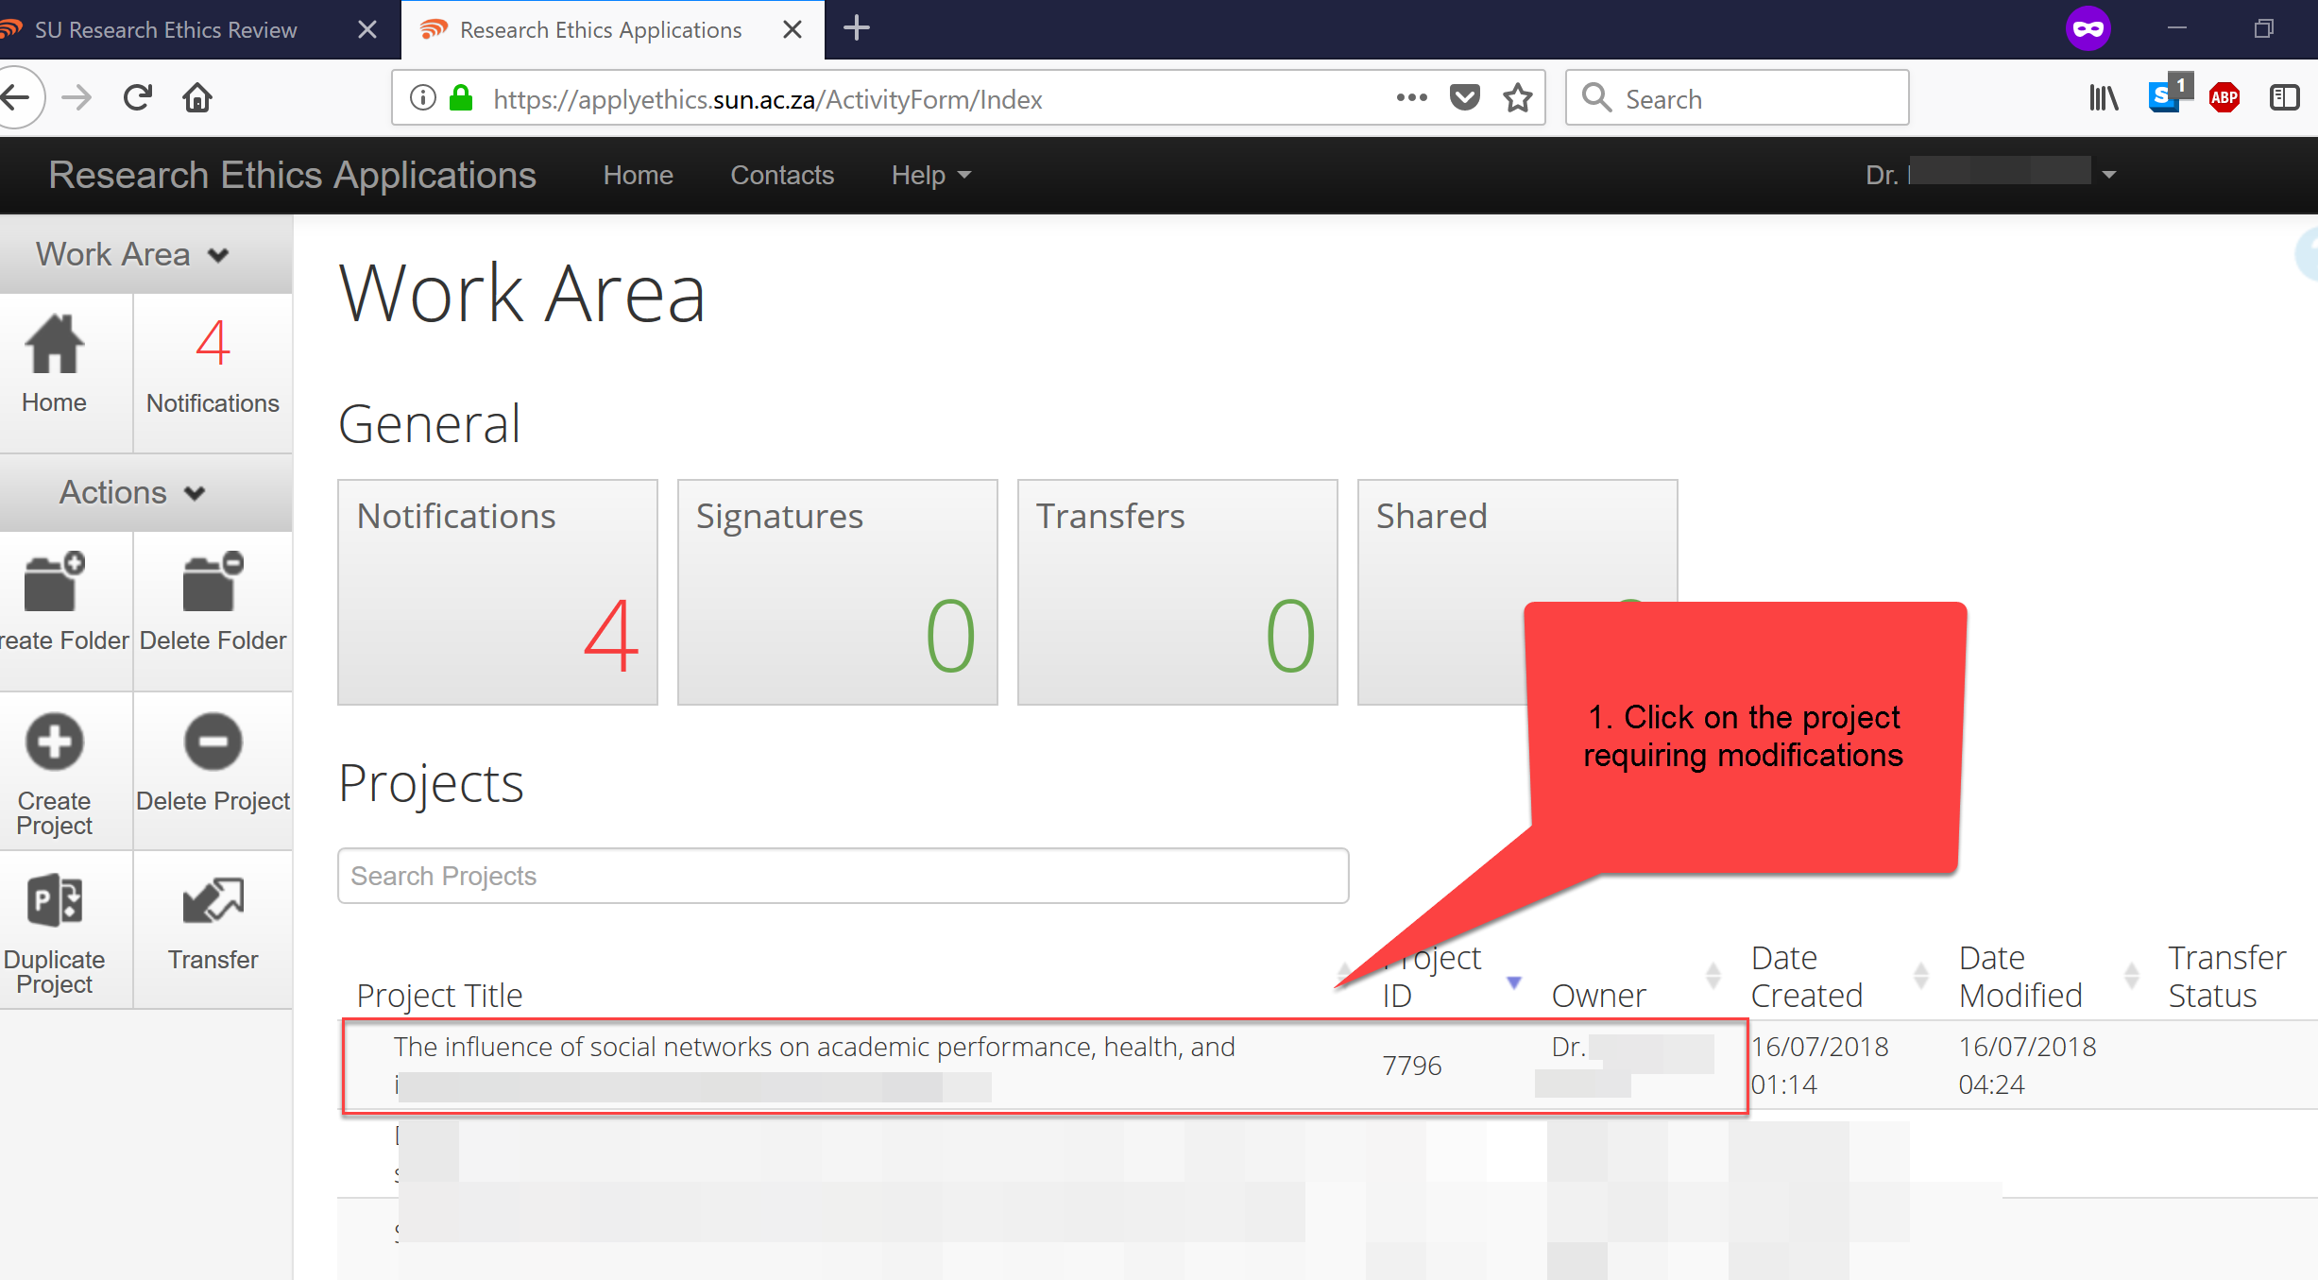

Scroll down to the form’s section list and click on the sections you need to edit (also see screenshot below)
3.1) If you need to revise an attachment or document uploaded to the application form, please delete the original attachment first and then upload your revised attachment.
3.2) Please remember to highlight the revised sections in the attachment so that it is convenient for the reviewer to find the revised content.
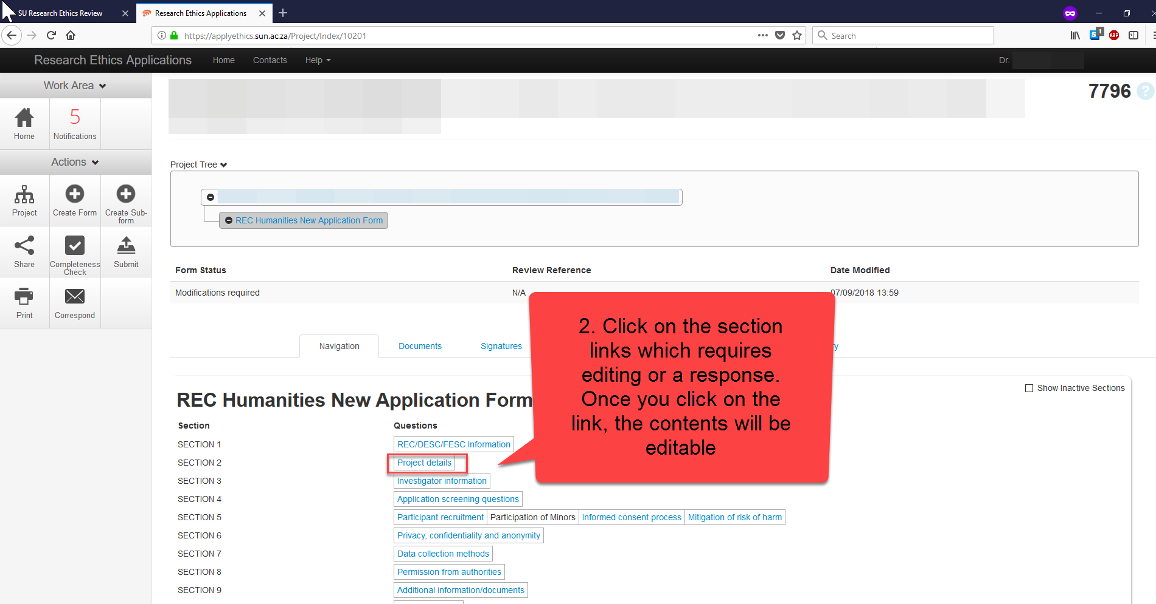

Attach your Response/cover letter to section 9.2 of the online form

4.1) Why do I need to attach a response letter?
The response/cover letter assists with expediting the review of your revised form. By including a response letter, you guide the reviewer to the specific section(s) that you have revised. It also gives you the opportunity to explain or motivate the reason(s) for your response/revision. Please ensure that you write your response in a numbered-format (based on the numbering of the comments in the feedback letter) and that you indicate which section, or page number you made your edits to the form/attachments.

4.2) To download a template for such a response/cover letter, please click here: [DOWNLOAD HERE]

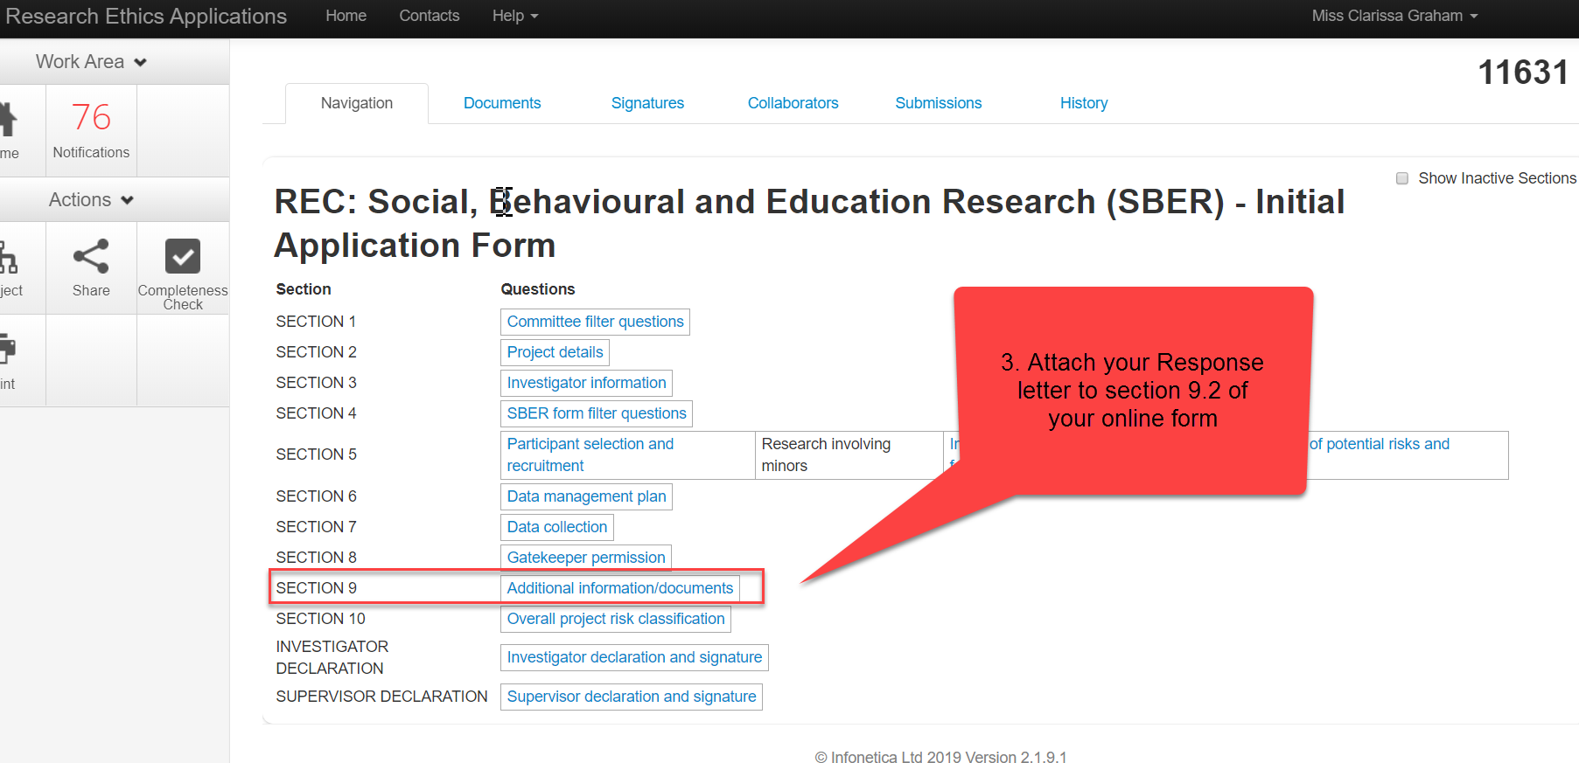

Final step: Submit your form for review (also see screenshot below)
The application system is set up to automatically submit your online form to the committee after all required signatures are in place.

5.1) To submit your form, please sign the INVESTIGATOR DECLARATION section.

5.2) If you are a student, you will need to sign the INVESTIGATOR DECLARATION section AND you need to request your supervisor’s signature in the SUPERVISOR DECLARATION section.

Your form will only be submitted after both you and your supervisor have signed the form.

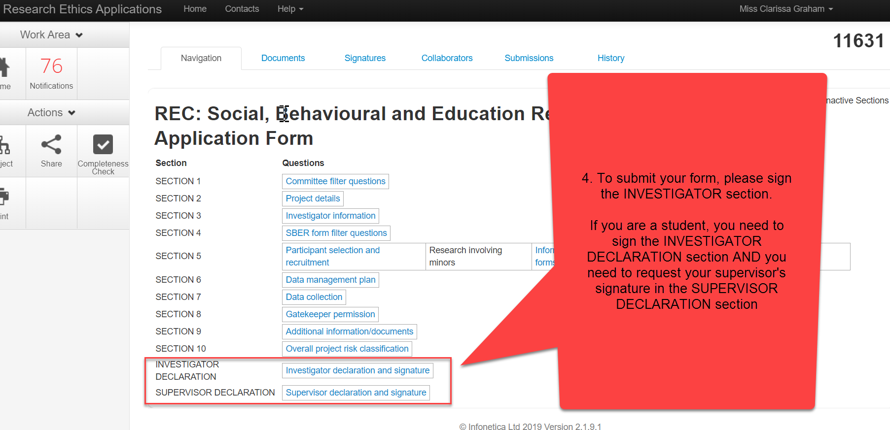

How do I know my form has been submitted?
The system will send you an auto-generated email confirming the successful submission of your application.

STUDENTS REMEMBER, the system will only send this confirmation email AFTER both you and your supervisor have signed the form. If you do not receive such an email within 3-4 days, please follow up with your supervisor.

If you do not receive the submission email, please contact the REC helpdesk for assistance: applyethics@sun.ac.za.

Below a screenshot of what the system email will look like:

