Name: | Grace Mngadi
Portfolio: | Womxn and Queer Empowerment
Subject: | Quarterly Report – Term 2/3 (2020)
Email Address: | 22671439@sun.ac.za
UNIVERSITY OF STELENBOSCH – SRC MANAGERIAL REPORT

Contents
Constitutional Responsibilities 3
Portfolio Overview 3
Budget Overview 4
Term Overview 4
1. The Impact of COVID-19 4
2. WAQE Design 5
3. WAQE Instagram Accounts 5
Instagram Accounts’ Objectives 5
Instagram Account Biographies 6
Instagram Account Stories 6
WAQE #UNFILTERED 6
4. Matie Media 7
5. Pride Month 7
6. Working Groups 8
7. Residences/ PSOs and AGBV 8
8. WAQE – USDU Debate 9
Plans for the Next Academic Term 9
1. Residences/PSOs and GBV 9
2. Women’s Day 10
3. Collaborative Campaigns 10
Recommendations for Portfolio Improvement 10
Important Contacts 10
Committee 10
Other 10

Constitutional Responsibilities
- Attend at least one SRC meeting per term
- Attend office duty sessions allocated by Secretary General

Portfolio Overview
“This portfolio aims to actively diminish institutional patriarchy, end rape culture and gender-based violence, encourage the upliftment of womxn, empower queer bodies, educate students on matters relating to gender inequality, and support overall equity on campus. The foundation of the portfolio is the encouragement of human dignity. It aims to provide a safe and equitable space on campus for all womxn and queer communities at Stellenbosch University, and the broader South African community.”
The mission statement of this portfolio is an overall, long-term end-goal being worked towards. Its aims cannot be created overnight but must be worked towards continuously through various methods and steps. The goals of the portfolio have been worked towards in the following ways this term, of which further details explained under “Term Overview” later in this report:
- “Actively diminish institutionalized patriarchy, end rape culture”:
  - The university is one institution in which a lot of smaller bodies co-exist. This term has focused on unpacking the institutionalized patriarchy that exists in residence spaces, security policies, and accountability structures at the university.
- “End […] gender-based violence”:
  - Each member of the WAQE Executive committee continues to sit in a designated Anti-Gender Based Violence Working Group, in order to continuously raise concerns of students and ensure Internal accountability.
- “Encourage the upliftment of womxn, empower queer bodies”:
  - Our Instagram account is aimed at empowering individuals through motivational quotes, educational resources, and providing a sense of community by highlighting peers in the community that have empowered those respective communities.
  - Our #UNFILTERED series on our social media stories encourage students to voice their unfiltered thoughts, which in turn empowers them to have a platform to speak and holds us accountable.
  - Pride month was celebrated through daily educational content in our stories
- “Educate students on matters relating to gender inequality”:
  - Our Instagram account continuously posts educational resources. A linktr.ee portal has been created in order to solidify a mix of educational sources we have shared with other resources we have been given through various other sources.
- “Support overall equity on campus”:
  - WAQE openly supports the Anti Gender-Based Violence Movement of Stellenbosch University
  - WAQE openly engages with topics related to social justice, and intersectional ideas such race (#BlackLivesMatter was particularly focused on this term)
- “Provide a safe and equitable space on campus for all womxn and queer bodies at Stellenbosch University and the broader […] community”:
  - Due to the effects of COVID-19, creating a physical safe space is near impossible. Resources have been shared via our Instagram account on ways to assist in making your home environment safer, ways to protect yourself in physically unsafe spaces, and ways that allies can create general safe spaces for gender-minorities.
  - Virtual safe spaces are being constructed with the assistance of Campus Security, our internal events coordinator, the Equality Unit, and the Safety and Security SRC Managerial portfolio.

Budget Overview
The following expenses occurred this term:
- WAQE-USDU Collaborative fundraiser for Queer theory awareness and COVID19 solidarity: R237

Term Overview

The Impact of COVID-19
Due to COVID-19, all of WAQE’s events have either been cancelled, postponed, or changed to a more suitable platform. All events for the rest of the year will be done virtually insofar as it is reasonable to do so. Due to the nature of the topics engaged with under this portfolio, open events have been tricky to plan because there are a number of technicalities behind the creation of virtual safe spaces. WAQE must do everything reasonably possible to ensure that members of various online communities cannot make spaces unsafe through inequitable comments and other problematic behavior. Our internal events coordinator has compiled a document on various precautions that can be taken in order to better the safety of online events. We hope that this can implemented in time for our Women’s Day event.

WAQE Design
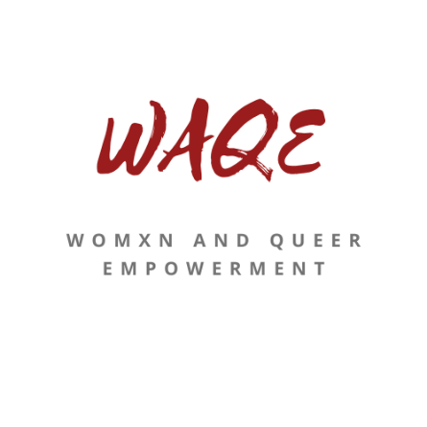
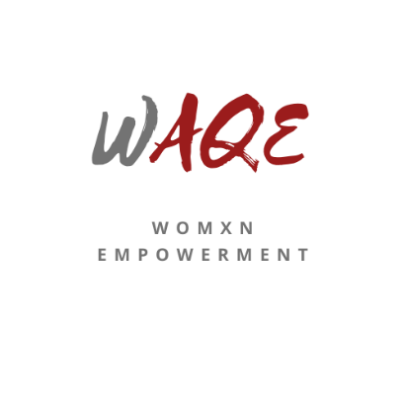
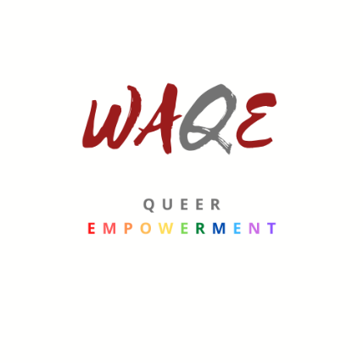
The WAQE Executive committee created a new design for the WAQE portfolio. This was done after a number of meetings and after consulting the university’s guidelines. Below are the designs for the WAQE logos:

WAQE Instagram Accounts
WAQE launched two separate Instagram accounts on 14 April 2020. The womxn empowerment account (@waqe_womxn) and the queer empowerment account (@waqe_queer) are separate because they speak to completely different communities, and because this further allows for an easy handover when the managerial positions are separated.

Instagram Accounts’ Objectives
Both Instagram accounts’ main posts have the same structure, albeit with varying themes, colours and designs therein. They follow a three-by-three aesthetic, by which each column focuses on a component of empowerment. These are:
- Inspiration - Empowerment through the recognition of community leadership:
Here, a sense of community is further created by acknowledging leaders of these respective communities. The fight towards an equal society occurs in many forms and largely exists outside of formal leadership structures. Stellenbosch students are thus recognized for the work that they do toward empowerment, so that they feel supported by the SRC, so that fellow students know who else they can rely on for content, so that these leaders feel celebrated and appreciated by the institution, and so that the student community as a whole feels less alienated from the SRC.
- Education - Empowerment through knowledge and resources:
Here, educational resources are shared. These resources either educate people by means of sharing facts or by sharing links to articles that assist in the creation of a safe and inspired society.
- Motivation - Empowerment through motivational encouragement:
Inspirational quotes are posted in order to encourage members.

Instagram Account Biographies
Our account biographies include the following:
- SRC Womxn (Queer) Empowerment at SU: Our position within society as a body
- Education. Encouragement. Support. Accountability.: The values that govern the Instagram account, drawn from the overall objectives of our mission statement
- Linktr.ee/waqe_womxn (or Linktr.ee/waqe_queer): A compressed link with all the shared resources, seeing as these are often suggested links that need to be further opened.

Instagram Account Stories
Our account stories mainly include:
- Informative re-posts, that relate to the content on our pages, from other Instagram accounts.
- During more content-heavy and continuous threads, our stories are also used (see “Pride Month” below as an example).
- Fun and interactive questions for people to share their knowledge on certain pop-culture topics

WAQE #UNFILTERED
WAQE #UNFILTERED is an initiative taken for students to better engage with the portfolio, by sharing their unfiltered concerns and suggestions. These are anonymously shared on our stories, and the portfolio then takes the initiative to assist the students in this regard, without giving any overly filtered and shallow response. It enables us to better gage what students want from us, without being alienated as SRC portfolios can sometimes become. Anonymously posting these replies shows that we publicly recognizing the issues that students have, whilst cultivating a culture of accountability and transparency. Our door is always open to suggestions and concerns, but reminders of our #UNFILTERED approach are given on our stories when there are specific societal uproars about specific issues, so as to provide a channel for these concerns.

Although the aforementioned aesthetic is used, sharing raw views and taking action is more important. We thus decided to disrupt our feed in order to engage on the following issues:
- Both accounts:
  - Black Lives Matter – A statement was released in the form of an unfiltered stance against the unfair discrimination of persons of colour
  - Virtual protest against GBV - #YouthDayShutdown
- Womxn’s Account:
  - The Silence of Men and Men’s residences – In response to a number of concerns by students as to the silence of men in relation to gender-based violence, an unfiltered thread was posted. This thread was a “guide” on how to be a better ally to the AGBV movement. It called out men’s residences for their silence specifically. This was reposted on the official Anti-GBV SU Movement’s Instagram account.
- Queer Account:
  - Pride – A re-affirmation that members of the queer community should feel proud every day, even outside of the designated Pride month.

Matie Media
After the “revamp” of the portfolio (in respect to the logo, increased engagement and visibility, and Instagram page) Matie Media wrote an article.
https://www.matiemedia.org/src-revamps-portfolio-to-empower-women-and-queer-students/

Pride Month
Our original plan for Pride Month was to host Stellenbosch’s first Pride Day festival. Because this could not happen due to COVID-19 restrictions, our Instagram stories followed the Pride month calendar, and shared educational content on each queer identity. This often included definitions, flags, histories, related organizations, and icons of that identified community. These have been highlighted in our stories for easy access in the future. We also encouraged students to follow events held by QueerUS society, who had amazing events planned in collaboration with similar structures at other universities.

Working Groups
The WAQE Executive Committee sits on all Anti-GBV Working Groups. During this term, each working group created their final report to hand over to the Rectorate. We will have a meeting will be had next term to reflect on the outcome of these working groups and what we can do to ensure its sustainability.

Residences/ PSOs and AGBV
WAQE is currently in the middle of an internal investigation on residences, their policies, their structures, and their cultures. Whilst we acknowledge the work of the aforementioned working groups, we have noted that a large degree of student perspective is missing. Thus, WAQE is engaging with residences who are willing to engage, in order to get a better idea of the following:
- What residences have done fulfill the promises they made upon signing the Anti-GBV residence memorandums in September last year? Further, what can the SRC do to further assist them in achieving these goals?
- Where have student leaders in residences and PSOs felt as they have been limited in their efforts to combat GBV due to the failure of the university?
- What changes have they made that had a huge positive impact on the residence culture?
- Where do they believe the disjointedness between the values projected and the values received by students, lay?
- What mechanisms have been put in place in order to ensure sustainable cultural changes withing the residence spaces?

The objective of this investigation is to get a better insight as to the cultures of the residence spaces. It is a method to both hold residences accountable to positive change, whilst ensuring that residences have access to the SRCs resources to achieve these changes. At the end of this investigation, a small internal report will be written. This report has no direct formal weight, but will rather aid in the creation of the following:
- A list of recommendations to all relevant structures in ways that they can assist student leadership structures and residences in having a more fruitful impact on students. This will include a list of policy concerns in relation to the university’s role in bettering residence culture.
- A list of recommendations to incoming House Committee and other relevant student leadership structures on initiatives that have been tried by other residences. This will serve as a method to share ideas on ways to combat gender-based violence. This will hopefully include a list of general resources for them to reference when trying to orientate themselves in their new positions.
- An internal recommendation as to the continuation of residence and PSO engagements with GBV related matters.
The above-mentioned documents will be made publicly available where possible. Other issues and suggestions have been raised that fall outside the scope of this task, which have been followed up separately. These were suggested in confidence, and so the outcomes thereof will be shared when possible, and in the handover report at the end of next term.
Residences that have not engaged with us in this initiative, or vis our social media initiatives, will be made note of so that there can be a track record. If other bodies struggle to get engagement from these residences, this can serve as proof of their lack of willingness to engage. This seems particularly fair considering encouragement for house committee members to engage with WAQE was also given by Pieter Kloppers as the head of CSC and by the Prim Committee.

WAQE – USDU Debate
Given the context, WAQE had a collaborated debate on Instagram Live with the University of Stellenbosch Debating Union. This event was done to raise money for Solidarity Fund by donating R1 each for every viewer present, to engage on nuanced topics related to the queer-community, and to generally raise awareness. The motion was, “This house believes that the queer community should actively dismantle heteronormative social norms (e.g. the nuclear family, the importance of marriage, monogamy, etc.)”. It was a huge success. We donated R237 for 237 viewers. The comments were flooded with engaged viewers.

Plans for the Next Academic Term

1. Residences/PSOs and GBV
WAQE will continue working on the planned outcomes from residence engagement. We are further hoping to work with management structures on the formation of a possible online-orientation and topics related to gender-based violence.

2. Women’s Day
We are planning on a women’s week to take place virtually, seeing as there is no way for our original plan to take place.

3. Collaborative Campaigns
We are currently working on 4 main campaigns which will hopefully be completed within our last term:
- WAQE is working with the Equality Unit on a more friendly guide on what to do when you have experienced gender-based violence. It was noted that the current guide is too dense and does not seem to be easily accessible. This campaign will simply be a victim-orientated pamphlet on what to do to easily access support from various places, whilst leaving out the information that may unnecessarily overwhelm victims.
- WAQE is working with the Human Resources department to host a workshop for lecturers on how to teach content more inclusively.
- WAQE is working with the Equality Unit on a series that will go on their social media that will be used to “break the stigma” on a variety of issues relating to gender norms.
- WAQE is working with the Safety and Security portfolio and other institutional bodies on an online safety workshop.

Recommendations for Portfolio Improvement
This portfolio needs to improve on its mission to assist the “broader South African community”. I also think that the portfolio needs to work on more ways to better its social media following.

Important Contacts

Committee
- Secretary and Treasurer: Nicole Thompson (24261793@sun.ac.za)
- Events Co-Ordinator: Tamara Foyn (21556164@sun.ac.za)
- Public Relations: Amy Nelson (23733861@sun.ac.za)
- Critical Engagements: Kgalalelo Rakgokong (21706212@sun.ac.za)
- Project Assistant: Nailah Ebrahim (23072776@sun.ac.za)
- Campus Engagement: Alexandra Osborn (23721618@sun.ac.za)

Other
- Niel de Kock: Prim Committee Administration 2020 (nieldekock13@gmail.com)
- Thulani Hlatswayo: Student Governance Coordinator (thulani@sun.ac.za)
- Katlego Letlonkane: Employment Equity and the Promotion of Diversity (letlonkane@sun.ac.za)
- Choice Makhetha: Director of Student Affairs (choicemakhetha@sun.ac.za)
- Grace Mngadi: Chairperson of USDU (usdv@sun.ac.za)
- Chante: Chairperson of QueerUS (0745744006)
- Kaylon Weppelman: Equality Unit’s Centre for Student Counselling (18494463@sun.ac.za)
- Nadine Christians: Equality Unit’s Media and Marketing (nchristians@sun.ac.za)
- Fanele Ndebele: Centre for Student Leadership and Structures (fanele@sun.ac.za)

