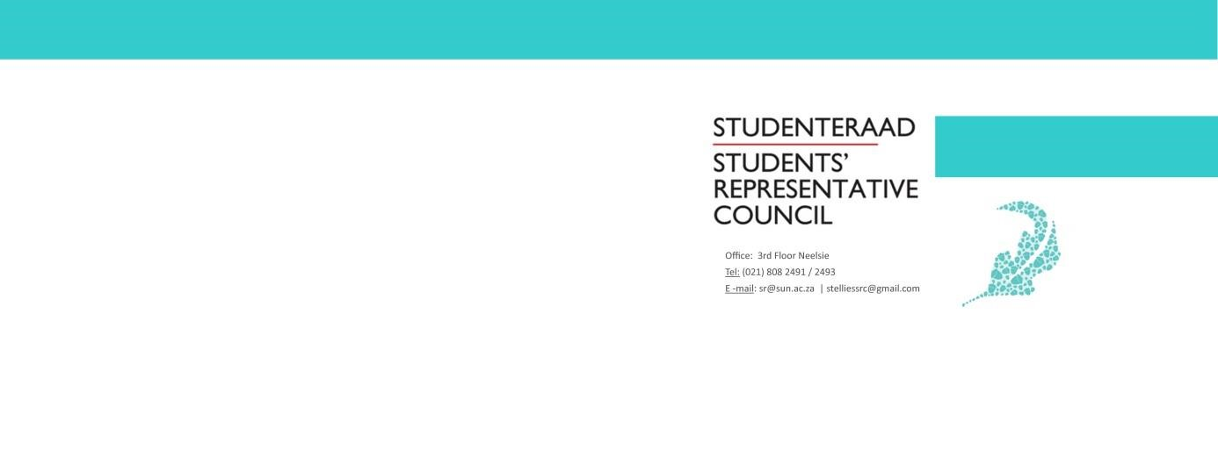
AGENDA
Student Representative Council Meeting
Date: 11 February 2020
Time: 17:30-19:30
Venue: SRC Office

- Welcoming Lewis
- Managerial Portfolios
- SRC Portfolios
- General Points
- Closing Lewis

