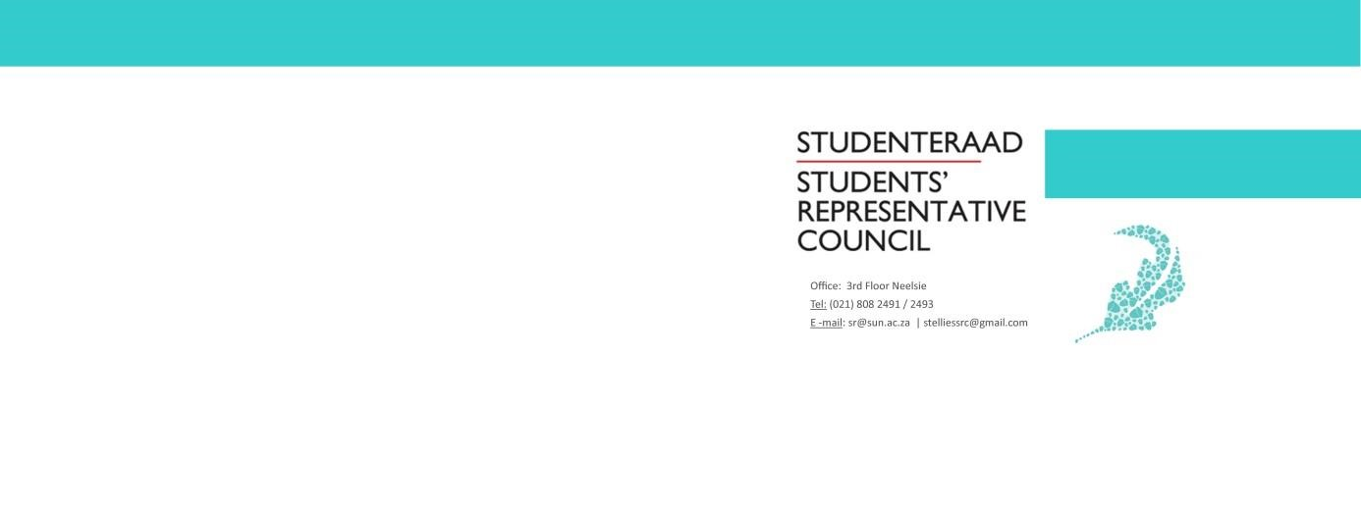

AGENDA
Students’ Representative Council Meeting
Date: 06 MAY 2020
Time: 17:30-19:00
Venue: Goldfields Conference Room

- Welcoming Lewis
- Attendance Fadeelah
- Approval of previous minutes Fadeelah
- Setting of the Agenda Fadeelah
- Feedback
  - Prim Committee Standing Point
  - Academic Affairs Council Standing Point
  - Societies Council Standing Point
  - TSR Standing Point
  - Military Academy Standing Point
- Voting
  - Scraping of Student Access as an SRC portfolio by the Executive Committee.
- Discussion
  - Registration Debrief: Tygerberg Ntsako
  - Code Of Conduct Wama
  - Managerial Portfolio’s Wama
  - Election Convenors and Disciplinary Committee Wama

- General Points
- Next Meeting Fadeelah
- Closing Lewis

