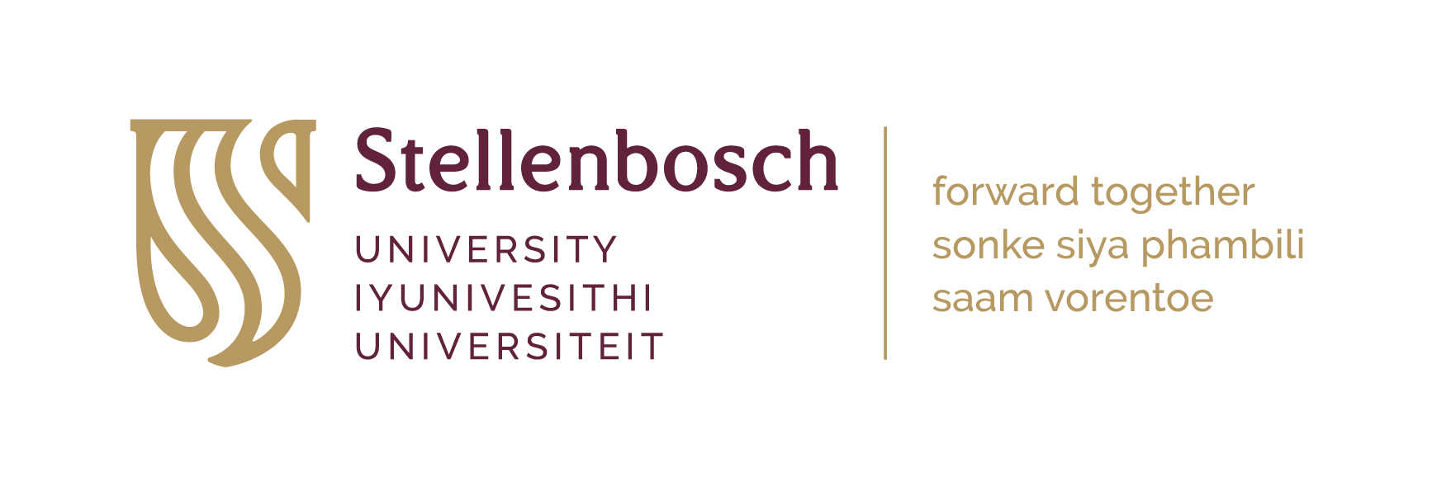
PGO Overseas Conference Grants

Terms and Conditions

PURPOSE OF GRANT

- The PGO Overseas Conference Grant (OCG) is a supplementary award to attend an international conference outside of South Africa to present a paper or poster.

CRITERIA

- Final-year Master’s and Doctoral students may apply. Applications should not be full-time employed (working for more than 20 hours a week).

- The support should supplement grants provided by other sources, as this award should not exceed 50% of the total budget to a maximum of R17 500.

- The applicant should submit proof of the acceptance of the presentation by the conference organizers.

- An applicant will only be eligible for a grant once during his/her postgraduate studies.

Preference will be given to:

  - Applicants with no funding from other grant schemes
  - Applicants invited to deliver oral presentations.
  - Applicants who have not attended other international conferences abroad during the past two years.

- NRF Scholarship holders who are eligible for the NRF travel grant will not be considered for the PGO Overseas Conference Grant.

- If more than one applicant from the same Department applies for this support to attend the same conference, only one award will be given to the Department, and funding could be awarded at the discretion of the Dean and relevant Chair, either to one of the applicants, or divided among applicants.

- A scanned version of the application form with signatures and the required CV must be submitted electronically to postgradfunding@sun.ac.za.

- Only applications for the relevant award cycle will be considered (see dates of the award cycles and corresponding closing dates on the application form).

- The applicant must ensure that the application form is complete, with all the required documents attached. Incomplete applications will not be considered.

Please note that the awards are made on a competitive basis and that funding is available.

FUNDING

- The OCG will not exceed R17, 500, and/or will not be more than 50% of the budget.

- Supplementary funds should be sought from other sources.

- Proof of price quotations (e.g., flights, hotel accommodation, and conference registration fees) should be attached to the application.

REPORTING

- Kindly note that recipients must submit a short report within ONE month of returning from the overseas trip.

AUTHORISATION

- Application forms must be signed by the Head of Department or equivalent manager or supervisor. Unsigned forms will not be accepted.

Please note that it could take up to 3 weeks for funding decisions to be announced.

For further information, contact:
Nugent Lewis
Deputy Director: Postgraduate Office
Room 3015, Wilcocks Building
Tel: (021) 808-2957
E-mail: nugent@sun.ac.za

