What to include when writing a Standard Operating Procedure (SOP)

This template is to be adapted to particular processes for individual labs. Where examples are given (in blue text), these MUST be adapted to suit your specific purpose, procedures and environment – do not just copy and paste. A specific SOP may need more sections than what are listed below. Once completed, a signed copy should be kept in the lab with documentation that researchers have reviewed and will comply with the approved document.

A well-written SOP will facilitate accuracy, reproducibility, safety and training, and should contain sufficient detail to ensure that someone with limited experience or knowledge of the procedure, but with basic understanding, can successfully carry out the procedure in a safe manner when unsupervised. It should be written in a concise, logical, step-by-step and easy to read format.

SOPs should be written by a person who has good knowledge of the task.

**Figure 1.** SOP review in context of overarching REC: BES process. Facility registration is first approved, and then projects (with SOPs embedded within projects). Where SOPs are common to more than 1 project, and were previously approved (without subsequent changes), then they would not need review. Previously approved SOPs do not need to be submitted again; approval numbers can be provided in supporting information section.

Section 1: Title page

The **front page** of the SOP should include the information:

* *Clear title*
* *SOP number*
* *Version number*
* *Number of pages*
* *Effective Date and next review date*
* *Names of author and reviewer(s)*
* *Name and signature of final approver*
* *Document number*
* *Table of Contents*

Section 2: SOP Version History

*This section must contain the history of the document from creation to archiving. It is also advisable to include a statement addressing how version control is managed in your environment.*

*EXAMPLE (of version control statement):*

"The latest REC-approved version of this SOP is available at: [provide URL and/or physical location]

This SOP must be accessed only directly through the above URL and/or physical location to ensure the correct version is used. NOTE: Do not “Google Search” nor ask a colleague for a copy as older, incorrect versions of the SOP document may be accessed.

The onus is on the SOP user to ensure they are working to the correct version of this SOP.”

*EXAMPLE (of document history):*

|  |  |  |  |  |
| --- | --- | --- | --- | --- |
| **Version No.** | **Date** | **Location of Change / History** | **Author/**  **Reviewer** | **Approving Official** |
| 1.0 | 23 MAY 2019 | *Document Created* | L Green(Postdoc)/ Dr N Red (Senior Scientist) | L Orange (QA) / M Blue (Laboratory manager) |
| 2.0 | 13 AUG 2021 | *Transferred SOP to new template; responsibilities and risk assessment made more comprehensive; changes made throughout. Added processing laboratories and waste disposal references.* | Dr L Green (PostDoc) | Prof N Red (PI and senior scientist) |

Section 3: Scope / Purpose of the SOP

*Provide a* ***brief*** *description of the work in this section*

*EXAMPLE:* This SOP describes the steps involved in culturing *Mycobacterium smegmatis*, under BSL2 conditions.

Section 4: Definitions and Abbreviations

*This section can be used to describe unusual or specialized terms and abbreviations.*

*EXAMPLE:*

PPE – Personal protective equipment

µl – microliter

O/N – Overnight

ml – milliliter

Section 5: Applicable Regulatory Requirements

*What guidelines and regulations apply to this work, e.g. Section 20 from DALRRD, GMO certification etc. Enquire with the REC: BES co-ordinator if you are unsure which apply. If available, you can also reference your REC:BES facility registration number here, as well as HREC, REC: ACU, as applicable.*

Section 6: Responsibilities

*Indicate who is doing what. Do not use people’s names if not necessary as those change. Rather use job titles e.g. laboratory manager, research assistant, student etc., see example below:*

*EXAMPLE:*

|  |  |
| --- | --- |
| **Responsible Person(s)** | **Responsibility** |
| ***Example:***  Laboratory Manager | * Ensure all persons who perform this procedure have documented training and competency prior to doing so; * Ensure that the equipment used in this procedure are maintained and in a safe working condition; * Ensure that this procedure is reviewed as per schedule and that new versions are issued when changes are made; * Ensure that all regulatory requirements are in place for this procedure. |
| ***Example:***  Students and Personnel | * Ensure that they are trained and competent in this procedure, and that they have signed this SOP prior to any work performed; * Ensure that they take specified safety precautions and are aware of the risks associated with this procedure; * Report any deviations and concerns to the laboratory manager. |

Section 7: Consumables and Equipment

*List/describe reagents, consumables and equipment required for the procedure.*

*EXAMPLE:*

*Reagents, consumables and equipment required:*

*1x PBS*

*1 ml pipette tips*

*1.5 ml microfuge tubes*

*1 ml pipette*

*Benchtop microfuge*

Section 8: Special Handling Procedures and Storage Requirements

*Describe any specific PPE that should be worn to perform this procedure.*

*EXAMPLE:*

*“When processing PBMCs, standard BSL2 precautions must be followed. This includes the wearing of a closed laboratory coat, non-latex gloves, closed shoes and eye protection. A face mask is part of the standard PPE whilst we are in the SARS-CoV-2 pandemic.”*

*Describe any particular handling procedures that should be followed, and any specific storage requirements based on the process or biological/chemical agents being used. Include primary and secondary containers, fridges, freezers, cabinets, etc.*

*EXAMPLE:*

1. *Sample integrity is at risk when Bronchoalveolar lavage cells (BAL) are not processed within 2 hours of collection. Please ensure that processing outside of this timeframe is logged into the database.*
2. *Scheduled drugs or toxins must be stored in access-controlled areas in a locked cabinet.*

*Describe possible transport between labs and/or buildings if hazardous agents are involved.*

*EXAMPLE:*

*“Only trained and competent staff are allowed to transport samples. Samples must be transported on ice in an IATA compliant temperature-controlled transport box with the UN3373 mark clearly displayed.”*

Section 9: Specific Procedure Description

*In DETAIL, describe the procedure. This can be a step-by-step guide. Any person should be able to follow this SOP and achieve the expected outcome.*

*Describe where the work will be done in the lab and under which BSL conditions (e.g. BSL1, BSL2 or BSL3). Also include room numbers for specific procedures;*

*Example: This procedure will be performed in Room 2013 in the BMRI under BSL2 conditions.*

*It is optional but can be helpful to provide a schematic overview of the procedure for quick reference at the start of this section.*

*EXAMPLE: For PBMC and Neutrophil isolation the flow diagrams below can be added at the start of this section:*

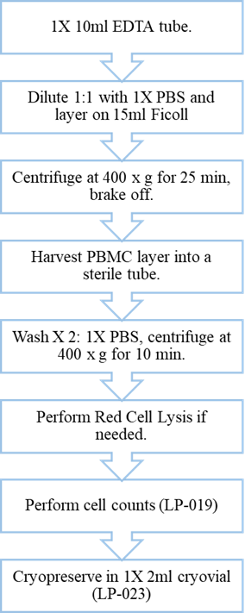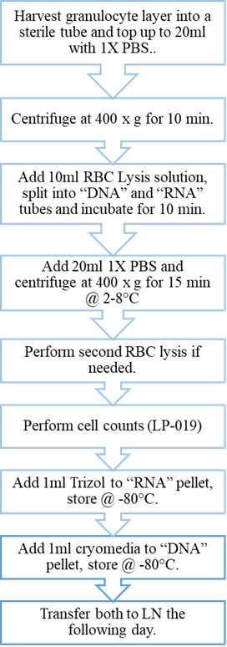

Section 10: Risk assessment and risk management

Risk assessment is a vital component of managing laboratory safety. Describe the risks involved when performing this procedure and how to avoid/reduce these risks for the SPECIFIC agents involved e.g. biological substances, toxins, nanomaterials, chemicals, GMO’s etc.

This risk assessment and risk management should also consider: The biohazardous materials that will be used; Specific risk factors for exposure to the identified hazards, including modes of infectious transmission for the organism (inhalation, ingestion, etc.); steps in the protocol that may create an exposure risk (use of sharps, creation of aerosols, injecting animals, etc.); possible consequences of an accidental exposure. The Biosafety level should be specified.

*Do not just copy and paste between SOPs as each procedure has different risks. It should identify all potential hazards and determine controls that can be implemented to eliminate or reduce the risk to employees, environment and property. See example below. Please note that this is an EXAMPLE only, and must be adapted for your specific purpose, procedures and environment.*

|  |  | ***Risk mitigation strategies*** | |
| --- | --- | --- | --- |
| ***Hazardous Activity/Substance*** | ***Possible harms*** | ***Engineering Controls and PPE*** | ***Administrative & other Controls in Place*** |
| ***Example:***  *Processing blood* | *Infection/Contamination from:*  *-Droplets*  *-Aerosols*  *-Fomites*  *-Incorrect waste disposal*  *-Unbalanced centrifuge* | *-Negative airflow (Biological Safety Cabinet)*  *-Centrifuge cups and lid or sealed rotor*  *-Balanced centrifuge*  *-Eyewash station*  *-Gloves*  *-Laboratory gown* | *-Documented BSL2 training*  *-Laboratory safety manual for working with biological substances, including spills and accidents*  *-SOP for waste disposal procedures* |
| ***Example:***  *Manipulating bacterial culture* | *Infection/Contamination from:*  *-Droplets*  *-Aerosols*  *-Incorrect waste disposal*  *-Unbalanced centrifuge* | *-Negative airflow (Biological Safety Cabinet)*  *-Centrifuge cups and lid or sealed rotor*  *-Balanced centrifuge*  *-Eyewash station*  *-Gloves*  *-Laboratory gown* | *-Documented BSL2 training*  *-Laboratory safety manual for working with biological substances, including spills and accidents*  *-SOP for waste disposal procedures* |
| ***Example:***  *Use of liquid nitrogen* | *-Asphyxiation*  *-Cryogenic burns*  *-Cryovial explosion*  *-Oxygen enrichment* | *-Oxygen depletion monitor*  *-Screwcap tubes*  *-Non-absorbent insulated gloves*  *-Closed front laboratory gown*  *-Closed shoes* | *-Documented liquid nitrogen training*  *-SOP for liquid nitrogen sample storage and retrieval*  *-Buddy system* |
| ***Example:***  *Concentrated 6.8M or more Hydrochloric Acid (HCl)* | *-Corrosive irritant that can cause burns*  *-Vapour irritates lungs*  *-Environmental contamination with incorrect disposal* | *-Fume cupboard*  *-Eyewash station*  *-Emergency shower*  *-Eye protection*  *-Protective gloves*  *-Closed laboratory coat* | *-Documented chemical safety training*  *-SOP for chemical spills and accidents (emergency procedures)*  *-SOP for chemical waste disposal*  *-Use lowest concentration possible*  *-Use smallest volume possible* |

Section 11: Spill and Accident Procedures

*Describe first aid measures if applicable, as well as clean up methods for the* ***specific agents*** *used in this procedure. If there is already an SOP for spills and accidents relating to the substance(s) used in this procedure, the SOP can be referenced.*

*EXAMPLE:*

**In the event of accidental release or spillage**, the following procedures should be followed:

1. Contain spill by surrounding it with absorbent paper towel.
2. Cover spill with absorbent paper towel.
3. Apply 10% bleach solution to the contained spill. Allow contact time of 10 min or more.
4. Mop up spill, working from the outside edges in.
5. Apply 10% bleach solution to surface and allow for contact time of 10 min or more.
6. Wipe down surface with 70% Ethanol.
7. Discard all contaminated paper towels in autoclavable biohazard bag

Section 12: Waste Disposal

*Describe how to handle and dispose of waste generated during this procedure, in an* ***appropriate*** *manner. Ensure that you don’t just copy and paste from other SOPs. If there is already an SOP for waste disposal for the substances used in this procedure, the SOP can be referenced here.*

*EXAMPLE:*

All liquid waste should be decontaminated in 10% bleach solution (freshly made each day) for 24 hours, after which it can be discarded down the drain. All solid waste and contaminated lab ware should be discarded in an autoclavable biohazard bag. Culture vessels should be soaked in 10% bleach overnight, before discarding bleach and discarding disposable plasticware into red biohazard bin for autoclaving and subsequent removal by designated professional waste removal company

Section 13: Supporting Documents

*List all referenced SOP’s here.*

*And any additional supporting documents that must be used together with this SOP e.g., user logs, forms etc.*

Section 14: Signature(s) of Compliance – *This can be a separate page attached to the SOP and signed by all trained staff and students.*

I have read and fully understand the above SOP. I have been trained and deemed competent to perform this procedure independently. I will adhere to all stated regulations and safety measures when performing this procedure.

__________________________________ _______________________________________

Name (Print) Signature and Date

__________________________________ _______________________________________

Name (Print) Signature and Date

__________________________________ _______________________________________

Name (Print) Signature and Date

__________________________________ _______________________________________

Name (Print) Signature and Date