POPULATION CERTIFICATE APPLICATION

Permanent / Temporary  (Delete which is not applicable) | 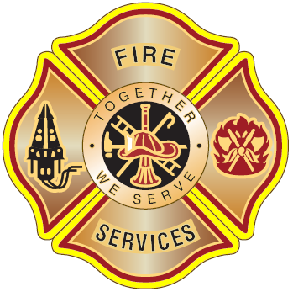  STELLENBOSCH  FIRE AND RESCUE SERVICES

APPLICATION FOR A POPULATION CERTIFICATE
This population certificate is issued in terms of Section 21 (1) of the Community Fire Safety By-law.

Name of applicant: | Cell. No.
Name of safety officer: | Cell. No
Name of event: | E-mail:

Type of event:

Date of event.

On what floor of the building is the venue situated (ground, 1st, 2nd etc.)

Street address:

Suburb: | Code

Details of Premises
How many floors does the building have. |  | How many floors are occupied by the venue for which this application is being made.

Square metres of usable area per floor  of the venue | Expected Population

Indicate a separate square meterage for each floor occupied by the venue in the blocks below. |  |  |  |  |  | Number of exits per floor  Indicate exits per floor separately in the blocks below.
Floor  ( ) | Floor  ( ) | Floor  ( ) | Floor  ( ) | Tent  ( ) | Tent  ( ) | Floor  ( ) | Floor  ( ) | Floor  ( ) | Floor  ( ) | Tent  ( ) | Tent  ( )

The controlling authority may refuse to issue the certificate applied for if the premises do not comply with the requirements of the National Building Regulations.

Signature of Applicant:

Print name:
Date:
Address:
For controlling authority (signature)
Return application to bertie.brandsen@stellenbosch.gov.za

