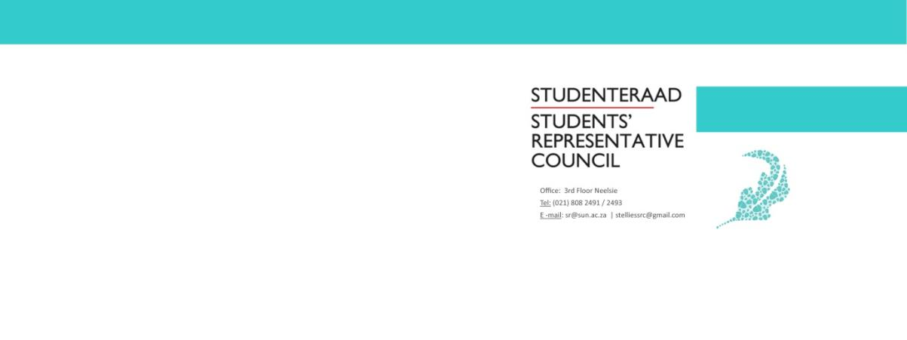
Name and Surname: | Joconde Nsumbu
Portfolio: | SU International Manager
Subject: | Second term report
Email: | 20361785@sun.ac.za

Constitutional Responsibilities
According to the Stellenbosch University Student Constitution, 2018, a manager is responsible for:
- Running portfolios that entail mainly organizational or administrative functions.
Portfolio Overview
The role of the SU International manager is to organize and administrate functions concerning the international students registered at Stellenbosch University.
This year, the objective planned out is to connect international students from different geographical backgrounds- to facilitate integration amongst international students. This entails, narrowing down the division between Euro-American and African students. Although both international groups are under the same administration (International Office) these two bodies of students are not integrated on campus.
This portfolio also aims to represent international students who often feel omitted; to assist international students who feel neglected during times of crisis; to finding solutions to the problems that may confront them; and to create a platform where international students can engage in student welfare.
Other Committees / Task Teams
SRC Executive Committee
African Student Board
Budget Overview
Owing to the nature of the problems that we had to deal with this term, the budget was not in use. This term focused on administrational issues concerning our international students, in partnership with the international office, and therefore the budget was not necessary this term.
Term Overview
While this report is meant to cover the experiences of term two in relation to our international students, due to the long-lasting effects of COVID-19 this term was dedicated to the administrational needs and experiences of international students. The leading challenge that our international students were confronted with was the matter of a lack of communication and transparency from the university. These issues were exacerbated when students went abroad and were left with little information following the international travel bans, and for students still on campus facing possible visa expiration concerns without the option of assistances from Home Affairs during the lockdown restrictions. Therefore, the events planned to facilitate international student integration on campus for term two were switched out for more meaningful administration support, with efforts focused on the effects of the travel ban on students abroad, visa expiration issues, issuing of permits for international students and the issues facing international students still on campus. Although social integration events are of great importance, and form the main objective for this portfolio, under Covid-19 restrictions, most of the events planned out were no longer feasible.
One of the projects set out for term two prior the spread of COVID-19 was the reestablishment of the African Student Board for 2020/2021. In previous years, this board acted as a platform to represent African International students and to assist with any challenges that our African Students may be confronted with. Previously the ASB was dedicated to creating opportunities were African students could meet up and foster relationships. This objective will still exist under the new ASB. However, previously the ASB was headed up by executive members selected after a series of interviews, with the reestablishment planned, the ASB will be headed up by all African Student Societies chairperson`s. This will allow for better representation on the board and will assist in confronting possible challenges with a more direct and hands on approach.
The SRC international manger Joconde Nsumbu, along with the International Office representative Angelo Jephtha, had set up a meeting with the respective African Student Leaders of their respective African Societies, this meeting was successful and future plans for term three are underway. The partnership between the SRC and the ASB is of great significance as this will help the SRC work collectively with our African students to assist tackle issues that were previously only dealt with by executive members of respective societies, while maintaining a channel for communication and transparency between all parties involved.
In relation to the lack communication and transparency from the International Office, this term we focused on frequently meeting with the international office and acted as the voice for all international students. This resulted in sitting in meetings with the international office members and working in partnership with them to find solutions that was more inclusive in its reach. The fruits of this labour are never directly felt in the short term, however, the aim is that our international students feel included in all the plans made and solutions found during the COVID-19 restriction period.
On issues concerning matters of visa expiration and issuing of permits for international students residing in South Africa, these solutions are still in process, and we will continue to represent our students’ best interest- both on campus and abroad.

Plans for Next Academic Term
I still plan to engage with international students who are abroad, as they might still be experiencing complications if the travelling ban is not lifted.
I will continue to engage with the International Office, as the groundwork for the solutions and concerns of our international students have been laid in the second term and will require consistent commitment from this portfolio and the SRC as a collective.
Recommendations for Portfolio Improvement
For my portfolio:
Maintain a healthy working relationship with the international office. Often one may feel inclined to want to create new events and build new networks, and this is create, however, the international office main objective is to support and work with international students. Aline your foundation with theirs and build your way up from that.

