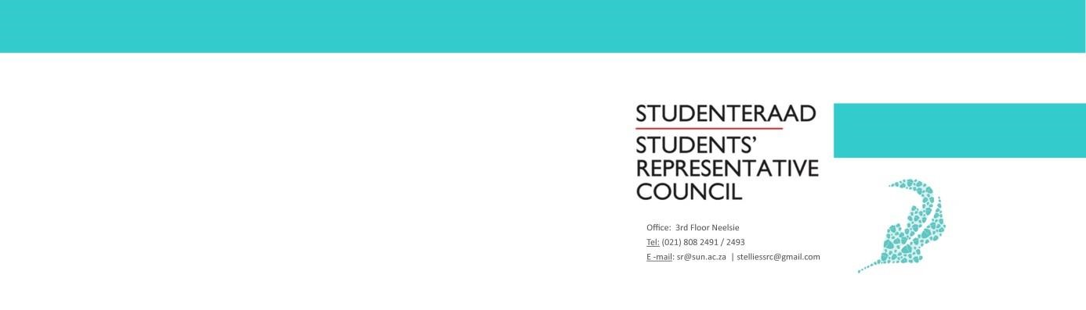

AGENDA
Students’ Representative Council Meeting
Date: 15 April 2020
Time: 14:00-16:00
Venue: Online

- Welcoming Lewis
- Attendance Fadeelah
- Approval of previous minutes Fadeelah
- Setting of the Agenda Fadeelah
- Voting
  - Policy Officer Wama
The SRC elected Policy Officer, Jonty Stokes, resigned at the beginning of March. An SRC member, Sifiso Zungu, has availed himself for the position. A vote of confidence in this SRC Member will take place.
  - SAUS Fadeelah
The SRC must decide whether or not they will become official members of the South African Union of SRC’s (SAUS).
- Discussion
  - G2G Task Team Brandon
Brandon Murray, Treasurer, will present a proposal for a Task Team he wishes to begin. General Points
  - SAUS Letter to the Minister Fadeelah
Response to the letter and potential implications for Stellenbosch.
- Next Meeting Fadeelah
- Closing Lewis

