Guidelines for teaching students with hearing impairment
(using the oral/aural method of communication) at university

Dr Diane Bell
(PhD in Education)
Email: diane.bell@usb-ed.com

Contents
1. INTRODUCTION 4
2. UNDERSTANDING HEARING IMPAIRMENT 7
2.1 Types of hearing impairment 7
2.1.1 Conductive hearing impairment 8
2.1.2 Sensori-neural hearing impairment 8
2.1.3 Mixed hearing impairment 9
2.2 Degree of hearing impairment 9
2.2.1 Mild 10
2.2.2 Moderate 10
2.2.3 Severe 11
2.2.4 Profound 11
2.3 Age of onset 11
2.3.1 Pre-lingual hearing impairment 11
2.3.2 Post-lingual hearing impairment 12
2.4 Prevalence of hearing impairment 12
3. COMMUNICATION 13
3.1 Communication choices 13
3.2 Communication aids 14
3.2.1 Hearing instruments 14
3.2.2 Lip-reading 16
3.3 Human aids to communication – working with a note-taker 17
3.3.1 Manual note-taking 18
3.3.2 Electronic note-taking 18
3.4 Technological aids to communication 19
3.4.1 Assistive listening devices 20
3.4.2 Sound field systems – induction loops 20
3.5 General guidelines when communicating with individuals with hearing impairment 21
4. HEARING IMPAIRMENT AND LANGUAGE 22
4.1 The role of language tutors 23
4.2 Possible effects relating to language difficulties 24
4.3 Guidelines when assessing written work of students with a hearing impairment 24
4.4 Language modification explained 25
5. STUDENTS WITH HEARING IMPAIRMENT AT UNIVERSITY 26
5.1 Benefits of studying at university for students with hearing impairment 26
5.2 Personal characteristics of students with hearing impairment 27
5.3 Guiding principles when communicating with students with hearing impairment 27
6. PRACTICAL RECOMMENDATIONS 27
6.1 For teaching 28
6.2 For field trips 30
6.3 For practicals 30
6.4 For oral assessments 30
6.5 For written assessments 31
6.5.1 Timed examinations 31
6.6 For students on work/industry or professional placement 32
7. PROFESSIONAL STAFF DEVELOPMENT AND TRAINING 32
8. LEARNING SUPPORT FRAMEWORK FOR STUDENTS WITH HEARING IMPAIRMENT IN HIGHER EDUCATION 32
9. CONCLUSION 35

UNTITLED POEM (by Anonymous)
Available from http://www.hearinglink.org/poetry

Trying to learn a new language
It’s not very easy to do
I need your help and assistance
So I thought I’d explain it to you.

Next time you are going to speak to me
Don’t turn your head away
For only by seeing the words on your lips
Can I understand what you say.

Talk to me more distinctly
Not too loud and not too fast
Don’t hide lips behind a cup or your hand
Or keep talking when walking past.

When you impatiently say “never mind”
I shrivel up inside
For I frantically fought to hear what was said
You don’t know how hard I tried.

The tick of a clock, the sound of a bird,
The sound on the roof of the rain
Approaching footsteps, a loved one’s voice
What I’d give to hear them again.

Will you help me to remember
Through the picture of a word
A sound, a melody that once I loved
And that once I also heard.

- INTRODUCTION
This document aims to provide guidance for lecturers who are currently teaching students with hearing impairment, or who may do so in future. If these guidelines are followed, communication will be more effective and students with hearing impairment will have access to their studies on an equal basis with their hearing peers, as far as practically possible. The information will not only allow for a better understanding of some of the difficulties faced by these students but also provides a number of strategies to implement in the teaching environment.
Before focusing on the more practical aspects of accommodating students with hearing impairment in higher education, it is important to understand the legislative and policy framework that drives inclusive education in South Africa. The most significant and relevant laws and policies are outlined, and pertinent excerpts are provided, below.
South African Constitution (Act 108 of 1996, Sections 29 (1) and 9 (2, 3, 4 & 5)) | Provides a challenge to all South Africans by requiring that we give all learners the fundamental right to basic education; addressing the imbalances of the past by focusing on the key issues of access, equity and redress.  According to the Bill of Rights contained in the Constitution of the Republic of South Africa, 1996 (Act 108 of 1996), everyone has the right to a basic education, including adult basic education and further education, which the State, through reasonable measures, must progressively make available and accessible (South Africa, 1996a).
South African Schools Act of 1996 | Promotes the concept of inclusion “… whereas this country requires a new national system for schools which will redress past injustices in educational provision, provide an education of progressively high quality for all learners and in so doing lay a strong foundation for the development of all our people's talents and capabilities, advance the democratic transformation of society, combat racism and sexism and all other forms of unfair discrimination and intolerance, contribute to the eradication of poverty and the economic well-being of society, protect and advance our diverse cultures and languages, uphold the rights of all learners …” (South Africa, 1996b).
Education White Paper 3 on the Transformation of the Higher Education System (1997) | The concept of student equity in higher education is explicated and the measures to drive the initiative are outlined. The policy states that one of the goals of the transformation process in South Africa is to build a higher education system that “Promote[s] equity of access and fair chances of success to all who are seeking to realise their potential through higher education, while eradicating all forms of unfair discrimination and advancing redress for past inequalities” (SA, DoE, 1997b:14). Equity, as stated in the policy, includes students with disabilities. It goes even further to provide a framework for how the needs of students with disabilities should be responded to by the education system as well as by universities, as individual institutions of higher learning; laying emphasis on the way in which they are structured and organised. The policy also acknowledges that students with disabilities are included as previously disadvantaged members of the population; and hence form part of transformation imperatives; although this is not evident in practice. White Paper 3 therefore argues that the new policy framework must “increase access for ... disabled students and should generate new curricula and flexible models of learning and teaching” (SA, DoE, 1997b:10).
Education White Paper 6 on Special Needs Education: Building an Inclusive Education and Training System (SA, DoE, 2001a) | This policy gave guidelines for the new education system it was going to create in South Africa so that all learners would have equal opportunities to be educated. In this policy, the Department of Education committed itself to:  “Promote education for all and foster the development of inclusive and supportive centres of learning that would enable all learners to participate actively in the education process so that they could develop and extend their potential and participate as equal members of society.”  The primary purpose of this document is the creation of educational opportunities for learners who have not been able to access existing educational provision or have experienced learning difficulties, largely because the education system has failed to “accommodate their learning needs” (SA, DoE, 2001a:6). Students with disabilities are viewed here as being one of the most vulnerable groups, having been victims of marginalisation and inequality. The focus of this paper is to ensure that the South African system is fully inclusive; attaining this through the creation of equal opportunities and the removal of barriers which limit equitable participation (Howell, 2006).
National Plan for Higher Education (2001) (SA, DoE, 2001b) | The main focus of this document is the commitment by government to increase access for non-traditional students to higher education. Students with disabilities are included in this term. This plan holds institutions accountable for implementation and also focuses on the connection between equity of access and equity of outcomes. Simple access being insufficient, the plan alludes to successful graduation of students with disabilities as one of the critical outcomes. Although the plan does not clearly place an emphasis on an integrated and holistic approach to teaching and learning support specifically for students with disabilities, it does discuss academic development as an important equalisation mechanism (Howell, 2006).
United Nations Convention on the Rights of Persons with Disabilities (UNCRPD) which was adopted by the United Nations (UN) in 2006, and ratified by South Africa on the 30 November 2007 | The UNCRPD states that disabled people should be guaranteed the right to inclusive education at all levels (primary, secondary and tertiary), without discrimination, and on the basis of equal opportunity (UNICEF, 2008).
Green Paper on Post-School Education and Training (SA, DHET, 2012) | This document highlights the fact that some progress has been made in transforming post-school institutions but that the “system still bears the marks of apartheid” such as “lingering discrimination” and problems with regard to “access, staffing, curriculum, management, student funding, and other forms of student support” (SA, DHET, 2012:x). There is an intention in this document to address ongoing equalities with regard to disability:  “The system continues to produce and reproduce gender, class, racial and other inequalities of access to educational opportunities and success. Eliminating all forms of discrimination and inequality and developing a general culture of human rights and democracy are among the key priorities of the DHET” (SA, DHET, 2012:x).  A number of recommendations are made: that the varied needs of disabled students should be responded to by individual institutions and the system as a whole which will require the allocation of additional resources; that a national policy on disability which guides education and training institutions in the post-school domain should be developed and as existing data on disability is inadequate and often inaccurate, the DHET intends commissioning a disability prevalence study across the post-school education and training sector so as to facilitate better planning at institutional and national levels.
It is important to note that the implementation of an inclusive education system, at all levels of education, including higher education, is not a choice on the part of educators, but a basic human right for persons with disabilities in South Africa.
Terminology and language
In South Africa, there are two main classifications of hearing impairment, Deaf and hard of hearing (HoH). Deaf (with a capital D) refers to those individuals who subscribe to Deaf culture and make use of South African Sign Language (SASL), and who generally are pre-lingually deaf. People who lose their hearing later in life, or who do not have a profound hearing impairment, are referred to as hard of hearing. This guide will make use of the following language: ‘persons/students with hearing impairment or hearing impairment’. This does not classify or label them, but respects them as people first before their disability.
NOTE
Currently, students with hearing impairment are under-represented and not sufficiently supported in higher education in South Africa. This guide provides information regarding international best practice for supporting students with hearing impairment. Heads of disability units and academics at South African universities should work towards implementing and providing all of the accommodations mentioned below to support students with hearing impairment in higher education holistically.
- UNDERSTANDING HEARING IMPAIRMENT
Hearing impairment is a complex phenomenon, and the experience of and accommodations required are unique for each individual student. This section will cover the various types and degrees of hearing impairment as well as other factors related to hearing impairment, such as age of onset.

2.1 Types of hearing impairment
Hearing impairment, according to the South African Society of Hearing Aid Acousticians (2009) can be categorised according to the part of the auditory system that is damaged, i.e. outer, middle or inner ear (refer to Figure 1 below). There are three basic types of hearing impairment: conductive hearing impairment, sensori-neural hearing impairment, and mixed hearing impairment. The most common type of hearing impairment is called ‘sensori-neural’ or ‘nerve deafness’, where damage to the auditory nerve has occurred.
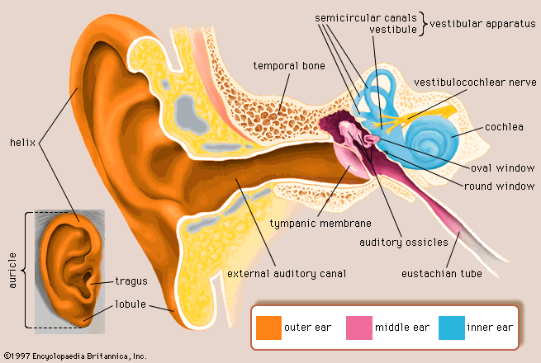
Figure 1: Structure of the ear (Encyclopedia Britannica, 1997)

2.1.1 Conductive hearing impairment
A conductive hearing impairment usually results from any type of interference with the transmission of sound from the outer ear canal to the eardrum, through the middle ear cavity and the ossicles (tiny bones) to the inner ear. This type of hearing impairment commonly presents as a reduction in sound level or an inability to hear faint sounds. It can be fluctuating or permanent, and often poses long-term learning risks. Conductive hearing impairments are potentially able to be treated medically or surgically (SAAA, n.d.).

2.1.2 Sensori-neural hearing impairment
This type of hearing impairment is also known as ‘nerve deafness’, and it is mostly caused by damage to the pathway for sound impulses from the hair cells in the cochlea of the inner ear, or to the nerve pathways from the inner ear (retrocochlear) to the brain. Sensori-neural hearing impairment results in an inability to hear faint sounds, which impacts on the ability to hear clearly. It also affects speech understanding. A sensori-neural hearing impairment is permanent and cannot be corrected medically or surgically (SAAA, n.d.). It is the most common type of hearing impairment, accounting for 60–90 per cent of all deafness (RNID, 2007). Cochlear implant technology is currently offered as an alternative to amplification for individuals who meet criteria for cochlear implant candidacy.

2.1.3 Mixed hearing impairment
Sometimes a sensori-neural hearing impairment occurs in combination with a conductive hearing impairment. In other words, there may be damage in the inner ear (cochlea) or auditory nerve as well as the outer or middle ear. When this combination presents it is known as a mixed hearing impairment and can range from a mild to profound loss.
Any of the above hearing impairments can also be:
Bilateral or unilateral: Bilateral hearing impairment means both ears are affected, while unilateral hearing impairment means only one ear is affected.
Symmetrical or asymmetrical: Symmetrical hearing impairment means that the degree and configuration of hearing impairment is the same in both ears. An asymmetrical hearing impairment is one in which the degree and/or configuration of the loss is different for each ear.
Progressive or a sudden hearing impairment: Progressive hearing impairment refers to a hearing impairment that becomes increasingly worse over time. A sudden hearing impairment is one that has an acute or rapid onset and therefore occurs quickly, requiring immediate medical attention to determine its cause and treatment.

2.2 Degree of hearing impairment
A hearing impairment is described in terms of degree of loss and is measured in decibels. The hearing impairment is plotted on a graph called an audiogram and is reported as a function of frequency or pitch and decibels or intensity (see Figure 2 below). An audiogram is a chart which records the hearing response of each ear from 125 Hz (hertz) to 8000 Hz, which is the range most essential for speech perception. A hearing impairment of less than 25 dB (decibels) (between -10 decibels and +15 or 25 dB), averaged across the frequencies of 500, 1000, 2000 and 4000 Hz (the range of frequencies involved in the perception of speech), is regarded as being within the normal range of hearing. An average hearing impairment of 25 dB or more in both ears is regarded as a significant hearing impairment, and an average hearing impairment of more than 70 dB in both ears can be regarded as deafness (Richardson, 2001).
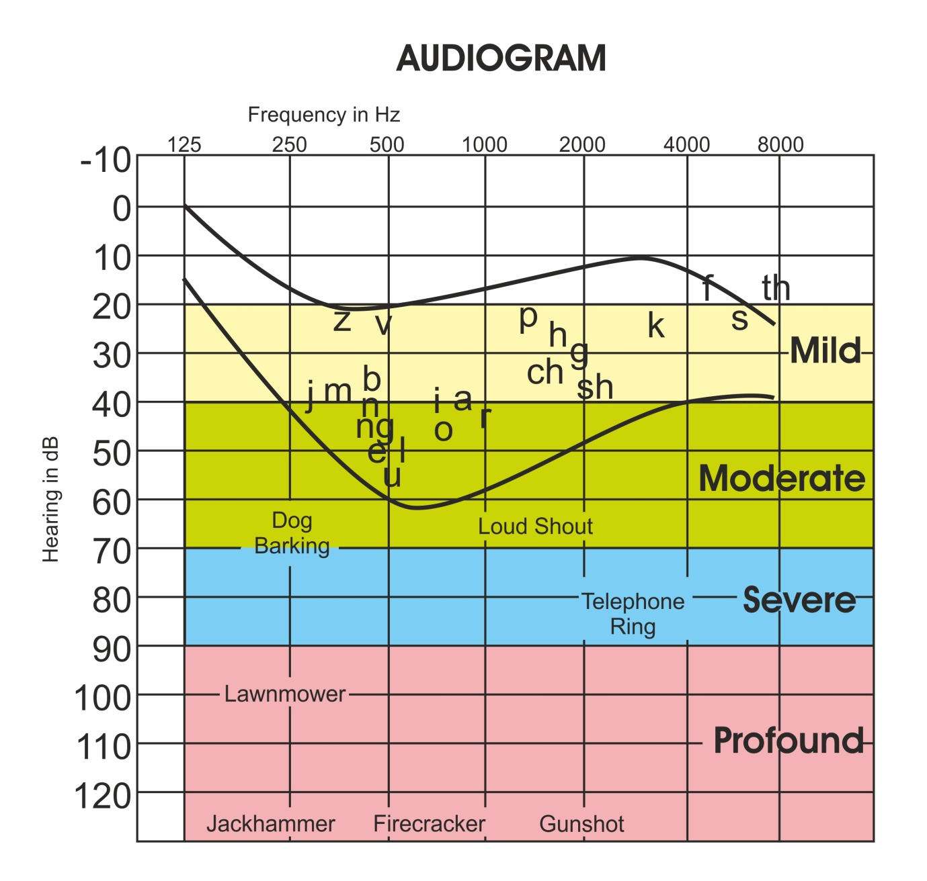
Figure 2: An example audiogram indicating degrees of hearing impairment and common sounds at various frequencies
Although hearing response is unique for each person, the range of hearing impairment can be roughly sub-divided into four main areas.

2.2.1 Mild
A loss of 26 dB to 40 dB is considered a mild loss. People with a mild hearing impairment may have difficulty understanding speech, especially in noisy situations and may be thought not to be paying attention. They may or may not wear hearing aids and may not be able to hear soft sounds like leaves rustling or people whispering. The student with this degree of loss is likely to understand most speech at close distances, but may miss the highest frequency sounds (like /f/, /th/, /s/), which are also the softest. Students with a mild hearing impairment often do not realise that they are not hearing well and may misunderstand directions. The learning environment may be stressful as the student must try harder to hear.

2.2.2 Moderate
A loss of 41 dB to 55 dB is considered a moderate loss. People with a moderate hearing impairment will probably wear a hearing aid. Without a hearing aid they will most likely have difficulty understanding speech, even in normal conditions. Without amplification the amount of speech missed can be 50 to 70 per cent with a 40 dB loss. With a 50 dB loss, 80 to 90 per cent of speech can be missed. They may be able to use a voice telephone that has an amplifier and/or an inductive coupler if they wear hearing instruments (hearing aid and/or cochlear implant/s) with the telecoil function.

2.2.3 Severe
A loss of 56 dB to 70 dB is considered a moderate to severe or a moderately severe hearing impairment. Conversation is not usually understandable at two metres without a hearing aid and/or visual clues. A loss of 71 dB to 90 dB is considered a severe hearing impairment, and without amplification, the student may hear loud voices if he or she is standing less than half a metre away, but may not be able to understand speech. People with severe hearing impairment will probably wear some kind of hearing aid but may find it difficult to understand speech – even with the hearing aid. They will often rely on lip-reading, facial expressions and other gestures to follow communication. They may also find it difficult to use a telephone, even with powerful amplification, and may therefore use the SMS function on their cell phone as a primary mode of communication. They probably will not be able to hear sounds such as trucks driving nearby. Some people with a severe hearing impairment may receive a cochlear implant (see Figure 3).

2.2.4 Profound
A loss of 91 dB or more is considered a profound hearing impairment. People with profound hearing impairment may find a hearing aid of very little or no benefit at all and will rely heavily on lip-reading, facial expressions and other gestures to follow communication. They will often not be able to use voice telephones at all and will rely on SMS functionality on their cell phones. They probably will not be able to hear sounds like pneumatic drills or aircrafts flying overhead. Some people with a profound hearing impairment may have received one (unilateral) or two (bilateral) cochlear implants (see Figure 4).

2.3 Age of onset
The age at which hearing impairment occurs is crucial for the acquisition of a spoken language. The older the child at age of diagnosis of hearing impairment, the more likelihood there is of a language delay and other related complications.

2.3.1 Pre-lingual hearing impairment
When a hearing impairment occurs before the acquisition of language, it is known as pre-lingual. This type of hearing loss can either occur through of loss of hearing in early infancy or as a result of various congenital conditions. It impairs a person’s ability to attain a spoken or oral language as his or her first language. Individuals either make use of some kind of hearing aid to enhance their residual hearing or have a cochlear implant, bypassing the auditory canal. Others elect to make use of Sign Language (SASL = South African Sign Language) as their first language and they become part of the Deaf community and embrace Deaf culture.

2.3.2 Post-lingual hearing impairment
This refers to a person who loses his or her hearing after acquiring language. Hearing impairment after birth may develop suddenly as a result of viruses, disease and injury, or progressively as a result of a hereditary and idiopathic causes. See Woodcock and Aguayo (2000) for a review of the many causes of hearing impairment and deafness. This type of hearing loss can even manifest as a result of a side-effect of various medications. Usually, the hearing impairment is quite gradual and therefore often goes undetected for a long time. Once diagnosed, individuals often learn to lip-read, wear a hearing aid or have a cochlear implant. This type of deafness is far more common than pre-lingual deafness.

2.4 Prevalence of hearing impairment
For a number of reasons, statistics regarding the prevalence of hearing impairment in South Africa are largely inaccurate and usually show less than the actual figures. There are, however, two important statistical publications which I shall mention. Firstly, the estimates of overall crude prevalence rates for hearing impairment across the life span of South Africans, as given by the Deaf Federation of SA (DeafSA), are shown in Table 1 below. These figures indicate a total rate of prevalence of hearing impairment, across all ranges of hearing impairment of 10 per cent.

Table 1: Estimates of crude prevalence for hearing impairment (%), 2004
Range of hearing impairment | Prevalence rate (%)
Mild | 6
Moderate | 3
Severe/profound | 1
Total rate hearing impairment | 10
Deaf Federation of South Africa (DeafSA) (1997)
Secondly, according to the 2010 General Household Survey (SSA, 2011), the following statistics for hearing impairment were reported: some difficulties with hearing = 778 000, a lot of difficulties with hearing = 178 000; unable to hear = 25 000 out of a total of 981 000.
Furthermore, statistics in South Africa regarding the numbers of students who have disclosed disabilities, and more specifically hearing impairment, are also not readily available due to factors such as differing definitions of disability, misinterpretation of disability codes on university application forms and stigma associated with disclosure of a disability. According to Crous (2004), from a survey of three universities in South Africa, it was found that fewer than 0,5 per cent of the student population was represented by students with disabilities. A more recent study, involving fifteen of the twenty-three universities in South Africa, reported the following findings: the proportion of students with disabilities as a percentage of the total student population was less than 1 per cent, disability units support, on average, between 21 and 400 students per year, only 17 out of 23 universities have a disability unit, there is a focus on supporting visual and mobility impairments and very few disability units provide services for hearing impairment, cognitive and psychosocial disabilities (FOTIM, 2011).
HEMIS data for the period 2003 to 2010, obtained from the Department of Education indicate the following prevalence of hearing impairment in higher education institutions in South Africa:
 | 2003 | 2004 | 2005 | 2006 | 2007 | 2008 | 2009 | 2010
Hearing (total) | 155 | 163 | 197 | 245 | 277 | 299 | 302 | 326

This data reveal that the numbers of students disclosing a hearing impairment increased from 155 in 2003 to 326 in 2010 and, according to various heads of disability units, the number is increasing year on year. If one merges these two data sets, one could expect to find that 10 per cent of the student population in higher education has some degree of hearing impairment.
- COMMUNICATION
Communication choices and communication aids will be discussed in this section.

3.1 Communication choices
When considering the communication needs and choices of people with hearing impairment, they can basically be broken down into two broad categories. The focus of these guidelines is on the first category, namely people who make use of the oral method of communication and who use technology to enhance their hearing. The second relates to persons who are ‘culturally’ Deaf and who make use of Sign Language.
- Students with hearing impairment use predominantly English (as the preferred lingua franca at most South African universities, although students may have other language backgrounds) as their spoken language and use hearing instruments (hearing aid/s or cochlear implant/s) and lip-reading (including facial expressions and other non-verbal clues) to receive information. They are likely to use their own voice to communicate. In formal situations such as meetings and training and they may need to use a note-taker.
If the onset of hearing impairment occurred later in a person’s life, after the acquisition of spoken or written language, then such person would most likely fall into this category. However, due to the advances of technology, many people born with a profound hearing impairment are implanted at a young age, and also fall into this category
When people communicate in this way, namely orally (also known as auditory/oral, aural/oral or the oral method), it is often easy to forget that they have a hearing impairment and to assume that he or she can follow everything that is being said. This is not the case, despite the most sophisticated technology, and care must be taken to ensure communication is successful using the guidelines suggested within this document.
- Some people with hearing impairment may use South African Sign Language (SASL) as their first language. They choose to be referred to as being Deaf, both culturally and linguistically. This communication choice is not part of the ambit of this document.

3.2 Communication aids
The four main types of communication aids will be discussed, namely hearing instruments, lip-reading, human as well as technological aids.

3.2.1 Hearing instruments
In this section an explanation of hearing aids, cochlear implants, lip-reading as well as human (manual) and electronic note-taking will be discussed.
3.2.1.1 Hearing aids
A hearing aid is a battery-powered, external electronic device that makes listening easier for people with a hearing impairment by amplifying sound. A hearing aid consists of a microphone, an amplifier and a receiver. The microphone picks up sounds in the acoustic environment and turns them into electronic signals. The amplifier selectively amplifies the acoustic electronic signals. The receiver is a very small speaker that changes the electric signals back to sounds and delivers the sound to the ear. Most hearing aids available today are digital and therefore programmable, with a telecoil function. Types of hearing aids include: in -the-ear (ITE), behind-the-ear (BTE), canal (fit in the ear canal) or bone-conduction (BAHA). Fitting choices are determined by the age of the child, type and degree of hearing impairment, cosmetic concerns, ear anomalies as well as fitting requirements. Hearing aids may be worn either monaurally (one ear) or binaurally (two ears) depending on the amplification needs.

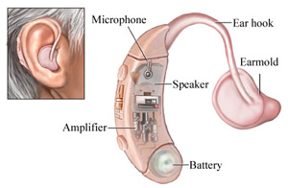
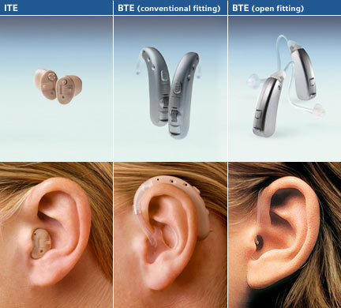
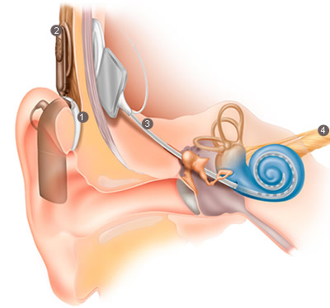

Figure 3: Hearing aid components and main types of hearing aids (ITE and BTE)
3.2.1.2 Cochlear implants
Persons with a severe to profound sensori-neural hearing impairment and those with a diagnosis of auditory neuropathy may be considered for cochlear implantation. Whereas hearing aids amplify sound, a cochlear implant transforms speech and other sounds into electrical energy that is used to stimulate surviving auditory nerve fibres in the inner ear. Potential recipients are evaluated for candidacy at cochlear implant centres by assessing their auditory acuity, middle ear function, speech perception with a hearing aid, medical history and developmental/cognitive status. A cochlear implant is a surgically implanted device which electrically stimulates the neural fibres of the inner ear or cochlea. A cochlear implant does not restore normal hearing but it is designed to provide sound detection that includes the speech range. Sounds are picked up by a microphone, coded by a speech processor (1) and delivered to the implanted electrode array via a transmitter (2) and a receiver (3) (see Figure 4 below). External parts of a cochlear implant include the speech processor (1), transmitter (2), microphone (1) and power source (1) (batteries or rechargeable battery pack). The internal parts include the electrode array implanted in the cochlea and a receiver (3).
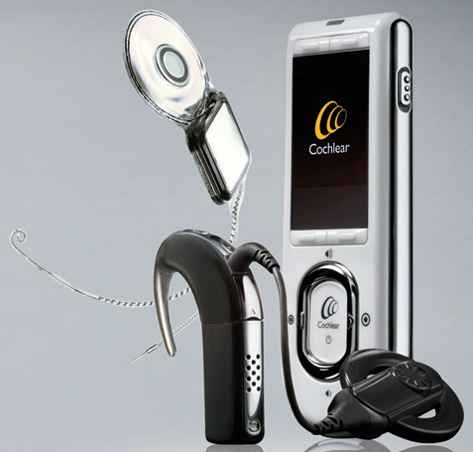

Figure 4: Cochlear implantation and technology components (Nucleus 5) (with permission Cochlear®)
For additional information regarding the advantages and disadvantages of both hearing aids and cochlear implants, see http://www.auditoryverbaltraining.com/ha-ci.htm

3.2.2 Lip-reading
Lip-reading is the art of understanding speech from observation of the lips, tongue and jaw movement using all available clues such as the topic of conversation, rhythm of speech, facial expression and other non-verbal clues. Therefore, the term ‘lip-reading’ is slightly misleading. In America, it is referred to as ‘speech-reading’ which appears to be a more appropriate and explanatory term. For people with severe or profound hearing impairment, whether pre-lingual (before acquisition of speech) or post-lingual (after acquisition of speech), lip-reading is a very important communication strategy.
Figure 5 below depicts the various components involved in the ability to lip-read speakers. The combination of sight, hearing and cognitive function result in communication.
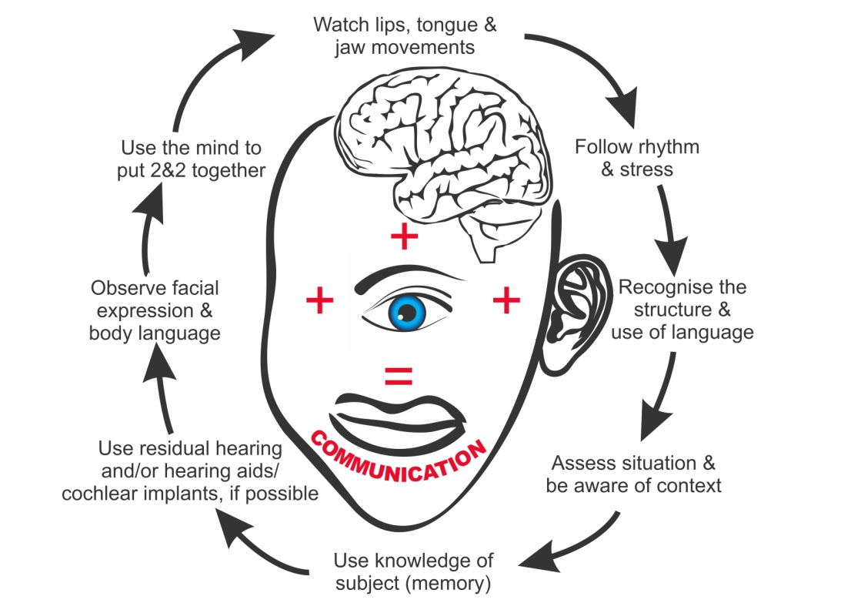
Figure 5: Components involved in lip-reading (adapted from Hearing Therapy Australia, 2007)
Some of the limitations of lip-reading include:
- At best, only about 30 to 40 per cent of all words can be seen and therefore lip-read
- Many groups of consonants have the same lip-pattern e.g. m, p, b. It is impossible to distinguish between the words ‘meat’, ‘beat’ and ‘peat’, so this is why the topic and context are so important to the lip-reader.
- Beards and moustaches can obscure the mouth, making lip-reading impossible.
- Unfamiliar accents have unfamiliar lip-patterns and are difficult to lip-read.
- People who speak too quickly or who do not speak clearly are difficult to read.
- Lip-reading requires intense concentration as lip-readers have to watch the speaker at all times, which results in severe fatigue.

3.3 Human aids to communication – working with a note-taker
A note-taker takes a comprehensive set of notes (manually or electronically) on behalf of the student with a hearing impairment, who has been assessed to require the services of a note-taker. The student may be physically unable to take his or her own notes or may be concentrating on lip-reading the lecturer. As far as possible, the note-taker will record all information, including student discussions, asides, jokes or interruptions. His or her task is to record all audible information in the teaching environment. Note-takers require training and orientation for their roles and responsibilities to the student who is hearing impaired and they should subscribe to a Code of Practice (see below). Note-takers may be volunteers, e.g. peers in the same class, more senior students or paraprofessionals, e.g. academic tutors.

3.3.1 Manual note-taking
This type refers to another student who hand-writes notes on behalf of the student with hearing impairment. Sometimes they make use of carbon paper so that multiple copies are available, or they photocopy their notes after class and give the copy to the student. This situation is not ideal as often the student with hearing impairment struggles to decipher the note-taker’s handwriting, the note-takers cannot write fast enough to catch all that is said and/or the notes that are taken are the note-takers interpretation of the content being presented, and not a verbatim transcription.

3.3.2 Electronic note-taking
Electronic note-taking involves the note-taker using a laptop computer and specialist software to record what is said in a lecture. This transcription is shared real-time with the student with the hearing impairment, who is then able to read, almost immediately, what has been said. This system also allows the student with the hearing impairment to be seated at a distance from the note-taker (due to the use of a wireless network), to save the transcription as study notes and to communicate directly with the note-taker via the software, for example, if the student wishes to clarify an issue. The note-taker can respond to the query when there is a gap in the teaching. There are many types of commercially available software for electronic note-taking, but one system that is inexpensive, readily available and easy to use, is known as Polygraf, developed by Masaryk University in the Czech Republic. It consists of a speech-to-text reporter, a laptop on which they type on, an Apple Airport Wi-Fi connection and the student with hearing impairment can read the verbatim text either on an Ipod, an Iphone, a netbook, notebook, or laptop or as a projected image.
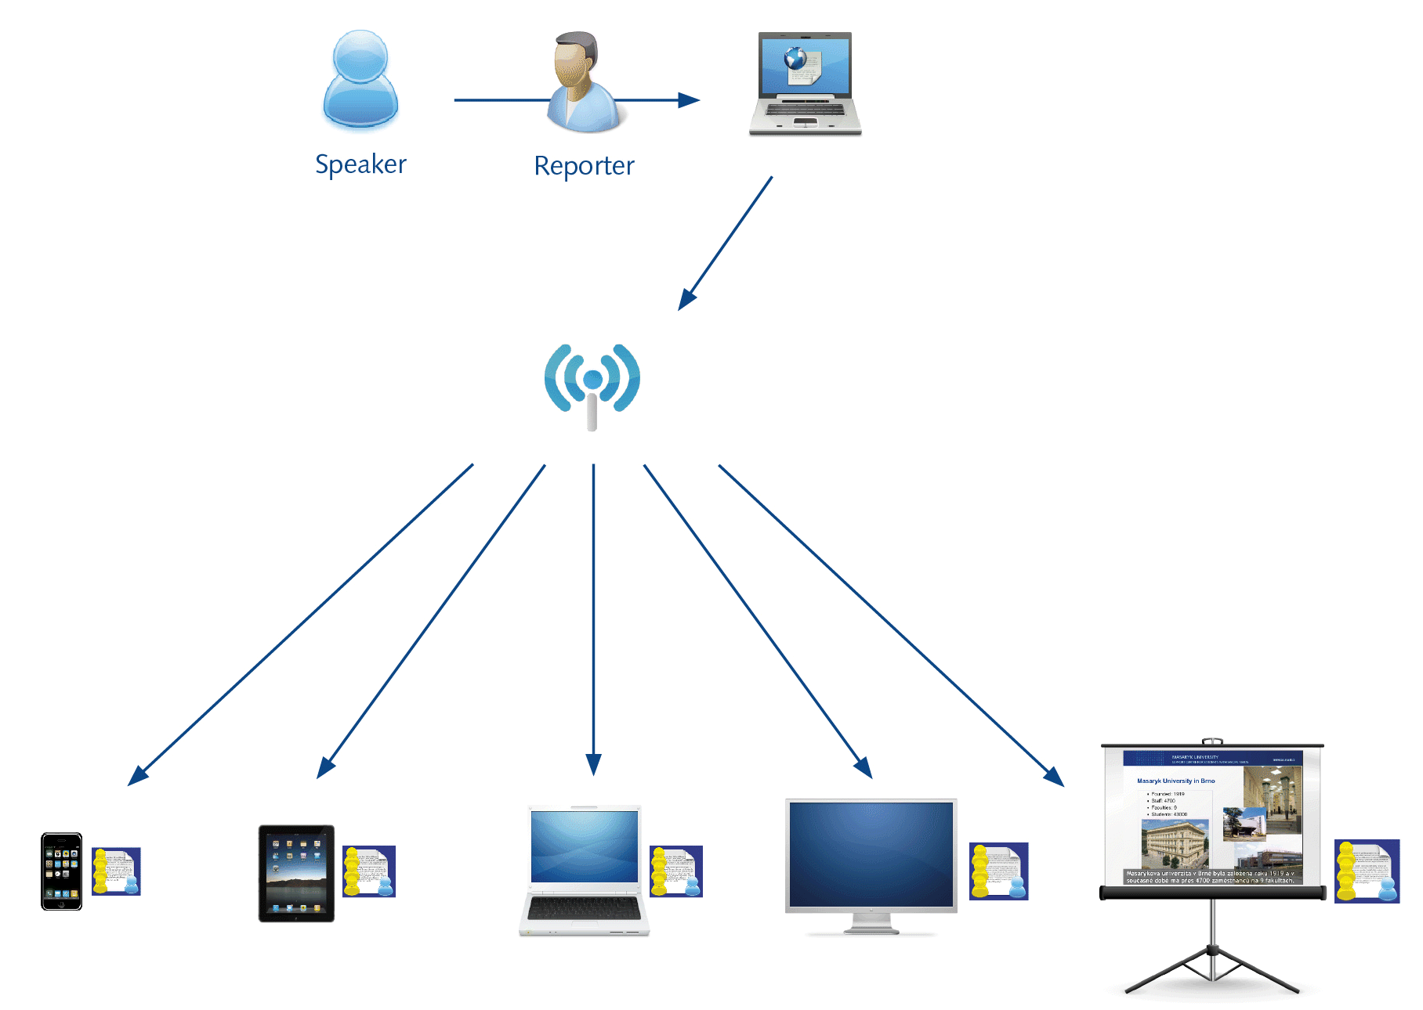
Figure 6: Diagram of the functioning of Polygraf (with permission Masaryk University)
See http://www.teiresias.muni.cz/?chapter=8-4 for further information.
Other types of real-time captioning systems such as Communication Access Real-time Translation (CART) are also available. CART is a word-for-word speech-to-text interpreting service for people with a hearing impairment. Unlike computerised note-taking or abbreviation systems, which summarise information for the consumer, CART provides a complete translation of all spoken words and environmental sounds, empowering the individual to decide for him- or herself what information is important to him or her. Section 36.303(b)(1) of the Americans with Disabilities Act specifically recognises CART as an assistive technology that affords effective communication access. See http://cart-info.org/classroom_01.html for further information.

As a lecturer, it is useful to be aware of the following information when working with a note-taker:
- It is helpful for the note-taker to have information in advance, including the topic and the format of delivery, e.g. lecture, seminar, group discussion, etc.
- If possible, it would be helpful if note-takers could be provided with copies of handouts and visual aids such as PowerPoint slides at the start of a class to be able to annotate/reference. This allows the note-taker to annotate the handouts along with the lecturer’s accompanying explanation/commentary.
- It is not necessary that the note-taker sit next to the student, but the note-taker will need to sit in a position that is most conducive to him or her for taking notes, i.e. where they can clearly see and hear. The note-taker should be assisted to carry out his or her role effectively by making sure that the room is well lit and that noise levels are minimised.
- The role of the note-taker is not to participate in the class, so their opinions should not be asked and they should not be invited to join in on discussions. Similarly, note-takers should not give advice or offer personal opinions in any teaching session.
- Although, not yet developed in South Africa, note-takers usually work within and follow a code of practice, which means that they work in a confidential and impartial way. An example of a Code of Practice for note-takers can be found at: http://www.notetext.co.uk/userimages/CoEP.pdf

3.4 Technological aids to communication
In this section an explanation of assistive listening devices, sound field systems and general guidelines when communicating with individuals with hearing impairment will be provided.

3.4.1 Assistive listening devices
In addition to personal hearing aids and cochlear implants, students with hearing impairment sometimes benefit from assistive listening devices to supplement and support their personal amplification, particularly in the classroom setting. Teaching environments with hard surfaces, uncarpeted floors, windows without curtains, student and other background noise, and lecturers who are positioned at less than optimal distances from students who have a hearing impairment, comprise a challenging listening environment.
Frequency modulation (FM) systems may reduce some of the difficulties that a student with a hearing impairment faces in the teaching environment by improving the signal-to-noise ratio. Typical systems include a transmitter which the lecturer uses (in his or her pocket or on a belt clip) together with a lapel microphone and the receiver which the student uses. If the student uses a hearing aid or a cochlear implant, then he or she will switch the devices to T-coil and connect the receiver to an induction neck loop to receive the sound input wirelessly. The student may use one of several devices which receive the sound input. This system enables the student to hear the lecturer’s voice at a consistent volume regardless of the lecturer’s location in the venue. There are many types of FM systems available commercially.
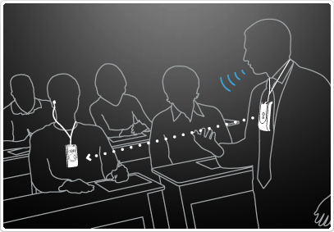
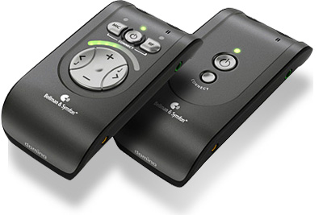
Figure 7: Example of a personal listening system (FM) and its usage in the teaching environment (with permission Bellman & Symfon®)

3.4.2 Sound field systems – induction loops
Induction loop systems consist of a copper wire, usually being placed around the perimeter of a venue, e.g. lecture theatre, auditorium, etc. The wire is connected to a loop amplifier (which maintains a steady current in the wire) as well as the existing audio equipment in the venue, such as a public address system (microphone and speakers). The induction loop system magnetically transmits sound to hearing aids and cochlear implants with telecoils (T-coils). This type of system has a number of advantages: as the hearing aid/CI user always carries and maintains his or her own receiver, the system is a cost-effective solution for many users and the system is totally discreet and requires no maintenance. In venues that are looped, lecturers would be required to ensure that the loop amp is switched on (it usually remains on all the time) and to make use of a microphone (which is the sound input to the loop amp). Figure 8 below depicts the international symbol used to indicate that an induction system is available and that hearing aid and cochlear implant users with telecoil functionality should switch to ‘T’. Figure 9 below shows a teaching venue with an induction loop around the perimeter and the speaker making use of a microphone connected to the loop amp. It also depicts what the telecoil looks like inside a hearing instrument.
Note: personal loop systems are also available, e.g. loop cushion (on a chair) with an amplifier connected to a television set.
Figure 8: International telecoil availability symbol
Figure 8: International telecoil availability symbol
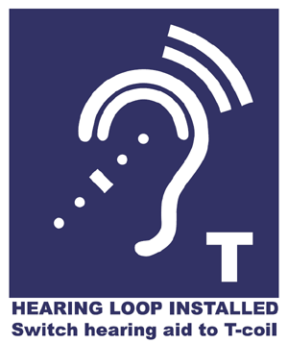
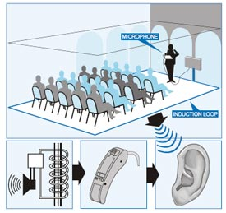
Figure 8: International telecoil availability symbol Figure 9: Induction loop system in venue
(with permission Bo Edin®)

3.5 General guidelines when communicating with individuals with hearing impairment
- Attract their attention – make sure that they are looking at you. This could be done by gentle tapping or waving.
- Maintain eye (visual) contact both when you are speaking and when the person with a hearing impairment is speaking.
- Try to keep background noise to a minimum. Hearing aids amplify all sounds, not just your voice. The person with a hearing impairment may not be able to distinguish your voice from all the other sounds around.
- Do not stand in front of a window or bright light. Your face will be silhouetted or shadowed; therefore the person with a hearing impairment will not be able to see your face clearly to read your lips.
- Don’t cover your mouth or eat when speaking. Also refrain from chewing gum and/or smoking.
- Speak a little slower than normal but maintain a natural rhythm. Don’t exaggerate mouth movements. This will make you more difficult to lip-read.
- Make sure that, if you change the topic of conversation, the person with a hearing impairment is aware of it. Only 30 to 40 per cent of all words can actually be seen on the lips. Another 60 per cent is rather like guesswork, trying to fit in what they think you might be saying about a particular topic using any residual hearing they might have, patterns of the lips and gestures – so it is very important they know the topic of conversation.
- Do not shout. Shouting distorts the face and makes you look angry. Also, other people/students will turn around, drawing unwanted attention to the person with a hearing impairment. Shouting may also ‘hurt their ears’ due to the excessive loudness once amplified.
- Highlighting key words during speech facilitates its understanding.
- If the person with a hearing impairment does not seem to understand what you are saying, try to re-phrase using different words and sentence structure. Do not simply re-state over and over in the same way. If you do have to write things down, please keep your English/Afrikaans plain and use short, clear sentences.
- If in a group situation, only one person should speak at one time. Change of speakers should also be indicated to the person with a hearing impairment.
- Please do not become impatient or give up on them.
- Refer to an article by Nancy Tye-Murray from the University of Iowa Hospitals for further information regarding Communication Strategies at http://www.audrehab.org/jara/1994SI/Tye-Murray,%20%20JARA,%20%201994.pdf
- Also: http://www.familysupportconnection.org/html/repair.htm
- HEARING IMPAIRMENT AND LANGUAGE
The main barrier experienced by students with a hearing impairment (choosing oralism) is that of a language barrier.
We learn spoken languages mainly through hearing them – being exposed to plentiful, meaningful, linguistic interaction during childhood. For those people who are born with a profound hearing impairment, or who are pre-lingually deaf (i.e. the onset of hearing impairment occurred before the age of two), the quality and quantity of this linguistic input is severely reduced and they therefore do not acquire spoken/written languages naturally. (Note: for culturally Deaf persons, the learning of Sign Language is seen as a natural process.)
Because of this, spoken language learning for them may be a very slow, laborious process. All new words/vocabulary may have to be taught individually. When trying to understand the spoken word, they mostly rely on lip-reading and any residual hearing they might have which is amplified through the use of some kind of hearing instrument.
Furthermore, hearing people (without any language impairments) usually learn to read languages they can already speak. Research shows that the reading age of students with a hearing impairment leaving high school is below the national average. Clearly, people with a hearing impairment reaching higher education are functioning at a relatively advanced level but reading can still be a difficult task for some of them. Their vocabulary and general knowledge can be considerably restricted compared with their hearing peers as they will not be able to absorb information in the same way, i.e. through television, radio, classroom chatter, etc. This incidental information often helps to form the opinions and develop the skills necessary for higher education; yet, students with hearing impairment are often denied access to this whole wealth of general knowledge and life experiences. Unfamiliar words, or words which have not been specifically introduced to the student, cannot be lip-read; hence, they have to research not only the technical jargon of their subject but also language that is commonplace amongst their hearing peers.
It is therefore not surprising that hearing impairment can lead to linguistic problems and that the written work of students with a profound hearing impairment may appear lacking in depth and maturity.
Students with a hearing impairment who do experience linguistic problems are entitled to:
- a language tutor who assists the student outside of the classroom with the understanding and production of written text;
- language modification of assessment papers (refer to section 4.3); and
- written work marked for content and context, and not standard written English/Afrikaans (refer to section 4.2).

4.1 The role of language tutors
Language tutors work with the student, not for the student. A breakdown of their role includes:
- to help students prepare for assignments, i.e. checking comprehension of the task and the understanding of written materials, assisting with planning/organisation of projects, the structure of the essays, etc.;
- to advise students about the presentation of written or spoken work;
- to modify the language of course materials to facilitate access to texts; and
- the language tutor could also be utilised to modify the language of assessments.

4.2 Possible effects relating to language difficulties
*Note: These effects depend on age of onset and type of hearing impairment, and also vary from individual to individual.
**Note: These effects are completely independent of the intellectual ability or potential of the student with a hearing impairment.
Students with hearing impairment in higher education may exhibit some or all of the following traits:
- written work may appear immature and may lack depth due to limited vocabulary and general knowledge;
- difficulty extracting meaning from text, including lecture notes, assignments and reference materials;
- restricted vocabulary shown by the acceptance of particular words as having a fixed meaning relating only to previous experience;
- difficulty absorbing and using new technical terminology;
- difficulty using everyday words in specific technical contexts;
- misinterpretation of information, especially where there is some ambiguity in terminology or phraseology;
- incorrect verb endings and spelling mistakes in written work;
- syntactical errors such as incorrect word order, words missed out or extra words included;
- difficulty producing discussion elements of an assignment, particularly where these depend on abstract thinking rather than practical observation;
- taking longer to read, understand and absorb information;
- relying heavily on dictionaries, references and tutors to check their understanding;
- taking longer to plan and produce written work than the average student; and
- lower self-confidence regarding their academic work.

4.3 Guidelines when assessing written work of students with a hearing impairment
These guidelines are particularly relevant for students with a profound hearing impairment where their first language is in a less developed form as compared with their hearing peers. The guidelines should be seen as a means of awarding marks that reflect the students’ understanding of the subject rather than the level of their linguistic skills.
- If possible, mark their written work using two different coloured pens: one for comments about the content (material and use of ideas) and the other for comments concerning spelling and grammar.
- The final mark allocated for the piece of work should be the mark awarded on the basis of the material, argument, analysis, etc. (excluding the grammatical errors).
- Spelling mistakes or poor use of grammar and punctuation should not be marked down. Rather advise the student of such.
- The use of constructive comments about both the factual content and the use of language is encouraged, explaining what is required or what is wrong by using simple language.
- It is important to check the student’s level of understanding of the technicalities of language and presentation as there is sometimes conscious knowledge but an inability to use, and at other times there is no conscious basic knowledge. Discuss the level of correction that the student will be able to use and which reference books the student might find useful.
- The marking of errors should be done in the margin against the line where they occur. The aim is to let the student find the errors and correct them.
- The use of a system of symbols which is convenient, such as sp for spelling, ss for sentence structure, pn for punctuation, gr for grammar and lt for layout (or presentation) is encouraged.
- It may be necessary to discuss the piece of work with the student him- or herself where there is particular ambiguity in the language.

4.4 Language modification explained
As explained previously, where a student’s language has been severely impaired, it may be necessary to modify the language of his or her assessment papers and major assignment briefs. The aim of language modification is to make the English or Afrikaans (lingua franca at universities in South Africa) as clear as possible and to ensure no time is spent trying to decode the language.
When modifying text, only the non-technical carrier language (words which tie language together such as it, ‘them’, ‘and’, ‘with’ etc.) should be changed and, most importantly, the meaning and intent of the question should not be altered. All modifications should be peer-reviewed to ensure that all the modifications are fair and acceptable. All modified papers should also be approved by the head of department before processing.
Modification should always be carried out with a particular student’s access to language (lingua franca) in mind; therefore, the same assessment paper may be modified differently for different students.
Generally, language modification involves:
- shortening of long sentences;
- replacing high-level carrier language with lower-level alternatives;
- replacing passive verbs with active verbs;
- removing superfluous language;
- removing ambiguity; and
- re-formatting e.g. using bullets, spacing, etc.
For further information and resources, see http://www.batod.org.uk/index.php?id=/articles/resources/training-materials/language-modification
- STUDENTS WITH HEARING IMPAIRMENT AT UNIVERSITY
As previously mentioned, students with hearing impairment are under-represented in higher education in South Africa and are also under-supported. Additionally, according to literature, the students who are successful in being admitted into higher education face a high rate of attrition and generally poor educational outcomes. One study, in particular, reported that almost 75 per cent of students with hearing impairment do not graduate from postsecondary educational institutions (colleges and universities). It is for these reasons and the fact that students with hearing impairment benefit significantly from studying in higher education, that these guidelines should be followed. Following, some of the benefits of studying at university and characteristics of students with hearing impairment will be discussed. Some guiding principles regarding communicating with students with hearing impairment will also be presented.

5.1 Benefits of studying at university for students with hearing impairment
Students with hearing impairment, provided with the correct support and access to communication, may be able to benefit significantly from attending university, graduating and transitioning into employment.
Salend and Garrick’s (1999) review of the literature on inclusion concluded that benefits of inclusion for students with disabilities may include gains in academic achievement, increased peer acceptance and richer friendship networks, higher self-esteem, avoidance of stigma and possible lifetime benefits, such as higher salaries and independent living.
Other benefits may also include:
- improved communication skills;
- gains in academic achievement and therefore overall development;
- enhanced self-esteem;
- learning new skills, such as self-advocacy;
- gaining experience in interacting with hearing individuals and building friendships, and therefore improved intra-personal skills; and
- enhanced opportunities for employment and career-advancement, leading to an improved socio-economic status.
It is, however, undisputed that students with hearing impairment studies will be faced with many challenges during their higher education, some of which may be minimised by the provision of appropriate accommodations to ensure communication access. The main barriers are those of communication and language.

5.2 Personal characteristics of students with hearing impairment
Without attempting to be disrespectful or stereotyping students with hearing impairment, literature shows that some exhibit one or more of the following characteristics, which may hamper their educational attainment, and which may require intervention:
- lack of self-advocacy skills (ability to request/negotiate support provisioning);
- low self-esteem;
- limited network of friends – isolation;
- unclear self-identity (Deaf or hearing cultural identity);
- over-motivated to ‘prove’ academic ability, often to their detriment;
- lower levels of well-being (than their hearing counterparts); and
- poor study habits and time-management skills.

5.3 Guiding principles when communicating with students with hearing impairment
- Approach the student directly and not through a hearing friend or note-taker.
- Get their attention (e.g. waving, tapping gently on the shoulder or moving into their line of vision).
- Face the student, speak normally and talk to the student directly.
- The student may ask you to:
  - write down information;
  - repeat spoken information;
  - type information on a computer;
  - use the SMS facility on a cell phone; or
  - ask a note-taker to write down what you say.
- Be patient and allow extra time to communicate.
- Remember that a student with a hearing impairment cannot do two visual tasks at the same time, e.g. writing and lip-reading.
- PRACTICAL RECOMMENDATIONS
Students with a profound hearing impairment rely on being able to receive information visually (in varying degrees), therefore the following suggestions are made to facilitate communication in various contexts.

6.1 For teaching
- All requirements for passing assessment must be clearly defined per subject. It is preferable that this information is provided in written format.
- Lecture notes, handouts and copies of electronic presentations should be provided well in advance to students with hearing impairment to allow them to pre-read and prepare for class, e.g. learn new vocabulary, terminology, etc.
- Make every attempt to face the class at all times to allow for lip-reading.
- Avoid writing on the board and talking at the same time.
- Try not to walk around the classroom whilst talking as this makes it difficult for the student to maintain visual contact, making lip-reading impossible.
- Try not to stand with a light or window behind you as this can cast shadows which will make it more difficult to lip-read.
- In addition to speech, it is useful to make use of all available means of expression (facial expressions, gestures, etc.)
- Notify students with hearing impairment of any important sound stimuli, e.g. fire alarm for fire drill, etc.
- The use of visual aids to illustrate the presented topic would be most helpful.
- After writing something on the board, or showing a slide with information which the students need to write down, catch the attention of the student with hearing impairment to re-establish eye contact before continuing with the lecture.
- If you have asked the class to read a piece of text, please wait until the student with a hearing impairment has finished before continuing to speak – they are unable to read and lip-read at the same time.
- Handouts are extremely important to students with hearing impairment. These, together with hard or electronic copies of overhead transparencies (OHTs) or PowerPoint slides, should be given to the student via email or posted on an electronic learner management system (such as BlackBoard) at least 24 hours before the lecture wherever possible to enable these students to prepare beforehand, e.g. learn new vocabulary, terminology, etc. A copy of the handouts and OHTs or slides should be given to the note-taker at the start of the lecture to facilitate annotation and referencing of the slides. Please remember to use plain language.
- Try to give glossaries of terminology and write new terms on the board wherever possible.
- Avoid idioms and jokes or play on words as these will usually be lost on students with hearing impairment and they will understandably be curious what their peers are laughing at, which make them feel embarrassed.
- Try to structure teaching sessions clearly. Rapid changes of topic will defeat most lip-readers. If you change the topic of conversation, make sure that the student is aware of it. Only 30–40 per cent of all words can actually be seen on the lips. The student will be using contextual clues relating to the topic whilst making use of any residual hearing he or she might have together with lip-reading to access the message.
- Try to be explicit at all times. When describing diagrams or graphs, etc. do not use ‘this’, ‘that’, ‘here’, ‘there’ – the support worker, e.g. note-taker, will not know what is meant.
- Allow more time to make communication effective. Note-takers work, by necessity, several seconds behind the speaker. This means that a student with hearing impairment often ‘sees’ a question start as hearing students hear it end. As a result, it can be very difficult for a student with a hearing impairment to fully participate on an even basis with their hearing peers. A lecturer, when demonstrating experiments, etc., should be aware of this time delay and should allow the student to actually see the activity and grasp it before moving on.
- Where a student consistently struggles to grasp a particular concept, after consulting with an academic tutor, it is advisable for an individual consultation with the lecturer.
- The use of assistive devices in the teaching environment such as FM systems is encouraged, where a lecturer would be required to use a transmitter, sometimes with a lapel microphone.
- The presence of note-takers in the teaching environment should not opposed.
- Hearing peers should be encouraged to be respectful of the rights and needs of students with hearing impairment such as keeping preferential seats open in the front of the class.
- Group discussions are notoriously difficult for students with hearing impairment as people often speak over one another. The optimum size of a group is between 6 and 10. If a group is bigger than this, it is unlikely that people will be near enough to lip-read, and following contributions to discussions becomes more complicated. If students with hearing impairment are not given the opportunity to locate the speaker, they will miss some or all of the discussion and will therefore either not contribute or be very reluctant to do so for fear of repeating previously voiced comments. Try to control group situations allowing one person to speak at a time (they should raise their hand before speaking) and allow time for contributions from students with hearing impairment. If the student is using a loop system in the venue, please remember that all contributors to the discussion will need to speak into the microphone. Ensure that this is known to the group before the discussion starts.
- Questions and contributions from elsewhere in the room may not be heard, so it is helpful to repeat the question before going on to answer it to facilitate communication.
- If the lecturer plans to show a video in class, he or she should either ensure that the video has subtitles, or the video will have to be summarised before screening. The video summaries should be given to the student at least a week in advance. Alternatively, a transcript of the video should be found online at one of the following free transcript websites:
  - http://www.dailyscript.com
  - http://www.script-o-rama.com/table.shtml
  - http://www.simplyscripts.com
  - http://BestMovieScriptsForFree.com
  - http://www.MovieScriptSource.com
  - http://www.SimplyScripts.com
  - http://www.WeeklyScripts.com
  - http://www.Twiztv.com/scripts/
Note: This list is not exhaustive – Google can be used to search for additional websites.
- Changes to time tables means changes to support requirements for students with hearing impairment. It is usually the student’s responsibility to book the support they need, e.g. note-takers. Support is booked at the start of each semester for the duration of the semester. If there is to be a room change or cancellation of class (as examples), the student with hearing impairment needs to be informed as early as possible so that he or she can tell the co-ordinator at the disability unit, who can then try to accommodate these changes.

6.2 For field trips
- Special provision may have to be made for students on field trips. A student who copes well with lip-reading in a lecture theatre may be quite unable to manage without further support when on a windy beach or in a noisy factory.
- Be flexible and talk through the possible options and solutions with the student well in advance to avoid problems.
- It may be necessary to liaise with staff members from the disability unit also.

6.3 For practicals
- Try not to stand behind the student when he or she is working – they are not able to watch the work and lip-read the lecturer at the same time.
- When teaching points arise during the session as a result of supervising the work of other students, remember to attract the attention of the student with hearing impairment before speaking.
- Lecturers should make sure during demonstrations the student with hearing impairment can clearly see what they are saying and doing.

6.4 For oral assessments
Also see section 4.2.
- Students with hearing impairment are often required to give oral presentations as part of their course and this should be encouraged, except in exceptional cases where a student’s well-being might be adversely affected.
- Generally, their oral presentations should be assessed in a similar manner to their hearing peers taking into account their language level (refer to 4.2). If written assessments are marked for content and context only and not for standard written English/Afrikaans, then the student should not be penalised for any grammatical or spelling errors contained in handouts or slides.
- Some students may not have a clear voice. Their voice may be monotonal and lack expression and the student may feel very embarrassed or lack confidence because of this.
- Depending on the type of hearing impairment the student has, he or she might or might not be able to hear his or her own voice and this may result in a voice that is either too loud or too soft.

6.5 For written assessments
The overall aim is to make assessments equitable for students with hearing impairment. This, however, does not mean lowering the standard expected from these students. The work of the student should still be marked according to the specified assessment criteria and the piece of work should still reflect the cognitive skills and critical thinking expected of all undergraduate students.
The adoption, however, of more innovative assessment strategies may assist to reveal the actual intellectual ability rather than recourse to the more traditional ‘essay’ type questions and end-of-term/semester examinations, which serve to highlight the linguistic disability and which often accompanies the students’ hearing impairment.
Students with hearing impairment are often eligible for additional arrangements during assessment/examination periods. These arrangements may include:

6.5.1 Timed examinations
  - Extra reading time (usually 10 to 15 minutes per hour).
  - Individual examination/assessment strategy designed specifically to meet the needs of the student whilst maintaining academic standards (as explained above).
  - The use of a separate venue to facilitate the abovementioned.
  - Modified examination/assessment paper written in a language more appropriate to the student’s needs. Refer to 4.3 above. Alternatively, the lecturer could ensure that the paper is written in plain English/Afrikaans.
  - Long essay-type examination questions could be replaced by shorter answer questions.

6.6 For students on work/industry or professional placement
- Staff members from the disability unit should work closely with students with hearing impairment, faculty placement staff and placement providers (employer) to ensure that a student’s placement experience is both beneficial and positive.
- The placement provider (employer) should be sensitised to the needs of the student and should make every effort to reasonably accommodate him or her. There may be a need in the work environment for communication support, equipment solutions and/or sensitisation training for staff.
- The university does, however, have a responsibility to try to ensure that no student is placed in an environment where he or she is likely to experience discrimination.
- PROFESSIONAL STAFF DEVELOPMENT AND TRAINING
Orientation and continuing education of direct (e.g. lecturers) and support staff (e.g. disability unit) serving students with hearing impairment is necessary to ensure successful educational experiences for these students in higher education and to stay abreast of the latest developments. This training could include topics such as:
- instructional strategies;
- communication methodologies;
- amplification needs;
- assistive technologies; and
- assessment.
- LEARNING SUPPORT FRAMEWORK FOR STUDENTS WITH HEARING IMPAIRMENT IN HIGHER EDUCATION
One of the main aims of my PhD research study entitled ‘Investigating teaching and learning support for students with hearing impairment at a university in the Western Cape’ was to develop an academic learning support framework for these students which could be implemented at higher education institutions. Using my personal experience with supporting learners with hearing impairment, the findings and recommendations from this study, the review of the literature regarding best practice for supporting students with hearing impairment in higher education as well as Bronfenbrenner’s bio-ecological systems theory, I conceptualised the learning support framework depicted in Figure 10.
The student with hearing impairment is most important and is therefore placed in the central position. At the top of the framework, one should note the potential factors that impact on the language, communication and learning outcomes of the students such as type and degree of hearing impairment, as well as age of onset. Their communication choice, namely the aural/oral method is also important as it impacts on their self-identity. Surrounding the student with hearing impairment (in the centre) are six significant areas of interaction at university in which the communication needs of the students should be considered, with the necessary accommodations being implemented. These six areas are: teaching and learning, practicals, assessment, residence accommodation, field trips and external placement.
On the outskirts of these six areas, the role of the disability unit is indicated, supporting both the student, the academics as well as liaising with the centre for academic development and companies (or other external role players) with regard to placement or employment. The role of the disability unit to ensure that registration and orientation are fully accessible is also indicated. Other areas of importance are also shown, such as the need for government and university funding, the supportive role that faculties need to play, the importance of a conducive social environment and an accessible physical environment. Paramount is the university culture and commitment towards making the environment inclusive and accessible for all. Finally, the role of communication technologies is indicated, such as the provision of electronic note-takers and induction loop systems.
The aim of this learning support framework is the provision of a holistic approach to meeting the communication and other accessibility needs of students with hearing impairment, within the university and other educational environments. It is hoped that this framework will assist staff from the disability unit, lecturers, university management and other role players to improve the academic support for students with hearing impairment, hopefully leading to less barriers being experienced, a reduced need for personal (and other) coping strategies, as well as improved overall educational outcomes.

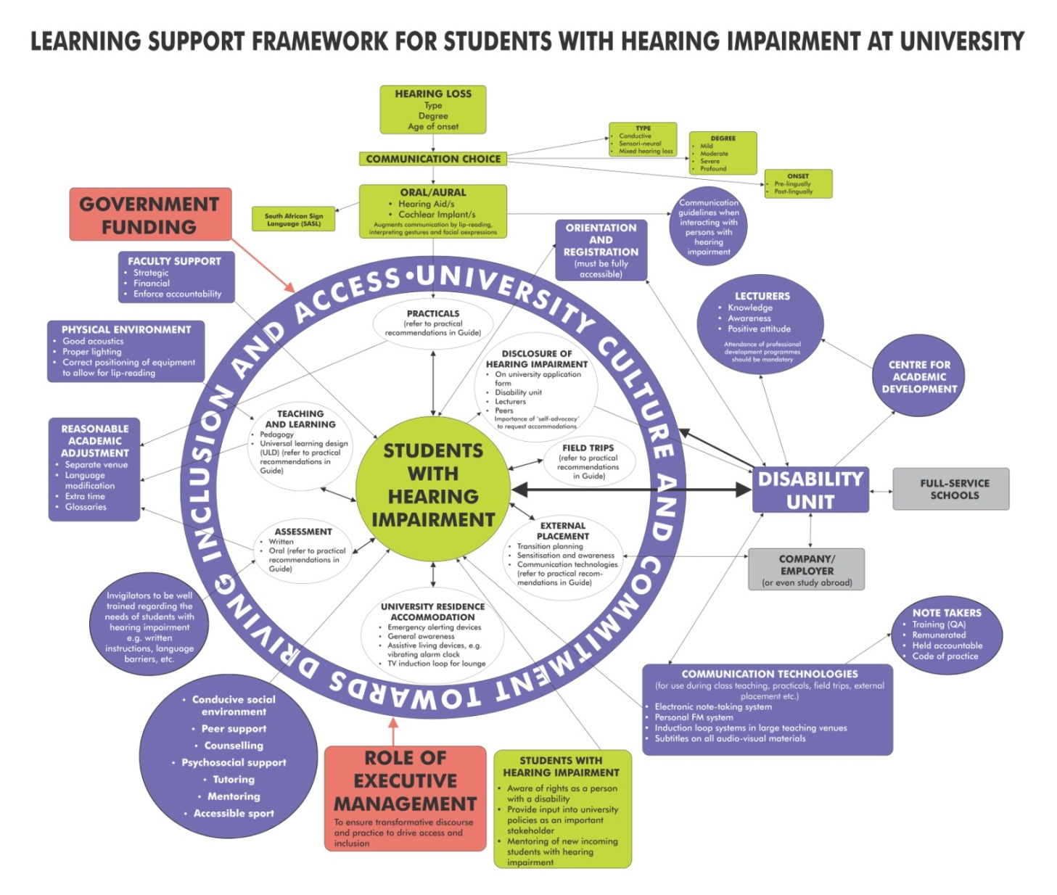

- CONCLUSION
Every young South African, irrespective of race, gender, culture, creed or disability has the right to pursue a study career in higher education. With the increasing access to university for students with hearing impairments, lecturers are faced with new and unique challenges in attempting to ‘level the academic playing field’. The needs of students with hearing impairment vary considerably, depending on factors such as type of hearing impairment, severity of hearing impairment, age of onset and use of assistive devices and other communication aids. What is imperative is that they receive equal access to information and communication – the same as their hearing peers. This guide has attempted to contextualise inclusive education, explain hearing impairment and related technologies, and most importantly to provide teaching strategies to facilitate communication in accessible learning environments.

NOTE:
I wish to acknowledge firstly Margaret Burke, senior disability adviser (Deaf), Student Services Centre, Sheffield Hallam University (UK) as well as Lynne Barnes, divisional co-ordinator: BSL & Deaf Studies, School of Education and Social Science, University of Central Lancashire (UCLan, UK) for allowing me to draw on some content from the following university publications:
- Guidelines for working with deaf students in the teaching environment. Sheffield Hallam University (SHU: Disabled Student Support, n.d.) (permission received electronically 9 July 2012).
- Teaching strategies to use with deaf students: advice for lecturers in higher education. University of Central Lancashire (UCLAN, n.d.) (permission received electronically 9 July 2012).
Furthermore, heads of disability units, other support personnel, academics and administrators at universities are encouraged to make use of the self-assessment tool: “Deaf students in higher education – How inclusive are you?” available online from: http://www.staffs.ac.uk/assets/Deaf%20Students%20in%20Higher%20Education%20How%20Inclusive%20Are%20You-RNID_tcm44-33425.pdf .

