**Day 1: 14 September 2020**

**Student Panel Discussion:**

**(12:00-12:30)**

Students’ reflections: being included in SU – gains and gaps

**Mr Bongani Mapumulo**

Postgraduate Diploma in Disability & Rehabilitation Studies student at Stellenbosch University and former SRC Special Needs Manager

**Mr Jeff Ngobeni**

Postgraduate in Systematic Theology and Ethics and SRC Transformation Officer at Stellenbosch University

**Ms Josie Joubert**

Student in BSc Human Life Sciences at Stellenbosch University

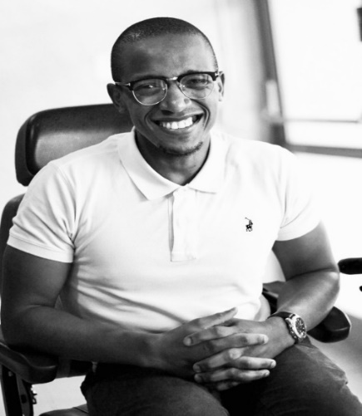

**SEMINAR: SU DECLARATION OF 2020 AS THE YEAR OF PERSONS WITH DISABILITIES: REFLECTIONS AND WAY FORWARD**