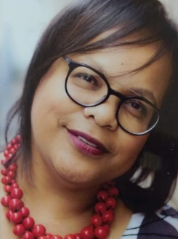

**Seminar Facilitators:**

**Dr Marcia Lyner-Cleophas**

Educational Psychologist and Head of Stellenbosch University Centre for Student Counselling and Development’s Disability Unit

**Prof Gubela Mji**

Professor and Director at Stellenbosch University Centre for Disability and Rehabilitation Studies. She is the current chairperson and visionary behind AfriNEAD

**Ms Luigia Nicholas**

Student assistant and mentor at the Disability Unit, Special Needs Manager on the SRC and intern at The International Collaboratory for Leadership in Universally Designed Education (INCLUDE)

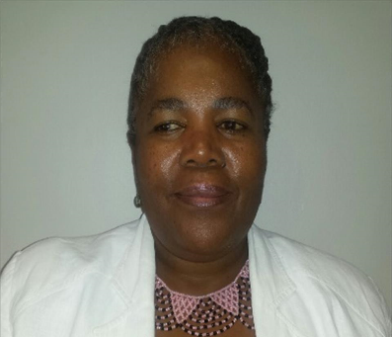**

**SEMINAR: SU DECLARATION OF 2020 AS THE YEAR OF PERSONS WITH DISABILITIES: REFLECTIONS AND WAY FORWARD**