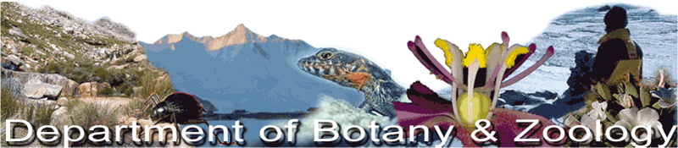

Venue: Room 2020
Time: 13h00 – 14h00

Date | Speaker | Title
06/07/2022 | Catherine Wilkinson | Phytochemical and molecular analysis of novel wild rooibos chemotypes and their potential application in skin cancer treatment
19/07/2022 | Megan Claase | Shared marking site use in African wild dogs Lycaon pictus.
20/07/2022 | Esmarie Botha | The implications of ocean carbonate chemistry for cultured mussels in Saldanha Bay
21/07/2022 | Matt Danckwerts | Physical patterns and post-hoc measures of wildfire behaviour in grassland ecosystems: Relevance for forensic indicators in wildfire investigations
27/07/2022 | Jonathan Bell | Right time, right place: a mixed method approach for assessing property access for invasive alien species management.

