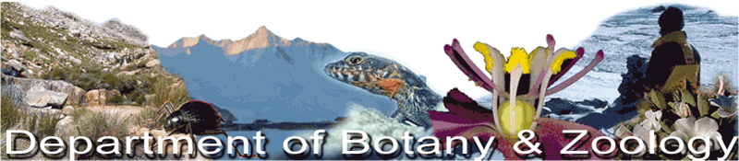

Seminar Schedule

Venue: The Broom
Time: 13h00

Enquiries: Dr Tammy Robinson (trobins@sun.ac.za)

July 2019

Wednesday 3rd No Seminar

Wednesday 10th MSc defence Namita Vanmali Assessing the Feasibility of Assisted Colonisation to Reduce Climate Change Extinction Risk for Western Cape Proteaceae. (Supervisors: Prof. Guy Midgley, Prof. Wendy Foden)

Wednesday 17th Cancelled
MSc defence Seyed Amir Sadat Rezaei Did rapid adaptation drive the recent divergence between estuarine and marine Clinus species? Insights from next-generation sequencing. (Supervisors: Prof. Sophie von der Heyden, Prof. Peter Teske)

Wednesday 24th Dr Melike Fourie Studies in Trauma and Transformation, Stellenbosch University. Empathy and perspective taking across racial boundaries in South Africa as measured using neuroimaging.
Abstract
South Africa provides an important opportunity to study intergroup processes and the transgenerational impact of historical trauma, given its racially divided past. While much attention has been paid to right the wrongs of the past at a socio-political level, the long-term implications of gross human rights violations at a more interpersonal level have not been considered adequately. In this talk I will present neuroimaging (fMRI) and self-report data on intergroup empathy and perspective taking in South African individuals in a range of settings.
Bio
Dr Melike Fourie is a Senior Researcher in the Historical Trauma and Transformation Unit at Stellenbosch University. Her research interests are in social psychology and social neuroscience, with a particular focus on intergroup relations and the factors that affect how we see and respond to members of social (racial) outgroups. She believes a deeper understanding of implicit brain processes that drive behaviour is key in this undertaking.
Wednesday 31st MSc proposal Christopher Delport Evaluating and testing risk assessment protocols for alien plant species by explicitly considering the underlying assumptions. (Supervisors: Dr Sabrina Kumschick, Prof. John Wilson)

