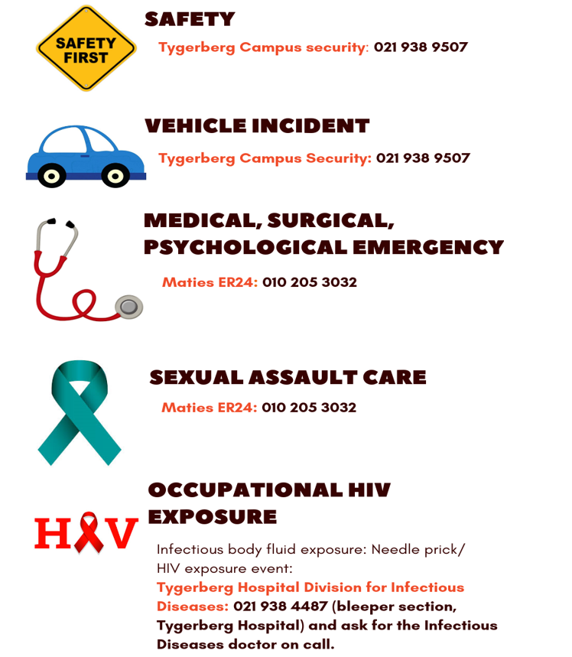

TABLE OF CONTENTS

1. 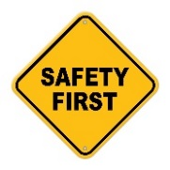 SAFETY 3
2. VEHICLE INCIDENT 3
3. MEDICAL, SURGICAL, PSYCHOLOGICAL EMERGENCY 5
4. REPORTING OF AN INCIDENT 5
5. SEXUAL ASSAULT CARE 6

6. OCCUPATIONAL HIV EXPOSURE 6

Approved: CUT, 1 October 2019

EMERGENCY SAFETY GUIDELINES

Emergency numbers are listed below. It is the responsibility of students to store these numbers on their personal cell phones as required.

SAFETY

Campus Security: 021 938 9507
- Worcester Campus Security: 023 346 7820
- It is important that students look after themselves and keep themselves as safe as possible. Students have the right to, at any time, raise concerns regarding reasonable safety and the precautionary measures in place at any placement.
- In the event that a student’s safety is compromised, the student/s should leave the area where they are placed, as soon as possible, using the safest route and inform the relevant lecturer or staff member immediately.
- If students become aware of temporary danger to person/s or property in a clinical training area (e.g. because of protests, gang violence, etc.), it is the responsibility of students to consult with SU staff/ lecturer/ module co-ordinators to make alternative arrangements for the completion of the relevant part of the clinical training.

INCIDENT WITH FLEET VEHICLE

Campus Security: 021 938 9507

- In the case of theft or an accident, immediately phone Campus Security on 021 938 9507. Additionally you can phone the Vehicle Fleet on 021 938 9349/50/51 (08:00 - 16:30).
- SU fleet vehicles are leased to staff and students for official use e.g. clinical rotations, academic activities, research, sports and cultural purposes. No private trips should be undertaken.

- Drivers must be in possession of a valid driver’s license (which must have been obtained at least one year previously) which must be shown upon collection of keys. Those in possession of a driver’s license for less than one year will be subject to competency testing.

- Drivers receive a trip card which must be completed in full in the case of each vehicle rented. Together with this they receive a key which must be handed in at the booking office on returning the vehicle. If after-hours, place the keys in the slot in the wall of the building on the left-hand side just outside the exit gate.

- Any damage to a vehicle must be reported to the booking office before departure and recorded on the trip card under complaints/defects. After-hours, damage must be recorded on the trip card and reported to the booking office upon return. Locking the vehicle as well as the gear lock, where fitted, is compulsory.

- Should students be involved in an accident with a SU car and negligence on the part of the student can be proven, the student will be held liable for payment of the insurance excess of R 3 000.

- Kindly peruse all SU vehicle car policies which are in the glove compartment on the passenger side. The log book must be completed and a vehicle check must be undertaken at the start of the trip. The student will also be held liable for any damages to the car or property if found negligent.

- Car doors must always be kept locked and items of value, e.g. handbags, laptops, purses and cellular phones and even study material, must always be kept out of sight. Wherever possible, lock up facilities should be provided by the clinic or other institution. If these are not provided, ensure that all valuables/important items are out of sight, preferably locked in the boot of the car. Students should be vigilant about the risk of smash and grab theft through car windows and car hijacking.
- Cars must be parked in the grounds of the clinic or other institution, or as near as possible to the particular place of work or contextual visit and in well-lit areas when working after hours.
- Under no circumstances may students transport patients in private or official vehicles.

3. MEDICAL, SURGICAL, PSYCHOLOGICAL EMERGENCY

MATIES ER24: 010 205 3032

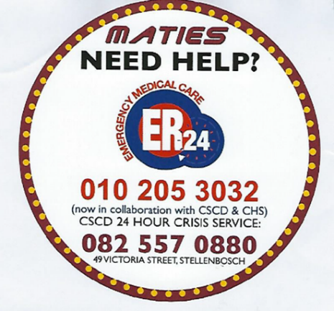

- ER24 service includes a medical assessment for medical emergencies as well as the services of a trauma counsellor, free of charge.
- Counselling can be face-to-face or telephonic, depending on the need of the student. The medical assessment of a student at the scene is free of charge.
- A fee will be charged if an ambulance has to transport the student to hospital. If the student is not able to pay for that service, financial assistance from the University can be negotiated with the Director of the Centre for Student Counselling and Development.

4. REPORTING OF AN INCIDENT

If a criminal offence has occurred, immediately also report it to the local police station (SAPS: 10111).

Please report any incident that occurs during your training to ensure that the FMHS may monitor the safety of student placements on the distributed training platform.
Complete the form below within 24 - 72 hours of an incident occurring.
Forms to be used by students to report an incident can be found on the FMHS website under SUNLOC. Go to Safety tab, then Safety Guidelines, then Reporting of an incident.
For Incident Report Form click here

An incident is any occurrence where a student/staff member considers that her/his safety has been compromised, e.g.
- personal injury/harm
- an attempt to injure/harm
- possessions were stolen / damaged / tampered with, or
- an attempt was made to do so

SEXUAL ASSAULT CARE

MATIES ER24: 010 205 3032

Other contact numbers include:
Thuthuzela Care Centre (sexual assault care) at Karl Bremer Hospital: (021) 948 0861

OCCUPATIONAL HIV EXPOSURE

Tygerberg Hospital Division for Infectious Diseases: 021 938 4487 (bleeper section, Tygerberg Hospital) and ask for the Infectious Diseases doctor on call

Universal precautions are to be applied at all times. Infectious body fluid exposure: Needle prick / HIV exposure event: Please see the Faculty of Medicine and Health Sciences emergency support options that are specifically available to all FMHS students.

Student HIV exposure incident
2. IOffice hours: report injury directly to CHS and Complete the incident form. After hours: report injury to C1D/ Trauma/ F1. Report to CHS the following morning and complete the incident form. CHS after hours nr is 076 431 0305. At peripheral sites: report to Dr/ Sr in charge.
Contact the Division for Infectious Diseases: 021 938 4487 (bleeper section, Tygerberg Hospital) and ask for the Infectious Diseases doctor on call or Dr/ Sister in charge at local facility

1. Wash skin with water and soap, or rinse mucous membranes with water
3. Post-exposure prophylaxis*:
Take TRUVADA and ALUVIA available triple therapy immediately (do not delay for blood draw or results)

Source is
HIV negative
3.1 Draw blood from source:
HIV (ELISA)
Hepatitis B (sAg)
Hepatitis C (IgG)

Send bloods to NHLS laboratory
Stop ARVs

Continue with ARVs for 28 days
Source is
HIV positive

AND
3.2. Draw blood from exposed person (student):
HIV (ELISA)
Hepatitis B (sAg + sAb)
Hepatitis C (IgG)

Send bloods to ………
4. Enter post-exposure support system if:
- Questions on exposure risk and PEP
- Adverse reaction on PEP
- Source: On 2nd or 3rd line ARVs
- Source: HBsAg positive
- Exposed: HBsAb titre <10
Phone Tygerberg Hospital (Division for Infectious Diseases) available 24 hours a day: 021 938 4487 (bleeper section, Tygerberg Hospital) and ask for the Infectious Diseases doctor on call.

Exposed student is HIV positive:
Stop ARVs and contact your health care practitioner /campus health services

* Post-exposure prophylaxis:
Triple therapy [Tenofovir/Emtracitabine plus Aluvia or Tenofovir/Lamivudine/Dolutegravir] are available at all distributed platform training sites (check with SUNLOC)
Campus Health Services (Sr. February)
NO contra-indications for taking first dose - ONLY contra-indication for full course is renal failure

Submitted to CUT, April 2022

