ISIKHOKELO SOKUVUMA KOMNTWANA

QAPHELA! LICIME ELI KHASI PHAMBI KOKUSEBENZISA ISIKHOKELO KWIPROWUJEKTI YAKHO!

Nceda uqaphele:

- Abantwana abanakho ukuba nengqiqo ngeengongoma ezisisiseko sophando mabanikwe ithuba lokunikezela ngemvume yokuba sesifundweni sophando. Ngopkuqhelekileyo abantwana abaphakathi kweminyaka esi-7 neli-17 mabanike imvume yophando. Lo asingomqathango umisiweyo yaye abanye abantwana abangaphantsi kweminyaka esi-7 banganawo umbnono nengqiqo yokunikezela ngemvume yophando.
- Xa besala ukunikezela ngemvume, nokwala oko kwabo kufuneka kwamkelwe, akukhathaliseki nokuba abazali bebevumile na. Zingakho izehlo ezahlukileyo apho lo mqathango unakho ukungasebenzi. Kufuneka kuboniswane ne-REC.
- Esi sikhokelo senzelwe kuphela abantwana abaneminyaka ephakathi kwesi-7 ne-12 leminyaka kanti nakwabo bafikisayo ebuntwini obudala sinakho ukusetyenziswa.
- Ukuba uza kufaka iindidi zabantwana kwiprowujekti yakho, uza kudinga iindidi ezimbini zeemvume eziguqulweyo, enye yeyabantwana abaselula, eyesibini yeyabo bafikisayo ebuntwini obudala yaye kufuneka ibe neenkcukacha ezininzi.
- Esi sikhokelo ungasisebenzisela ukuba masimelane nezidingo zeprowujekti yakho, oko kuhlanganisa ukucinywa kwamacandelo abonakala ukuba awafanelekanga.
- Olu xwebhu lokuvuma kufuneka lusetyenziswe kunye neNcwadana eneeNkcukacha zabaZali kunye noXwebhu lweMvume, nazo kufuneka zibandakanye iprowujekti ngokunzulu kwicala leeenkcukacha.
- Ukuba iprowujekti yakho yamkelwe yaye unenombolo yesalathisi, ezo nkcukacha ‘zisemazantsi’, endaweni yazo ungabhala ezakho, nanku umzekelo: INombolo yeProwujekti …… IsiKhokelo seMvumo, Version 1.1; Umhla: ngowe-10.ku-Agasti ngo-2009.

EMBED Word.Picture.8 | IDYUNIVESITHI YASESTELLENBOSCH  KWICANDELO LENZULULWAZI NGEZEMPILO | 

INCWADANA YEENKCUKACHA ZOMTHATHI-NXAXHEBA NOXWEBHU LOKUVUMA

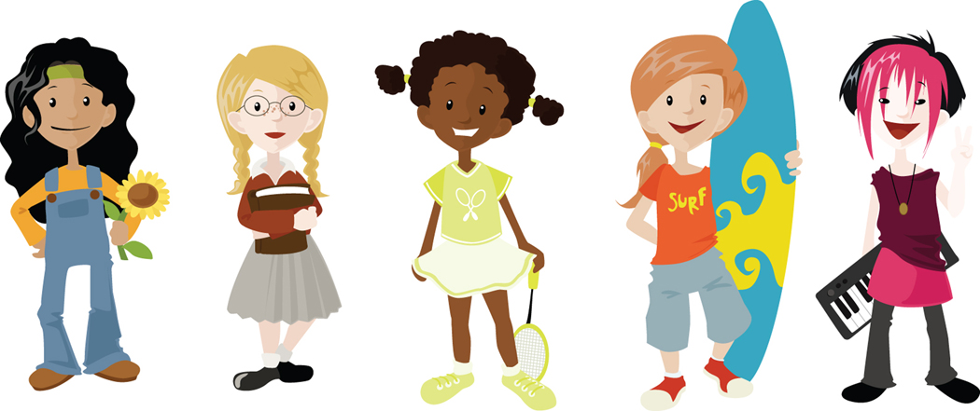

ISIHLOKO SEPROWUJEKTI YOPHANDO:
Faka isihloko seprowujekti yakho. Mawufundeke lula umbhalo xa kukho imfuneko.

IGAMA (AMAGAMA) ABANTU ABAPHANDAYO:

IDILESI:

INOMBOLO YOQHAGAMSHELWANO:

Luyintoni na UPHANDO?

Uphando ngumsebenzi esiwenzayo ukuze sizuze ulwazi olutsha ngendlela izinto (nabantu) abasebenza ngayo. Sisebenzisa iiprowujekti zophando okanye izifundo sizinceda ukuze sazi ngokubanzi ngezifo nangengulo. Kwakhona uphando luyasinceda ekufumaneni iindlela eziphucukileyo zokunceda okanye zokunyanga abantwana abagulayo.

Le prowujekti yophando imalunga nantoni na?
Nika inkcazelo ngeprowujekti yakho ngolwimi olulula olubafaneleyo abantwana nolunobuhlobo. Iinkcukacha ozifumanayo zisebenzisele ubudala obulingene abantwana ozimisele ukubadibanisa apho.

Bekutheni ukuze ndimenyelwe ukuthatha inxaxheba kule prowujekti yophando?

Lo mbuzo wuphenduleusebenzisa intetho evakalayo nelula.

Ngubani okanye ngoobani abaphandayo?
Zazise uxele nomntu omsebenzelayo okanye xela isizathu sokulwenza kwakho olu phando.

Kuza kwenzeka ntoni xa ndikwesi sifundo?
Xelela umthathi-nxaxheba ngezinto eziza kulindelwa ukuba makazenze. Zichaze zonke iindlela zokusebenza usebenzisa intetho evakala lula ukanti neengongoma ezinobucukubhede kwanezonyango bachazele ngazo.

Ikhona na into embi enokundehlela?
Nika inkcazelo ngomngcipheko anokungena kuwo umntwana, sebenzisa intetho elula nevakalayo. Ukuba kungakho into evisa iintlungu,makuchazwe oko kuxwebhu lwemvumo. Chaza ukuba umntwana makabazise abazali bakhe xa egula okanye xa esiva iintlungu ngenxa yokuba ekhona kwesi sifundo.

Ikhona into elungileyo enokwenzeka kum?
Baxelele abantwana ngoncedo olwaziyo kuphela malunga nesi sihloko. Nakwabanye ungaluhlanganisa naluphi na uncedo olunokufumaneka kwixa elizayo. Xa lungekho uncedo olwaziyo, baxelele ngolo hlobo.

Ukhona umntu onokuyazi into yokuba ndikhona kwesi sifundo?
Chaza ngentetho evakalayo nelula ukuba ukuthatha inxaxheba kwesi sifundo kwakuba yimfihlelo, noxa kunjalo zonke iinkcukacha ezimalunga nomthathi-nxaxheba zakunikezelwa kummeli wesifundo. (QAPHELA: Ezi nkcukacha zisenokungasebenzi kumaxwebhu emvume afanele abantwana abancinane).

Ndinhgathetha nabani ngesifundo esi?

Bhala uludwe lwabantu abafanelweyo sesi sihloko (kudityaniswe neenkcukacha zokuqhagamshelana nabo) ukuba kukho imibuzo umntu afuna ukuyibuza okanye xa enengxaki ezimalunga nesi sifundo.

Ukuba andifuni kuyenza le nto kwakwenzeka ntoni?
Mxelele umthathi-nxaxheba ukuba usenokwala ukuthatha inxaxheba nokuba abazali bebesele bevumile. Baxelele kananjalo ukuba bangayeka ukubakhona esifundweni nanini na yaye soze bangene ezinkathazweni.

Esi sifundo sophando unengqiqo na ngaso yaye uyavuma ukuthatha inxaxheba kuso?
EWE |  | HAYI

Umphandi uyiphendule yonke na imibuzo yakho?

EWE |  | HAYI

Uyayiqonda into yokuba nanani na ungayeka ukubakhona kwesi sifundo?

EWE |  | HAYI

________________________ ________________________
Ukutyikitya komntwana: Umhla:

