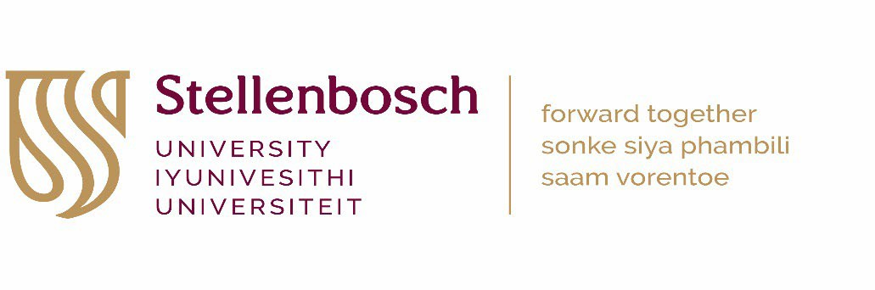

HEALTH RESEARCH ETHICS COMMITTEE 1 AND 2 PAYMENT INSTRUCTION: HEALTH/HUMAN RESEARCH RECIPROCAL REVIEWS - 2023
(INFORMATION SHOULD BE TYPED)
Please submit this completed form and proof of payment (or internal requisition number) with your HREC application

SECTION 1: DETAILS OF APPLICANT/PRINCIPAL INVESTIGATOR
Title, First name, Surname: |  | SU Number: | PROJECT ID NUMBER/ETHICS REFERENCE NO  (HREC office use only)
University DIVISION or DEPARTMENT:
SECTION 2: TITLE OF STUDY
Title of Research Project:
SECTION 3: FUNDING SOURCE (Please check [X] the relevant funding source and indicate funder and project budget)
 | A. NIH/US government funded research
 | B. Other international grant funded research (e.g. Wellcome Trust)
 | C. National grant funded research (e.g. NRF, MRC, CSIR, etc.)
 | D. Harry Crossley funded research (exempt from HREC review fees)
 | E. Research funded solely from SU departmental budget (exempt from HREC review fees)
 | F. Self funded research (exempt from HREC review fees)
 | G. Non-sponsored student research for degree purposes at Stellenbosch University (exempt from HREC review fees)
FUNDER:
TOTAL PROJECT BUDGET:
SECTION 4: SUBMISSION FOR HREC REVIEW
(Please circle/highlight the appropriate HREC fee for either section A + B: International grant or C: National grant)
Submission for HREC review |  |  |  | HREC FEE
 |  |  |  | A + B | C
1. New application (research budget > R10million) |  |  |  | R15 460.00 | R3 875.00
2. New application (research budget > R5million) |  |  |  | R10 210.00 | R3 875.00
3. New application (research budget R1million to R5million) |  |  |  | R6 960.00 | R3 875.00
4. New application (research budget R500,000 to R1million) |  |  |  | R3 640.00 | R2 075.00
5. New application (research budget R100,000 to R500,000) |  |  |  | R1 865.00 | R1 035.00
6. New application (research budget < R100,000) |  |  |  | R860.00 | R520.00
7. Extension / Roll-over study / Sub-study |  |  |  | R860.00 | R520.00
8. Annual re-certification / Progress report |  |  |  | R860.00 | n/a
9. Protocol amendment: Major (changes to study aims/methods/procedures) |  |  |  | R860.00 | R520.00

Protocol amendment: Minor (small changes that do not affect study design)
Informed consent amendment
Additional investigator (per investigator)
R625.00
R625.00 R440.00
n/a
R365.00
n/a
SECTION 5: HREC PAYMENT (Insert the amount you circled in Section 4 above)
……………………………………………..
Print Name
……………………………
Date
………………………………….R……………………………
SignatureAmount Paid

PAYMENT PROCESS:

Stellenbosch University applicants
- Submit a completed and signed Payment instruction form: health/human research AND proof of payment/internal requisition number along with your HREC application for a new project, progress report, amendment etc.
- Interdepartmental requisitions are payable to: Cost Centre 0885
- Payment reference: “Principal Investigator’s surname and initials: Ethics reference number and Project ID”
- Research applications with outstanding HREC review fees will not enter the review process.

External applicants
- Submit a completed and signed Payment instruction form: health/human research along with your HREC application for a new project, progress report, amendment etc.
- You will receive an HREC invoice.
- Payment reference: “Principal Investigator’s surname and initials: Ethics reference number and Project ID”
- Research applications with outstanding HREC review fees will not receive their HREC letter.

Enquiries: Elvira Rohland elr@sun.ac.za

