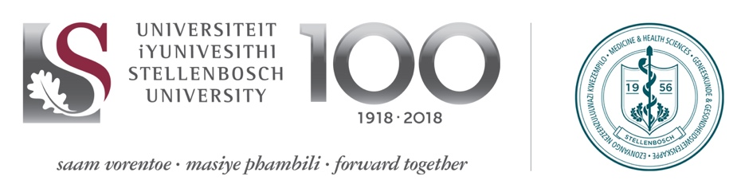

Application form for DAAD scholarships for MSc or PhD study at Stellenbosch University Division of Molecular Biology and Human Genetics (first step)

Send electronically completed application form and required documents to mbhgapplications@sun.ac.za

Deadline: 30 April 2020, at midnight

 |  |  |  |  |  | Office use
Application | MSc |  |  | PhD
First name(s)
Family name
Gender | Male |  |  | Female
Citizenship
Visa type for studying in South Africa
Sub-Saharan African region | West | Southern |  | Central | East
Highest qualification | Degree
 | Institution
 | Year obtained
 | Final mark
Current activities | Position/degree of study
 | Institution
 | Duration
 | If study, expected completion date |  | month/year
English proficiency | Basic | Conversant |  | Fluent | Native
Other languages

Provide a personal statement. Include the reasons for wanting to get a MSc or PhD degree, what topic you would like to study and how you will use the acquired skills to the benefit of your home country in future (max 500 words).
Documentation included | Yes/No
Hand signed curriculum vitae*
Recommendation letter by university teachers (Master 1, PhD 2)
Certified copies of university degree certificates
Certified copies of academic transcripts
Copy of passport
*(please use the European specimen form at http://europass.cedefop.Europa.eu), including a list of publications (if applicable).

