

GAUTENG DEPARTMENT OF EDUCATION
PREPARATORY EXAMINATION
2017
10832
LIFE SCIENCES
SECOND PAPER

TIME: | 2½ hours
MARKS: | 150

18 pages

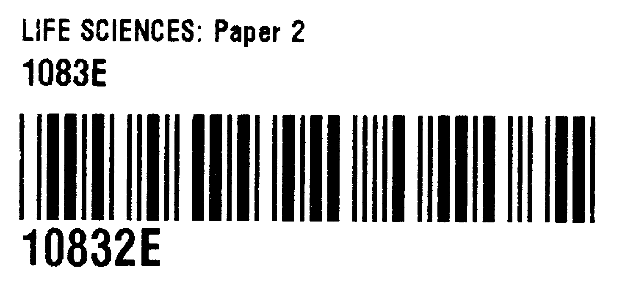
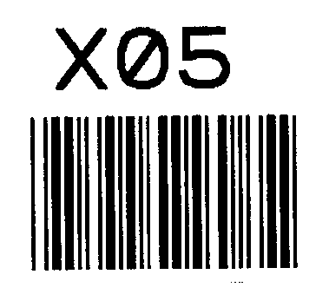
M
GAUTENG DEPARTMENT OF EDUCATION
PREPARATORY EXAMINATION

LIFE SCIENCES
(Second Paper)

TIME: 2½ hours

MARKS: 150

INSTRUCTIONS AND INFORMATION
Read the following instructions carefully before answering the questions.
- Answer ALL the questions.
- Write ALL the answers in the ANSWER BOOK.
- Start the answers to EACH question at the top of a NEW page.
- Number the answers correctly according to the numbering system used in this question paper.
- Present your answers according to the instructions of each question.
- Make ALL drawings in pencil and label them in blue or black ink.
- Draw diagrams, flow charts or tables only when asked to do so.
- The diagrams in this question paper are NOT necessarily drawn to scale.
- Do NOT use graph paper.
- You may use a non-programmable calculator, protractor and a compass where necessary.
- Write neatly and legibly.

SECTION A
QUESTION 1
1.1 MULTIPLE-CHOICE QUESTIONS
Various options are given as possible answers to the following questions. Choose the correct answer and write only the letter (A – D) next to the question number (1.1.1. – 1.1.8) in the ANSWER BOOK, for example 1.1.9 D.
1.1.1 The diagram below represents part of a DNA molecule.
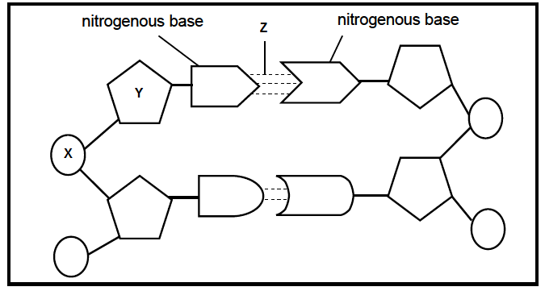
The correct labels for parts X, Y and Z respectively are …
A deoxyribose sugar, phosphate and hydrogen bond.
B phosphate, deoxyribose sugar and hydrogen bond.
C ribose sugar, nitrogenous base and peptide bond.
D phosphate, ribose sugar and hydrogen bond.
1.1.2 Study the list below.
1 Fossils
2 Modification by descent (Homologous structures)
3 Biogeography
4 Genetics
Which of the above combinations can be used as evidence for evolution?
A 1, 2 and 3 only
B 1, 2, 3 and 4
C 2, 3 and 4 only
D 1, 3 and 4 only

1.1.3 In humans, light hair colour is recessive to dark hair colour. In one family, the mother has dark hair, the father has light hair, one daughter has light hair and the other daughter has dark hair.

Which ONE of the following combinations best represents the genotypes for the mother and the daughter with dark hair?
A mother DD, daughter DD
B mother Dd, daughter Dd
C mother DD, daughter Dd
D mother Dd, daughter DD
Questions 1.1.4 and 1.1.5 are based ON THE FOLLOWING FLOW DIAGRAM, which is a representation of one pair of homologous chromosomes in a cell during meiosis.
Process 1
Process 2
Process 3
KEY: Chromosomes
A B
C
D
1.1.4 Which ONE of the following best represents the characteristics of the cells labelled D?
A Diploid and genetically identical
B Diploid and genetically different
C Haploid and genetically identical
D Haploid and genetically different
1.1.5 Process 1 represents …
A meiosis I.
B transcription.
C meiosis II.
D DNA replication.

1.1.6 The fossil of Australopithecus sediba (Karabo) was discovered by …
A Tim White.
B Lee Berger.
C Louis and Mary Leakey.
D Raymond Dart.
1.1.7 Ultraviolet radiation causes mutations, which sometimes leads to antibiotic resistance in bacteria. To investigate this, bacteria were first exposed to ultraviolet radiation and then their resistance to different antibiotics was measured. The results are shown in the table below.
✓ = resistant X = non-resistant

 | Antibiotic resistance
Treatment | Antibiotic P | Antibiotic R | Antibiotic S
Before exposure to ultraviolet radiation | ✓ | X | X
After exposure to ultraviolet radiation | ✓ | X | ✓

A suitable conclusion for the investigation would be that a mutation in bacteria led to a resistance to antibiotic …
A R only.
B P and R.
C S only.
D R and S.
1.1.8 In the tobacco plant, albinism (the inability to make chlorophyll) is a recessive trait. Two heterozygous tobacco plants were crossed and 300 seedlings were produced. What is the percentage chance that the seedlings will have albinism?
A | 75%
B | 300%
C | 50%
D | 25%
(8x2) |  |  | (16)

1.2 Give the correct biological term for each of the following descriptions. Write only the term next to the question number (1.2.1 – 1.2.8) in your ANSWER BOOK.
1.2.1 A large opening at the base of the skull through which the spinal cord passes
1.2.2 The type of inheritance where two different alleles of a gene are expressed in the phenotype
1.2.3 An explanation of evolution that describes the speed at which it takes place
1.2.4 A genetic cross involving only one characteristic
1.2.5 A testable statement that can be supported by scientific evidence
1.2.6 The natural shape of the DNA molecule
1.2.7 The position of a gene on a chromosome
1.2.8 A sex-linked disorder that affects the photoreceptors in the eye
(8x1) | (8)
1.3 Indicate whether each of the descriptions in COLUMN I applies to A ONLY, B ONLY, BOTH A AND B or NONE of the items in COLUMN II. Write A only, B only, both A and B or none next to the question number (1.3.1 – 1.3.2) in the ANSWER BOOK.

COLUMN I |  | COLUMN II
1.3.1 | The physical appearance of an organism due to its genetic composition | A  B | Genotype  Phenotype
1.3.2 A sex-linked disorder |  | A  B | Haemophilia  Down’s Syndrome

(2x2) | (4)
Use of fire
Use of tools
1.4 The phylogenetic tree below shows a possible representation of human evolution.

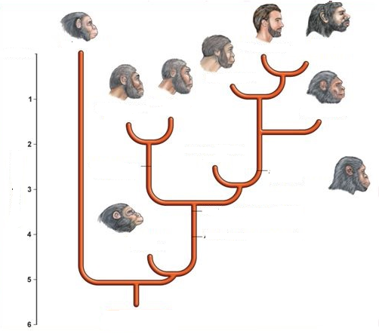
Time (millions of years ago)
Hominin ancestor
Australopithecus afarensis
Australopithecus anamensis
Australopithecus africanus
Australopithecus garhi
Ardipithecus ramidus
Homo habilis
Homo neanderthalensis
Homo erectus
Homo sapiens
Pan troglodytes
Paranthropus
robustus
Paranthropus
boisei
Paranthropus
aethiopicusus
Present
[Adapted from: www.humanevolutionofficial.weebly.com]
1.4.1 Name the most recent common ancestor of the Homo genus. |  | (1)
1.4.2 Give the period of existence for the species mentioned in QUESTION 1.4.1 |  | (2)
1.4.3 State the number of genera represented in the diagram. |  | (1)
1.4.4 Based on the diagram, give ONE facial feature that differentiated humans from Australopithecus africanus. |  | (1)
1.4.5 Identify any TWO species that used both tools and fire. |  | (2)
1.4.6 Name any ONE Australopithecus africanus fossil found in South Africa. |  | (1)
1.4.7 List TWO types of evidence that can be used to support the “Out of Africa” hypothesis. |  | (2)
 |  | (10)

1.5 In fruit flies, the characteristic for body colour is either grey colour or black colour. A second characteristic is normal wings or vestigial wings. Vestigial wings are crumpled and therefore prevent flies from flying properly.
1.5.1 In a cross between a fly that is homozygous dominant for both traits and a fly that is homozygous recessive for both traits, all the offspring are grey with normal wings. Identify the ...  - dominant trait for body colour.  - recessive trait for wing type. |  | (1)  (1)
1.5.2 This is a cross describing two characteristics. What type of cross does it represent? |  | (1)
1.5.3 Use the letters (B) for body colour and (W) for wings.  A fly is heterozygous for both traits. Give the ...  - genotype of the fly.  - phenotype of the fly.  - possible genotypes of the gametes that this fly can produce. |  | (1)  (1)  (2)
 |  | (7)

1.6 The table below shows the DNA base triplets that code for various monomers of proteins.

DNA Template | Monomer X
AAA | Phenylalanine
ACA | Cysteine
TCA | Serine
ATA | Tyrosine

1.6.1 Where would the DNA template be found in the cell? | (1)
1.6.2 Name the ...  - monomer X.  - bond that would form between the monomers. | (1)  (1)
1.6.3 Give the:  - codon for Tyrosine.  - anticodon for Cysteine. | (1)  (1)
 | (5)
TOTAL SECTION A: | 50

SECTION B
QUESTION 2

2.1 The graph below shows the variation of heights of a group of 18-year-old students.

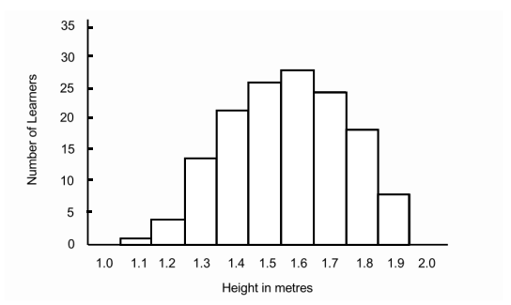

2.1.1 Identify the type of graph represented. | (1)
2.1.2 Explain why this type of graph mentioned in QUESTION 2.1.1 is most suitable for plotting data on continuous variation. | (2)
2.1.3 What is the most common height? | (1)
2.1.4 How many people in the group were shorter than 1.3 metres? | (1)
 | (5)

2.2 Insulin is a protein. The diagram below shows the process of how insulin is made.

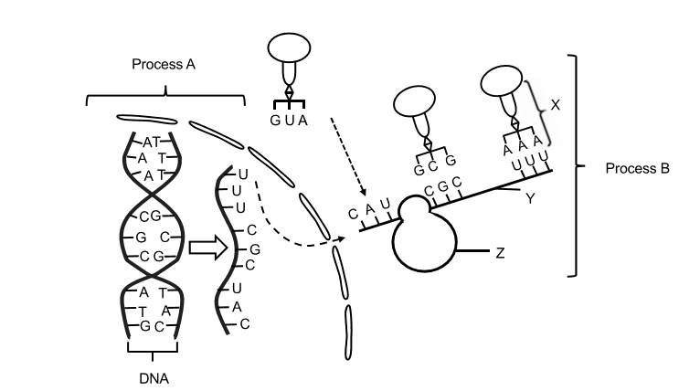

2.2.1 Name the following:
(a) Molecule X | (1)
(b) Process B | (1)
2.2.2 Describe Process A. | (5)
2.2.3 A sample of DNA was analysed and 28% of the nucleotides contain thymine. Calculate the percentage of nucleotides which contain cytosine. Show your working. | (3)
2.2.4 Describe how a DNA mutation will affect the structure of the protein formed. | (4)
2.2.5 Tabulate TWO differences between DNA and RNA. | (5)
 | (19)

2.3 The diagram below shows a cell during a phase of meiosis.
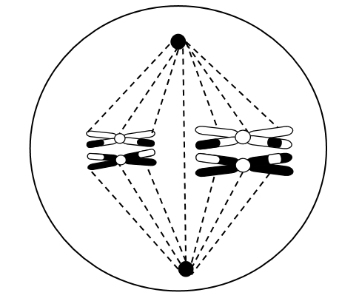
A
BA
 | 2.3.1 Give labels for:
 | (a) A | (1)
 | (b) B | (1)
 | 2.3.2 Identify the phase in the diagram. | (1)
 | 2.3.3 Give a reason for your answer to QUESTION 2.3.2. | (1)
 | 2.3.4 Explain why this is a diploid cell. | (2)
 | 2.3.5 How many chromosomes will there be in each of the gametes produced by this cell? | (1)
2.4 Explain the importance of genetic variation in the process of evolution. |  | (2)
 |  | (9)

2.5 The passage below refers to genetically modified foods.

GENETICALLY MODIFIED FOOD ON THE MENU

A research agency’s survey has found that South Africans are becoming more accepting of genetically modified (GM) food.

The survey found that 64 percent of South Africans now believe that GM food would become more widely accepted and less risky in the next few years.

An earlier survey revealed that people thought the risks outweighed the benefits.

2.5.1 Define the term genetically modified food. | (2)
2.5.2 Give TWO steps that should be considered in planning the survey. | (2)
2.5.3 State the following with regard to genetically modified organisms:
(a) TWO benefits | (2)
(b) ONE disadvantage | (1)
 | (7)
 | [40]

QUESTION 3
3.1 The diagram below shows the inheritance of coat colour in pigs through three generations.

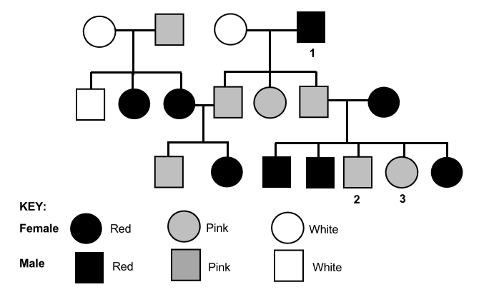
White

White

3.1.1 What type of inheritance is shown in the pedigree diagram? | (1)
3.1.2 Explain your answer to QUESTION 3.1.1 | (2)
3.1.3 Use R for the allele for red coat colour and W for the allele for white coat colour to give the possible genotype/s of:
(a) Individual 1 | (1)
(b) Individual 2 | (1)
3.1.4 The pig farmer is interested in breeding pigs with red coats. He has a red-coated male pig that he wishes to use for breeding purposes. He crosses the pig with individual 3.
Use a genetic cross to show the probability of the piglets being born with red coats. | (6)
 | (11)

3.2 | Brassica plants have hairs on their leaves to reduce transpiration. The number of hairs on the leaves vary from plant to plant.  An investigation was conducted to determine whether artificial selection could increase the number of plants with more hairs on the leaves.  The students carried out the following procedure:  - 180 Brassica plants were grown. This is the first generation.  - The number of hairs present on the edge of each mature leaf was counted per plant and an average was calculated.  - The number of plants, with their averages, was counted and recorded.  - The plants with the most hairs, i.e., 25 or more hairs on the leaves were separated from the rest of the group and cross pollinated with one another.  - The seeds produced by these crosses were germinated and allowed to grow into plants. 180 of these plants were selected to represent the second generation.  - The number of hairs present on the edge of a mature leaf from each of the second generation of plants was recorded.  The results of the investigation are shown below.

WITHOUT ARTIFICIAL SELECTION |  |  | WITH ARTIFICIAL SELECTION
Average  number of hairs | Number of plants |  | Average number of hairs | Number of plants
0-5 | 50 |  | 0-5 | 8
6-10 | 35 |  | 6-10 | 5
11-15 | 24 |  | 11-15 | 18
16-20 | 20 |  | 16-20 | 25
21-25 | 25 |  | 21-25 | 35
26-30 | 12 |  | 26-30 | 45
31-35 | 8 |  | 31-35 | 30
36-40 | 6 |  | 36-40 | 14
[Adapted from: www.media.collegeboard.com]

 | 3.2.1 | Identify the:
 |  | - Independent variable | (1)
 |  | - Dependent variable | (1)
 | 3.2.2 | State TWO ways in which the students ensured that this investigation was valid. | (2)
 | 3.2.3 | Give a conclusion for this investigation. | (2)
 | 3.2.4 | State TWO ways in which the learners could have made their results more reliable. | (2)
 | 3.2.5 | Draw a histogram showing the results with artificial selection. | (6)
 | 3.2.6 | Describe TWO differences between natural and artificial selection. | (4)
 |  |  | (18)

3.3 The diagram below shows the elongation of the neck of the giraffe according to Lamarck.
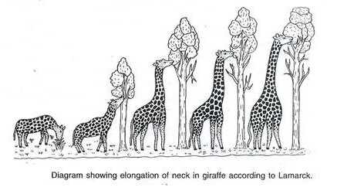

 | 3.3.1 Use the example in the diagram to describe Lamarck’s theory for changes in the giraffe’s neck over time. |  | (3)
 | 3.3.2 Why was Lamarck’s theory rejected? |  | (2)
 |  |  | (5)

  - The diagram below shows one method of cloning sheep.

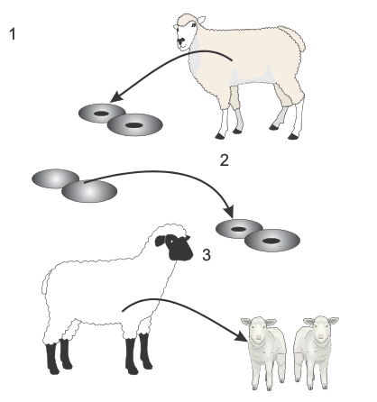
An embryonic cell is removed from the donor sheep and allowed to multiply.
The nuclei are taken from the donor cells and imported into “foster eggs” (nuclei-less ova from another sheep). They are allowed to develop.
The eggs are implanted into the wombs of foster sheep where they will develop until birth.

 | - Explain why the lambs produced by this technique are identical to each other. |  | (2)
 | - Explain why the lambs are not genetically identical to the sheep which produced the “foster” eggs. |  | (2)
 | - Describe how cloning in animals or plants can be beneficial to humans |  | (2)
 |  |  | (6)
 |  | [40]
TOTAL SECTION B: |  | 80

SECTION C
QUESTION 4
Describe Darwin’s theory of Natural Selection and explain how it could lead to speciation by geographical isolation.
Content: |  | (17)
Synthesis: |  | (3)
NOTE: NO marks will be allocated for answers in the form of flow charts, diagrams or tables.
 | TOTAL SECTION C: | 20
 | TOTAL: | 150

