ADDITIONS TO MEMORANDUM AFTER MEMO DISCUSSION PAPER 1 SEPTEMBER 2017
ADDITIONS ARE INDICATED IN RED

section a

QUESTION 1

1.1

1.1.1 | C
1.1.2 | D
1.1.3 | B
1.1.4 | C
1.1.5 | B
1.1.6 | A
1.1.7 | A
 | (7x2) | (14)

1.2
 |  | 1.2.1 | Gibberellins
 |  | 1.2.2 | Fallopian tube/ oviduct
 |  | 1.2.3 | Gestation
 |  | 1.2.4 | Umbilical chord
 |  | 1.2.5 | Epididymis
 |  | 1.2.6 | ADH
 |  | 1.2.7 | Aldosterone
 |  | 1.2.8 | Embryo
 |  | 1.2.9 | Implantation
 |  | (9x1) |  | (9)
1.3
 |  | 1.3.1 | A only
 |  | 1.3.2 | B only
 |  | 1.3.3 | A only
 |  | 1.3.4 | Both A and B
 |  |  | (4x2) | (8)

1.4 | 1.4.1 | (a) F  (b) A | (1)  (1)
 | 1.4.2 | (a) Plays a role in informing the cerebellum about movement of  the head / balance  (b) It controls all voluntary actions  It receives and interprets all sensations viz. sight, hearing, smell, taste.  It controls all higher thought processes such as memory,  judgement, and reasoning. Any 1 | (1)  (1)
 | 1.4.3 | (a) Pituitary gland/hypophysis  (b) LH / luteinising hormone | (1)  (1)
 |  |  | (6)

1.5
 | 1.5.1 | (a) Spindle fibres  (b) Centromere  (c) Centriole | (1)  (1)  (1)  (1)
 | 1.5.2 | (a) Metaphase II  (b) Anaphase I | (1)  (1)
 | 1.5.3 | 4 | (1)
 | 1.5.4 | Crossing over | (1)
 | 1.5.5 | 2 | (1)
 | 1.5.6 | Metaphase I | (1)
 | 1.5.7 | - Reduces the number of chromosomes by half which results in the formation of gametes  - Ensures that chromosome number remains constant within species | (2)
 | 1.5.8 | (a) Ovaries  (b) Testes/seminiferous tubules | (1)  (1)
 |  |  | (13)

 | TOTAL SECTION A: | 50

section b

question 2

2.1 | 2.1.1 | Day 14 | (1)
 | 2.1.2 | There is an marked increase in LH levels in the blood from day 12 to 14 | (2)
 | 2.1.3 | There is a developing / growing follicle in the ovary which is secreting the oestrogen causing the increasing levels | (2)
 | 2.1.4 | - Oestrogen causes the endometrium / lining of the uterus  - to become thicker and more vascular  - in preparation for implantation of the zygote  any 2 | (2)
 | 2.1.5 | (a) No  (b) - The progesterone level has dropped. This means that the corpus luteum has degenerated  - FSH levels begin to rise as progesterone is no longer inhibiting secretion  (Mark first ONE only) Any 1x2 | (1)  (2)
 |  |  | (10)
2.2 | 2.2.1 | The enzymes secreted by the acrosome digest the outer coat of the ovum | (1)
 | 2.2.2 | Tail / flagellum | (1)
 | 2.2.3 | - the tail is very long  - to create wavelike movement  - and propel the sperm through seminal fluid  Any 2 | (2)
 | 2.2.4 | - Mitochondrion  - Provides energy to the spermatozoa to swim to reach the ovum | (2)
 | 2.2.5 | - accessory organs / prostate  - produce alkaline fluid to neutralize acids in urine | (2)
 | 2.2.6 | 35ºC / 2ºC lower than body temperature | (1)
 |  |  | (9)

2.3 | 2.3.1 | Total amount of solid waste in a town from 1999 to 2004  Total amount of solid waste (tons)  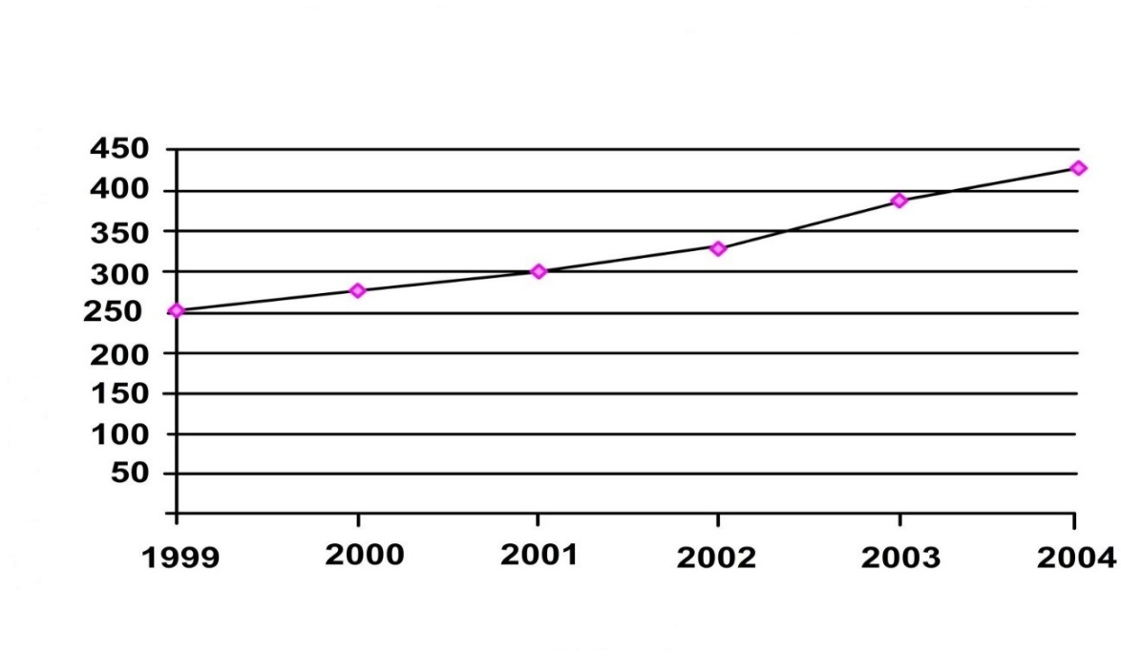  Year

 | Criterion Elaboration Mark  Type of graph Line graph drawn 1  Caption Includes both variables 1  X-axis Correct label and units and correct scale 1  Y-axis Correct label and units and correct scale 1  Plotting of points 1 mark: 1 – 4 points plotted correctly 2 marks: All 6 points plotted correctly 2 |  | (6)
 | 2.3.2 | 388 – 300 = 88 tons | (3)
 | 2.3.3 | - Construction of more landfills– Could create a negative impact on the environment / land pollution / seepage into groundwater  - Recycling of materials such as glass, plastic, metal  Decrease pollution of the environment  - Combustion of waste– Positive on land pollution, but negative on air pollution  - Composting of organic matter– increases the fertility of the soil  - Providing incentives/education to the public to recycle their rubbish– reduces pollution  (Mark first TWO only) Any 2x2  (One mark for strategy, and one mark for impact) | (4)
 |  |  | (13)

2.4 | 2.4.1 | - Excess CO₂ leads to global warming  - because of the enhanced greenhouse effect  - global warming could cause drought and floods / changes in weather patterns | (3)
 | 2.4.2 | - Availability  - Alien invasive plants may use water excessively  - and thus reduce the amount of water available for the natural vegetation of an area  - Quality  - Alien invasive water plants in excess causes increased eutrophication,  - blocking the waterways, reducing light to other aquatic plants.  - These plants eventually die and decompose.  - Bacteria that decompose these plants eventually depletes the oxygen supply in the water,  - causing other plants and animals to die / suffocate.  - decreasing the quality of water  or  - alien invasive aquatic plants outcompetes indigenous aqautic plants  - cause negative effect on water ecosystems  - could cause animal and plants (organisms) to die  - depleting oxygen in water  - causing decrease in water qaulity  Any | (2)  (3)
 |  |  | (8)
 |  |  | (40)

QUESTION 3
3.1 | 3.1.1 | I – fovea centralis / yellow spot | (2)
 | 3.1.2 | Light has to pass through B, the cornea, C the pupil and  G, the lens before reaching H , the retina.  (The learner must give the name and letter for each structure  to get the mark.) | (3)
 | 3.1.3 | - E / the ciliary muscles relax  - ciliary body goes back to normal position / moves backwards  - tension on J / the suspensory ligaments  - increases  - causing them to become taut / tight  - thereby pulling on G / the lens  - G / the lens becomes flattened / less convex / less round  - causing the refractive power of G / the lens is decreased  - and a clear image of the distant object / bird is formed on the  - retina  Any | (7)
 |  |  | (12)
3.2 | 3.2.1 | A mechanism in the human body that detects changes or imbalances in the internal environment and restores the balance | (2)
 | 3.2.2 | - Thyroxin levels increases above normal limits causing the pituitary gland to produce less TSH  - Low levels of TSH inhibits stimulation  - of the thyroid gland  - The thyroid gland secretes less thyroxin  - The thyroxin level thus decreases in the blood  - Thyroxin returns to normal Any | (5)
 |  |  | (7)
3.3 | 3.3.1 | Cold environmental conditions | (1)
 | 3.3.2 | - blood vessels are dilated  - to increase blood flow to the skin surface  - so that more heat is lost from the blood through radiation | (3)
 |  |  | (4)

3.4 | 3.4.1 | Between 07:00 – 08:00. | (1)
 | 3.4.2 | 93 mg / 100ml (accept range 92 – 94) | (1)
 | 3.4.3 | - After a meal or during digestion, glucose is absorbed into the blood / blood glucose levels increase  - Insulin released by pancreas, insulin levels increase  - Stimulates the conversion of excess glucose into glycogen  - which is stored in the liver / muscles  - stimulates the body cells to use glucose for cellular respiration  - This helps to drop raised blood glucose levels after a meal  Any 4 | (4)
 | 3.4.4 | Insulin levels will not rise after a meal / would stay the same and would remain relatively low. | (1)
 |  |  | (7)
3.5 | 3.5.1 | (a) gravity /the effect of the force of gravity  (b) the direction of growth of young roots | (1)  (1)
 | 3.5.2 | - Same species of seedlings  - Same temperature  - Same light conditions  - Same age of seedlings  - Same amount of water  - Place in the same place  - same method of mounting  - same initial direction of roots  - same type of cork disk  (mark first TWO only) Any 2 | (2)
 | 3.5.3 | - Repeat the investigation  - Increase the sample size / use more than 6 seedlings  (mark first ONE only) Any 1 | (1)
 | 3.5.4 | - To remove the effect of gravity  - on the direction of growth of young roots/act as a control | (2)
 | 3.5.5 | Radicles in apparatus B bend or grow downwards and grow towards gravity/positive geotropism . | (2)
 | 3.5.6 | The force of gravity (cancel tick),has an effect on the direction of growth of young roots/causes roots to grow downwards. | (1)
 |  |  | (10)
 |  |  | (40)
 |  | TOTAL SECTION B: | 80

SECTION C
QUESTION 4
Reflex action
- Pain receptors in the skin of his foot become stimulated
- They convert the stimulus of pain into an impulse
- which is then transmitted by the sensory neuron
- through the dorsal root of the spinal nerve
- into the spinal cord
- Synaptic contact is made
- with the interneuron
- and then with the motor neuron.
- An impulse is then transmitted by the motor neuron via the ventral root
- of the spinal nerve
- to the effector organ / muscle
- which contracts to withdraw his foot.
Max 8
Balance
- The cristae
- found in the ampulla
- at the base of the semi-circular canals
- are stimulated by the change in direction and speed of the head.
- The maculae
- in the utriculus
- and sacculus
- are stimulated by the change in the position of the head.
- Impulses are generated
- and transmitted via the auditory nerve
- to the cerebellum which also
- sends impulses to the muscles
- enabling the person to maintain balance and body position.
Max 9
 | Content:  Synthesis: |  |  | (17)  (3)  (20)

ASSESSMENT OF ESSAY

Criterion | Relevance (R) | Logical sequence (L) | Comprehensive (C)
Generally | All information provided is relevant to the topic. | Ideas are arranged in a logical / cause-effect sequence. | All aspects required by the essay have been sufficiently addressed.
In this essay | Only information relevant to the reflex arch and balance is given. (There is no irrelevant information.) | Generally each action is appropriately linked to the reflex action as well as how the person managed to maintain balance and body position with ideas arranged in a logical sequence. | The reflex action that takes place as well as how the person managed to maintain balance and body position is described.  Reflex action 5 / 7 and balance 7 / 9
Mark | R | L | C

 | Total Section C:  TOTAL: |  | 20  150

