# C:\Users\epl\AppData\Local\Microsoft\Windows\Temporary Internet Files\Content.Word\Foto0594.jpgDepartment of Educational Psychology STELLENBOSCH UNIVERSITY

**MASTERS IN EDUCATIONAL PSYCHOLOGY(MEdPSYCH) 2015-2016**

**INVITATION TO CANDIDATES FOR THE SELECTION PROCESS OF THE MASTERS DEGREE IN EDUCATIONAL PSYCHOLOGY FOR 2015-2016**

**THE SU MEdPSYCH DEGREE IN EDUCATIONAL PSYCHOLOGY CAN BE STUDIED AS FOLLOWS:**

* **Two year part-time (after hours)**
* 1st year comprises academic modules and approval of research proposal
* 2nd year comprises practicum module, approval of internship programme (submission end of July ) and completion of thesis
* 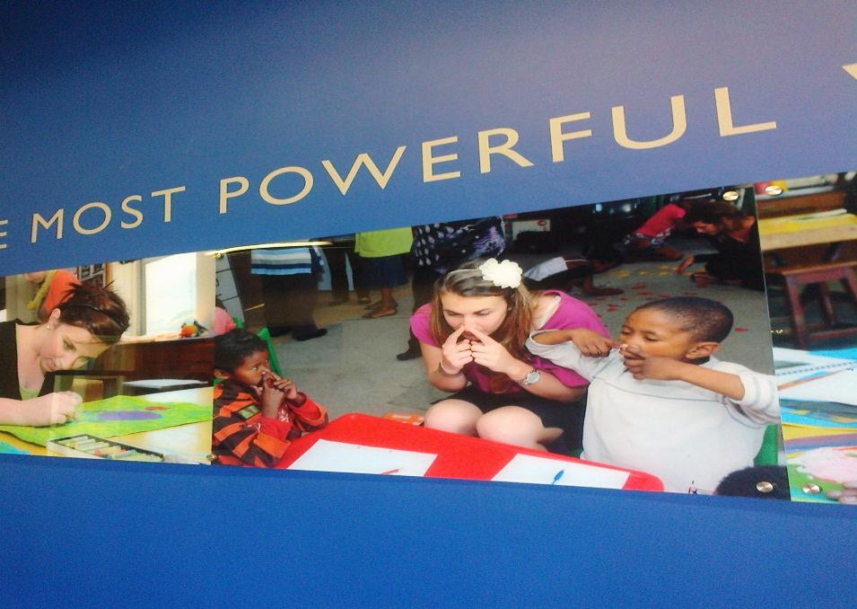In the 3rd year, a further fulltime twelve month approved internship should be completed as well as the Board for Psychology’s Examination before a student is eligible to register as an Educational Psychologist with the Health Professions Council of South Africa (HPCSA). Internship is not part of the degree – students have to finish the degree before they can start with the internship.

**PROSPECTIVE CANDIDATES MUST BE IN POSSESSION OF:**

* BEdHons degree in Educational Psychology **OR** BEdPsych/BPsych degree **OR** approved Honours degree in Psychology
* An approved teaching qualification
* A minimum of two years’ continuous, formal educational teaching experience
* A minimum of 65% for Educational Psychology or Psychology-orientated subjects passed on NQF level 8
* Visit [www.sun.ac.za/university/jaarboek](http://www.sun.ac.za/university/jaarboek) (Part 6) for further information

**ADDITIONAL SELECTION CRITERIA:**

* Academic writing competence
* Intra-personal and inter-personal skills
* Computer literacy

**APPLICATION: CLOSING DATE: 30 JUNE 2014**

* Apply on line at [www.sun.ac.za](http://www.sun.ac.za/) **OR**
* Application forms (hard copies) can be downloaded from the website [www.sun.ac.za](http://www.sun.ac.za/)

**FOR FURTHER INFORMATION/ENQUIRIES:**

* Go to [www.sun.ac.za/university/jaarboek](http://www.sun.ac.za/university/jaarboek) (Part 6) **OR** e-mail Stellenbosch University Client Services: [info@sun.ac.za](mailto:info@sun.ac.za) | 🕾 021 808 9111
* Alternatively, direct specific course enquiries to Mrs Charmaine Louw (MEdPsych Selection Co-ordinator) [cl1@sun.ac.za](mailto:cl1@sun.ac.za)

**Please note: Submission of an application form does not ensure that you will be invited automatically to the selection process**