BACKGROUND TO CA2025 STUDENT PORTFOLIO OF EVIDENCE
(Source: this document was constructed using SAICA’s CA2025 competency framework as basis)

The South African Institute of Chartered Accountants (SAICA) is the professional body to which South African Chartered Accountants (CAs(SA)) are affiliated. To become a CAs(SA), all of the following needs to be completed:
  - The Academic programme: made up of formal undergraduate (e.g. B Accounting) and postgraduate (e.g. Hons B Accounting and PGDip Accounting) qualifications.
  - Professional Assessment 1: The Initial Test of Competence (ITC). This can only be completed once a prospective CA(SA) has competed the SAICA-Accredited PGDA (e.g. Hons B Accounting and PGDip Accounting).
  - The Training programme (“articles”)
  - The Professional Programme (course that prepares the candidate for the Assessment of Professional Competence (APC))
  - Professional Assessment 2: The Assessment of Professional Competence (APC). This can only be completed once a prospective CA(SA) has competed the SAICA ITC; completed the professional programme and completed at least 20 months of the SAICA training programme.

SAICA has moved towards competency-based accreditation requirements for CAs(SA), the most recent of which contained in the CA2025 Competency Framework for Entry-Level CAs(SA). The competency framework is made up of the following components which in implementation are all integrated:

Ethically responsible leaders fulfilling their social mandate by using integrated thinking to create sustainable value | Icon | Elements of the professional competencies
 |  | Professional values and attitudes
 |  | Enabling competencies (defined as acumens)
 |  | Technical competencies in the value creation process

The Competency Framework prescribes the professional competencies that should be demonstrated by a CA(SA) at point of entry to the profession. SAICA defines professional competence as “the ability to perform a role to a defined standard”. Professional competence goes beyond knowledge of principles, standards, concepts, facts, and procedures; it is the integration and application of (1) professional values and attitudes, (2) enabling competencies and (3) technical competencies in the value creation process. Professional competence is developed and assessed over the various core components of the qualification process.” The professional competencies are listed below.

 | PROFESSIONAL VALUES AND ATTITUDES
 | I | Ethics, values and attitudes | I1 |  | Personal ethics
 |  |  | I2 |  | Business ethics
 |  |  | I3 |  | Professional ethics
 | II | Citizenship, values and attitudes | II1 |  | Personal citizenship
 |  |  | II2 |  | Professional citizenship
 |  |  | II3 |  | Corporate citizenship
 | III | Lifelong learning, values and attitudes | II1 |  | Self-development
 |  |  | II2 |  | Adaptive mind set and agility
ENABLING COMPETENCIES (DEFINED AS ACUMENS)
Z |  | Business acumen |  | Z1 |  | Business internal environment
 |  |  |  | Z2 |  | Business external environment
 |  |  |  | Z3 |  | Innovation, creativity and curiosity
Y |  | Decision-making acumen |  | Y1 |  | Analytical/critical thinking
 |  |  |  | Y2 |  | Integrated thinking
 |  |  |  | Y3 |  | Problem solving
 |  |  |  | Y4 |  | Judgement and decision-making
 |  |  |  | Y5 |  | Professional scepticism
X |  | Relational acumen |  | X1 |  | Communication skills
 |  |  |  | X2 |  | Leadership skills
 |  |  |  | X3 |  | People skills
 |  |  |  | X4 |  | Relationship-building skills
 |  |  |  | X5 |  | Teamwork
 |  |  |  | X6 |  | Self-management
 |  |  |  | X7 |  | Managing others
 |  |  |  | X8 |  | Emotional intelligence
W |  | Digital acumen |  | W1 |  | Computational thinking
 |  |  |  | W2 |  | Data knowledge and strategy
 |  |  |  | W3 |  | Data analytics
 |  |  |  | W4 |  | Automation
 |  |  |  | W5 |  | New developments and protocols
 |  |  |  | W6 |  | Cyber security
 |  |  |  | W7 |  | User competencies

TECHNICAL COMPETENCIES IN THE VALUE CREATION PROCESS
A |  | Strategy and governance to create sustainable value
B |  | Stewardship of capitals: business processes and risk management
C |  | Decision-making to increase, decrease or transform capitals
D |  | Reporting on value creation (financial statements)
E |  | Compliance (tax, laws and regulations)
F |  | Assurance and related services

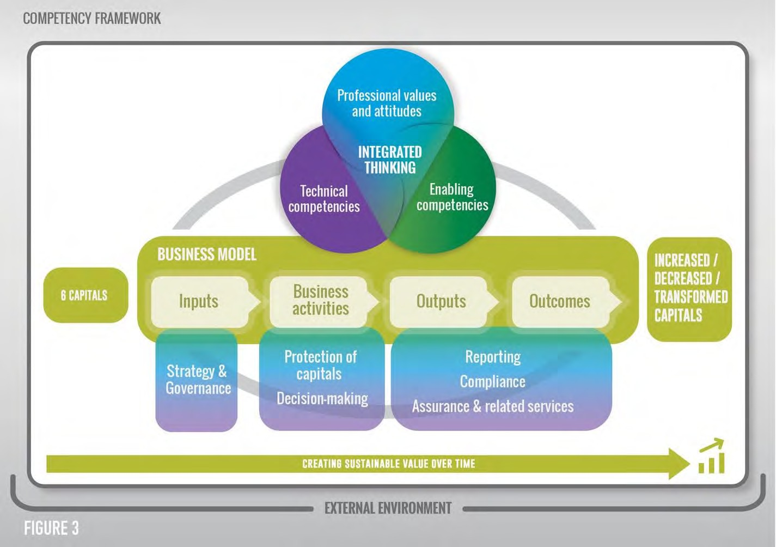
When considering the professional competencies, they should be viewed in terms of their usage in the value creation process, as depicted in the Figure below:

SAICA expects the academic programme (i.e. B Accounting and post-graduate programmes at Stellenbosch University) to address the development and assessment of both technical and the relevant non-technical competencies (i.e. the Professional Values and Attitudes and Enabling Competencies). While the academic programme will therefore seek to develop and assess these competencies, at Stellenbosch University we also believe that it is each student’s responsibility (in line with the Professional Value and Attitude of Life-long learning) to ensure that s/he is competent in relation to each of the non-technical competencies. This is where the portfolio of evidence fits in. The goal of this portfolio is to:
- Expose students, as prospective CAs(SA), to the Professional Values and Attitudes and Enabling Competencies (hereafter called values and acumens) contained in the CA2025 Competency Framework;
- Allow students to reflect in written form on the adequacy of their competency in relation to each of the values and acumens in the CA2025 Competency Framework; and
- Allow students to plan and execute remedial actions (where deficiencies in competencies are identified after reflection) or allow students to document their proficiency (where the students believe themselves competent after reflecting).

This portfolio could be continually updated, and ultimately form part of a person’s curriculum vitae. It is important that students save a version of this portfolio at the end of each year of their studies (i.e. at the end of their first, second, third and post-graduate years).

TEMPLATE FOR CA2025 STUDENT PORTFOLIO OF EVIDENCE

Student name and SU number: ………………………………………………

 | Nr |  | Name |  | Reflection | Details of planned remedial action for deficiencies and/or evidence of proficiencies
 | Ethics, values and attitudes
 | I1 |  | Personal ethics
 | I2 |  | Business ethics
 | I3 |  | Professional ethics
 | Citizenship, values and attitudes
 | II1 |  | Personal citizenship
 | II2 |  | Professional citizenship
 | II3 |  | Corporate citizenship
 | Lifelong learning, values and attitudes
 | II1 |  | Self-development
 | II2 |  | Adaptive mind set and agility
Business acumen
Z1 |  | Business internal environment
Z2 |  | Business external environment
Z3 |  | Innovation, creativity and curiosity
Decision-making acumen
Y1 |  | Analytical/critical thinking
Y2 |  | Integrated thinking
Y3 |  | Problem solving
Y4 |  | Judgement and decision-making
Y5 |  | Professional scepticism
Relational acumen
X1 |  | Communication skills
X2 |  | Leadership skills
X3 |  | People skills
X4 |  | Relationship-building skills
X5 |  | Teamwork
X6 |  | Self-management
X7 |  | Managing others
X8 |  | Emotional intelligence
Digital acumen
W1 |  | Computational thinking
W2 |  | Data knowledge and strategy
W3 |  | Data analytics
W4 |  | Automation
W5 |  | New developments and protocols
W6 |  | Cyber security
W7 |  | User competencies

