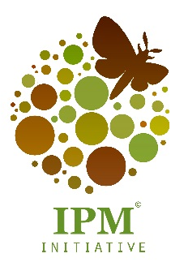
MASS-REARING OF INSECTS
WORKSHOP
09 – 13 September 2019

Venue: Dept. of Conservation Ecology and Entomology, Stellenbosch University

The mass rearing of insects is a science which lies between entomology and animal sciences. It represents the intensive production or farming of insects for various purposes. These purposes include functions such as insects for sterile insect technique (SIT), bio-control, waste management, feed production, food production and the production of raw materials for industry. This workshop is modelled after the International Insect Rearing Workshop hosted at Mississippi State University and organized by Dr. Norman Leppla, Dr. Frank Davis and Dr. John Schneider (editor of the textbook Principles and Procedures for Rearing High Quality Insects).
After the success of the first workshop, where general global principles were adapted specifically to the South African context and diverse topics were presented by top South African and international researchers with expertise in insect rearing, we decided that it should be an annual event. As a topic with a growing number of applications, this workshop will enable development of a network of insectary managers, personnel, and researchers for the continued exchange of ideas and best practice. Following on this workshop, it is hoped that a South African textbook will be written and that similar short courses will be designed and developed for a number of interest and skill levels, including for technical staff of insectaries.

Topics covered (provisional program):
Day 1: Principles of mass-rearing
Day 2: Insect breeding and pathology; half-day field trip
Day 3: Insectary design and insect nutrition
Day 4: Field trip to Citrusdal: mass-rearing programs
Day 5: Quality control and best laboratory practices

Organizers: Dr. Elsje Pieterse & Prof. Des Conlong

Contact: Caro Kapp, IPM Initiative
Department of Conservation Ecology and Entomology, Stellenbosch University
Email: ckapp@sun.ac.za

