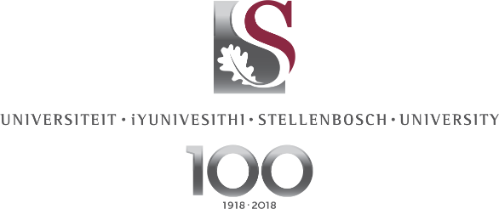

2 September 2021

ADMINISTRATIVE SERVICES
FULL DEGREE-SEEKING INTERNATIONAL STUDENT (STELLENBOSCH CAMPUS)

To mitigate the risk of virus transmission, all administrative services at the Stellenbosch University International Office (SUI) in the Krotoa Building (former RW Wilcocks), will be conducted Online on TEAMS or via email until further notice.
No walk-in service will be available without an appointment.

CLICK HERE to make an appointment for any of the following services should you wish to speak to an administrator or alternatively send an email:
Mr Grant Leukes | Housing | interhouse@sun.ac.za
 | Immigration & Health Cover | immigration@sun.ac.za
Mr Omar Isaacs | Finances | suifinance@sun.ac.za
 | Pre-registration Degree-Seeking International Students Sem2-2021 | intpreregistration@sun.ac.za
Ms Carmien Snyman | International Undergraduate Evaluation & Matriculation Exemption | suiundergrads@sun.ac.za

- HOUSING
Any information regarding housing can be viewed on this link: SUI HOUSING
- RE-APPLY for Housing for semester 1-2022 (Students currently staying in SUI Administered accommodation)
- New APPLICATIONS for Housing for semester 1-2022

- IMMIGRATION & HEALTH COVER
Any information regarding immigration & health cover can be viewed on this link: IMMIGRATION & HEALTH COVER
To request for a Letter of Undertaking / Letter of continuation (LOC) for study visa renewal, please ensure that your student account at Stellenbosch University is settled in full and that you have sufficient funding available to continue with your studies.
- Undergraduate Admission : immigration@sun.ac.za
- Postgraduate Admission : postgraduate@sun.ac.za

- STUDENT FINANCES
Any information regarding fees can be viewed on this link: INTERNATIONAL STUDENT FINANCES
- To GENERATE a Fee Quotation for 2022 Academic Year
- To PAY your Student Account (Quickest option to ensure the funds reflects immediately)
- To REQUEST for a letter to Open a Bank Account in SA
- To REQUEST for an Electronic transfer of funds / credit available on the student account
- To REQUEST for a refund/reimbursement to an International Bank account
- To UPLOAD or CHANGE SA banking details
- To request for a proof of address letter, please send an email to suireception@sun.ac.za

- INTERNATIONAL UNDERGRADUATE ENROLMENT & EVALUATION
- Information regarding matriculation exemption can be found on MATRICULATION EXEMPTION

For any other information, visit our website on STELLENBOSCH UNIVERSITY INTERNATIONAL or
Phone +27 21 808 2565 from Monday-Friday between 08h00-16h30.
Please regularly check the COVID-19: Stellenbosch University updates and information for information.

