Committee members/Komiteelede 2016/2017
 | Kalnisha Govender  Chairperson  19491166@sun.ac.za  Tel: 081 466 7254 |  | Lucia Daly  Marketing &  Technical Advisor  20143546@sun.ac.za  Tel: 071 167 0609
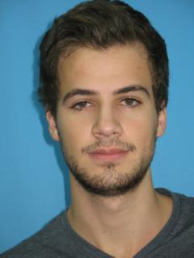 | Melt Hugo  Vice-chairperson  17322200@sun.ac.za  Tel: 079 508 4381 | 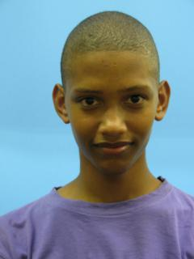 | Desren Jacobs  Marketing &  Technical Advisor 18998763@sun.ac.za  Tel: 074 257 4570
 | Shannon Swart  Secretary  18171265@sun.ac.za  Tel: 072 011 6380 |  | Felicia Kubheka  Student Affairs  19905114@sun.ac.za  Tel: 061 137 2243
 | Taariq Tayob  Treasurer  19343000@sun.ac.za  Tel: 072 888 1693 |  | Tasneem Adams  Social  18482538@sun.ac.za  Tel: 073 973 5527
Winnie Chabaari
Postgraduate Students
19660820@sun.ac.za
Tel: 079 053 4848

